

It’s Arts Play:

Young Children Belonging, Being and Becoming through the Arts
  - Instructor’s Resource Manual

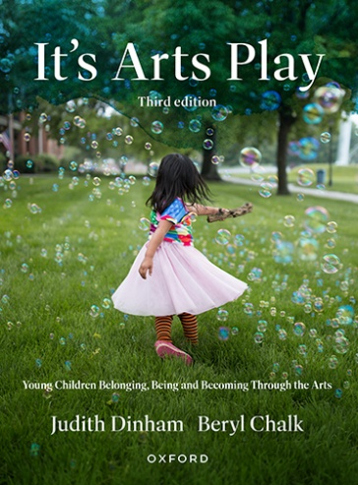
Judith Dinham Beryl Chalk
Oxford University Press
Print ISBN: 9780190354664
eBook ISBN: 9780190354671

List of Pause and Reflect and Sparkers
Chapter |  |  | Page
1 | Pause and reflect | Dancing in response to music | 8
1 | Pause and reflect | Puppetry traditions reflect cultural diversity | 15
1 | Pause and reflect | Learning promoted ‘in the moment’ | 18
2 | Pause and reflect | Communicating through the visual arts language | 41
2 | Pause and reflect | Are they just beans? | 42
2 | Pause and reflect | Dramatic play with boxes | 49
2 | Pause and reflect | Well, was that fun? | 50
3 | Pause and reflect | A young child’s play-based experience of musical concepts | 59
3 | Pause and reflect | How cookie-cutter or production line approaches serve to deny children’s authority and agency | 60
3 | Pause and reflect | Year 2 drawing a yabbie | 61
3 | Pause and reflect | Children respond to artworks by artists from other times and places | 62
3 | Pause and reflect | Reconciling intense and overwhelming emotions | 66
3 | Pause and reflect | Making moves | 68
3 | Pause and reflect | The complexity of play | 70
3 | Pause and reflect | The complexity of song innovation | 71
4 | Pause and reflect | Developing empathy for the feelings of others | 92
4 | Pause and reflect | Appreciation of the natural world | 93
5 | Pause and reflect | Responding in role as the ‘artist’ | 111
6 | Pause and reflect | Using metaphor | 122
4 | Sparkers | Provocations or catalysts for artistic explorations | 84
4 | Sparkers | Learning activities exploring the theme of People in  our community | 99
7 | Sparkers | Action songs | 145
7 | Sparkers | Choreography | 154
7 | Sparkers | Guided viewing of dance | 158
8 | Sparkers | Dramatic play | 169
8 | Sparkers | Process-drama | 175
8 | Sparkers | Story Drama | 178
8 | Sparkers | Puppetry | 184
8 | Sparkers | Guided active viewing of drama | 187
9 | Sparkers | Posters and book covers | 201
9 | Sparkers | Comics | 205
9 | Sparkers | Photo stories and digital storybooks | 209
9 | Sparkers | Video-making and stop-motion animations | 214
9 | Sparkers | Guided review of media artworks | 217
10 | Sparkers | Listening and exploring sound | 235
10 | Sparkers | Percussion | 239
10 | Sparkers | Singing (rhymes, chants, songs and voice play) | 247
10 | Sparkers | Composing | 252
10 | Sparkers | Guided active listening to music | 256
11 | Sparkers | Drawing | 273
11 | Sparkers | Painting | 283
11 | Sparkers | Sculptures and related constructions | 290
11 | Sparkers | Connecting to and exploring the visual arts world | 295

