Social Studies at LPS

Social Studies at Lincoln Public Schools

Vision Statement
Social Studies education in Lincoln Public Schools engages all students with the knowledge and skills necessary to be informed and active citizens, while also contributing to our diverse and interdependent world.
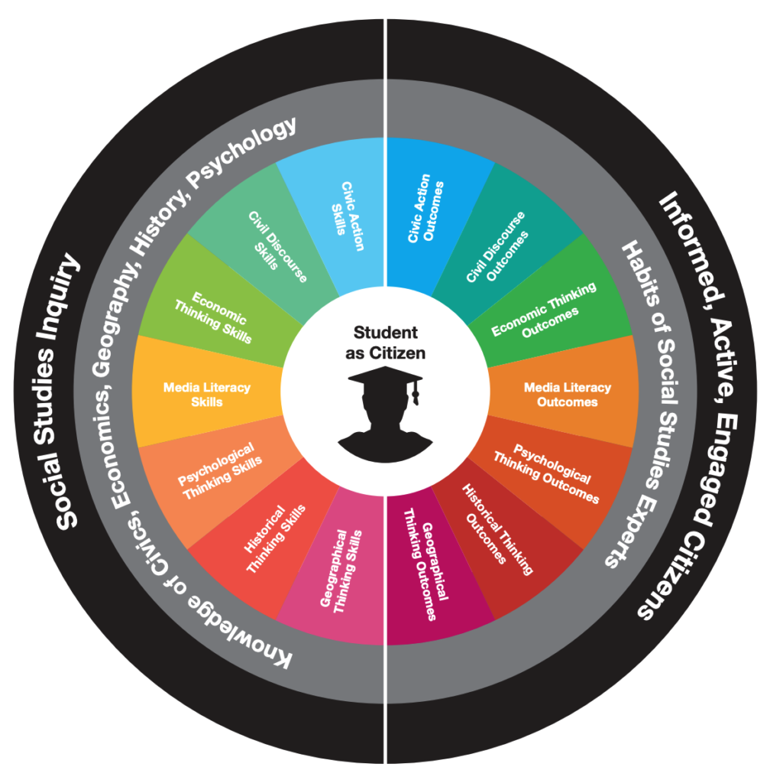

The Lincoln Public Schools Social Studies Blueprint (left) provides a frontpage for important resources for social studies teachers while also representing a design for the integration of social studies content and skills across a student’s career as a social studies learner. The “Student as Citizen” reminds us that student learning is at the center and emphasizes a broad definition of “citizen” that includes all students as participants in their communities, nations, and world. Students learn to become informed, active, and engaged citizens. Community Curriculum Council Presentation from November 16, 2020.

Students in Lincoln Public Schools will:

Know
- How to become engaged participants in public life
- Differences between democratic and nondemocratic political systems
- Realities of global interdependence
- Rights and responsibilities of citizens of a democracy
- Historical and contemporary understandings of basic freedoms and rights

Understand
- The human story across time at a local, national and global level
- The role culture plays in human and societal development
- Interactions between humans and their environment
- The historical development of ideas of human rights
- How they fit into their community, nation and world
- How people organize for the production, distribution and consumption of goods and services

Be able to
- Think flexibly about complex issues facing human societies
- Apply decision-making and problem-solving skills to real world issues
- Analyze causes and consequences of events and decisions
- Apply research methods associated with historical and social science inquiry
- Evaluate historical accounts made by others
- Use historical thinking skills to interpret the past
- Examine human thinking and behavior using multiple perspectives
Click here for a PDF version of the social studies vision in Lincoln Public Schools

Overview of Curriculum
K-12 Social Studies curriculum in Lincoln Public Schools covers many content areas, including: community and local history, Nebraska history, United States history, World history, Geography, Civics, Economics, Psychology and Government and Politics. Curriculum is guided by the Nebraska State Standards. For a list of textbooks used with each of our required courses, please see the LPS Curriculum page.*

Elementary School
In elementary school students are exposed to historical, geographical, civic, and economic thinking through the use of visual images and short texts. In early elementary (K-3), students become familiar with their community, nation, and world. Students begin to explore elements of effective citizenship and study the US Constitution. Students are also introduced to basic economic concepts through the exploration of goods and services in their communities. In upper elementary grades, students study the history of Nebraska and the United States in greater detail.

Middle School
Students continue to build knowledge and skills of history, geography, civics, and economics in middle school through the development of an understanding of the human story across time. In grades 6 and 7, students complete a chronological study of world history from the establishment of early farming communities through European encounters with the Americas. In grade 8, students continue a chronological study with American History as the focus. Topics at each grade level will be studied within the context of the time and include application to relevant contemporary issues. In addition, students will use geographic concepts, economic reasoning, and democratic processes to analyze how individuals and and societies change over time.

High School
High School students have the opportunity to continue to develop social studies skills through the in-depth study of a variety of disciplines over the course of four years. Freshman level required courses focus on developing citizenship and cultural awareness through the study of civics and geography. Sophomores and juniors conclude the chronological studies of world and U.S. history, respectively. Juniors and seniors experience courses in Economics and Psychology. Seniors conclude their social studies courses with the study of Government and Politics, emphasizing positive contributions to their communities by the completion of community service hours. There are also a number of alternative offerings, such as Advanced Placement courses and elective courses at the high school level. Please consult department chairs at individual schools for this information.
*Note: Please see the “Community Resources” tab for more information about about unique programs and opportunities in social studies classes at Lincoln Public Schools.
https://home.lps.org/socialstudies/

