Chapter 52
String and Orchestra Rehearsal Strategies
Supplemental Materials: Five Key Rehearsal Skills—Strategies and Activities
Joel Schut and Rebecca B. MacLeod

Breathing/Moving
Pass the Beat. Have the students sit in a circle so that everyone can make eye contact. The teacher, or designated student, begins the game by plucking an open string for 4 clear beats, makes direct eye contact with an individual, and visually passes the quarter notes to that student, who then takes over. The students may choose to keep the quarter notes for as many beats as they like, then pass to another student in time as long as they are clear! This means, they must keep a steady pulse, make clear eye contact, and prep on the beat prior to passing the note.

Follow the Leader. Teach the class a simple song by rote. It can be any song that everyone in the group can play well. Have individual students stand on the podium with their instrument and have the orchestra follow them. They must prep and breathe in order for the other students to know when to play. Have the leader vary their bow speed or articulation and have the orchestra follow exactly what the leader does.
Start without the Conductor: Step off the podium and coach like a chamber group. Join the ensemble playing your instrument for a Teacher-Performer Led Rehearsal. Model expectations for cues, breathing and connection demonstrating how to lead! Assign students to start a musical passage without the conductor nonverbally. Transfer the role to different players to encourage all students to breathe and lead from front to back of sections.

Listening/Adjusting
Intonation Detective: Choose one or two students to play detective and send them out of the room so they are not privy to the ensemble’s discussion. Then select a student, or students, to intentionally play out of tune. Bring the students back to rehearsal and have them locate the out of tune students.

The Rule of Octaves. The rule of octaves states that, “the lower octave is louder than the upper octave by a 3:1 ratio.” Have students listen for all moments of octaves and adjust their balance accordingly.

Imposters Among Us? Similar to the intonation detective, select students to deliberately play a rhythm inaccurately, or deliberately rush. Have classmates vote to find the “imposter among us.”

Backup Singer. This activity helps teach balance and melodic awareness. Everyone’s job is to listen to the melody. If you have the melody, make sure it is heard. If you do not have the melody, your job is to balance to the melody and make it sound great. Everyone’s ears should track the primary melodic figures at all times.

Subdividing/Counting
Metronome Game Outside/Inside - Have students count to 8 with a metronome on so that everyone can hear the pulse. Repeatedly have them count to 8 until the pulse becomes steady. Suggest that the students think the subdivision one level lower than the pulse (e.g. eighth notes). Next, the students must learn to internalize the pulse by counting silently in their mind without any external visual cues. When the teacher’s palms face up, students count out loud. When the teacher’s palms face down, the students count silently. The teacher should have a metronome on silent to be certain there is a steady pulse and turn palms up at different intervals (e.g. on beat 6, or beat 5). Have students count the first four beats aloud, then palms down. When palms face up, students should be on the SAME numerical beat. If not, repeat activity.

Human Metronome. Isolate a passage and have inside players perform the smallest note value of the passage (generally sixteenth notes) on the tonic note while the outside players perform the passage as written. Encourage students to both listen to and watch the sixteenth note bows. For a more sophisticated activity, ask the students to perform the melody of the passage using the smallest note value. In other words, perform a half note with 8 sixteenth notes. Switch parts so that the inside players perform the passage as written and outside players perform the passage subdivided.

Counting X Game: Using the formula: “1, 2, X, Go!”, this game requires students to count internally before speaking a number, clapping, playing at a predictable time. Encourage students to subdivide the beat.

Insert Rests: Strategically place additional rests in a difficult passage. This helps students maintain control in difficult passages creating a sense of calm and poise curbing the tendency to rush.

Watching/Matching
Toss a Ball. Toss a ball into the air and have students clap as you catch the ball. Tossing the ball should be just like the conductor’s preparatory beat. Next, toss the ball and have students pizzicato as you catch the ball. Transfer this activity to the conductor’s baton.

Mirror Game: Students should stand and face their partner with both hands raised palms facing each other. One student leads by slowly gently moving their hands as the other student moves as a mirror. The teacher can clap to indicate that the leader role should switch. This activity hones student visual awareness, reactiveness, and ability to use their peripheral vision.

Bow Twins: Have students face one another and play a memorized passage while staring at their partner’s bow. They should strive to have their bows look identical as they play.

One Inch Rule: At any point students should be within one inch of their section leader’s bow. This helps create matching tone and visual unity. Take a snapshot or find a moment to pause the ensemble.

Freeze: Learn to match bow movements quickly. A designated section leader or member intentionally stops their bow and everyone in the section does likewise. The goal is to increase student awareness and reaction time.

Bow Change Drones: While playing a single note, have a designed section leader or member move to various parts of the bow with the section matching as fast as possible. Consider using this exercise when establishing a drone pitch for scales.

Share a Bow: This exercise helps students play with precision and similar bow length and speed. Have students “share a bow” as they shadow bow a difficult passage. One student should hold the bow at the frog and the other student should hold the bow towards the middle. Important - both students must use their bow hand for this activity to transfer. Conduct the passage and have students shadow bow in their air. If they are not in time, they will kinesthetically receive feedback until the match one other’s rhythm, energy, and bow length.

Musicality/Motivation
Play Only the Down Beats: Yep, play only the down beats and imagine the rest.

Play The Essence Notes: Ask students to play only the contour, or important notes in a musical phrase rather than every note. Have inside players play the “essence” notes, and outside players play the passage. Switch!

Tonal Pillars: Establish crux moments based on tone color. Hold chords to set the ideal sound, voicing and resonance as listening arrival goals. This could range from a buzzing dissonance in a Beethoven symphony to a levitating Enchanted Garden climax in Ravel’s Mother Goose Suite.

Relay Rehearsal: Split the ensemble into two or more groups assigning unique musical sections by phrase structure, rehearsal number or measure groupings. Rehearse the work cleanly passing the musical baton between groups. Students must be ready to receive and pass off confidently!

Ensemble Seating and Setup: Movement and Physical Space can greatly enhance the rehearsal experience and focus listening goals. The list below provides several variable classical orchestra setup possibilities. Examples are grouped by section and ensemble listed in increasing order of chaos. Reverse engineer the rehearsal needs to determine which shape helps best accomplish the goal. For section unity consider section circles. For part independence consider chamber pods. For listening across a full orchestra consider moving wind players to the podium surrounded by strings. For waning student motivation provide three minutes to rearrange as a flattering cartoon of the director. In all movement and space reconfiguration, remember to include students in the musical why. Share: “Here is our musical problem. Which configuration will allow us to best address this?” When students own the goals, movement and altered space rehearsals avoid the trap of musical chairs only as an exercise.

​​Examples are grouped by section listed in increasing order of chaos
1. Section Leadership:
Section Leader Turn Around: Section leaders face their section facilitating chamber music skills and direct eye to eye communication. (See Figure 1)

Figure 1: Section Leader Turn Around Seating Example
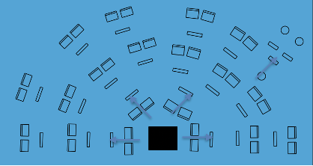

Section Leader Observation Perch: Section leaders sit in the back of their section as mentors. Encourage student led specific praise and constructive feedback based on their observations.

Section Leader Eviction/Promotion: Section leaders swap seats with a section member. This promotes a new leadership opportunity and allows leadership to pair with a student who may need extra support or mentorship.

2. Player Orientation:
Stand Spins: Students memorize sections and physically spin music out of view promoting observation and listening.

Reverse Seating: Students reverse seating aimed away from the podium promoting listening and trust. (See Figure 2)

Figure 2: Reverse Seating Example
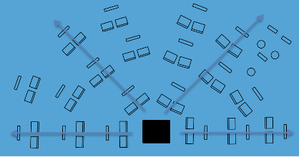

3. Player Movement in Traditional Ensemble Arrangements
Conveyer Belt Seating: Students rotate chairing systematically by day, week or portion of rehearsal. Options include inside/outside and forward/backwards. This is helpful for student assessment and allows all students to experience leadership opportunities at some point in the rotation. (See Figure 3)

Figure 3: Conveyer Belt Seating Example
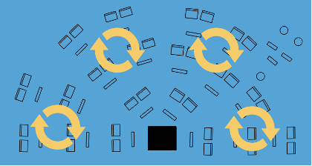

Scramble: Students randomly mix pairing student choice with new ways of listening. Scramble configurations can be mixed within section, row, or ensemble. I like to encourage students to sit next to someone they know least well or in a section they have never played. Students should be able to see the conductor and ideally parts are not placed adjacently. I like to use scramble seating the week before a performance to see if balance and ensemble listening remain intact. (See Figure 4 and 5)

Figure 4: Scramble Seating Example by row
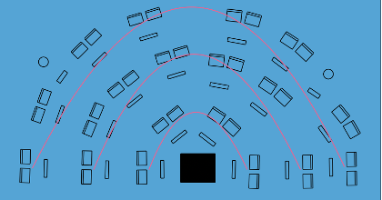

Figure 5: Scramble Seating by ensemble
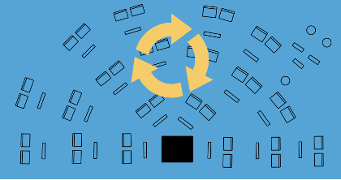

4. Player Movement in Non-Traditional Arrangements

Shapes: Ensembles can form a variety of shapes to promote listening, teacher access to students and put ears in unique scenarios. Some of my favorite shapes include:
- Section circles (with leadership seeing and not seeing the podium). (See Figure 6)
Figure 6: Section Circle Seating Example
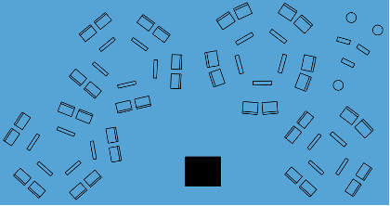

- Chamber music pods (ie. quartets, quintets). (See Figure 7)
Figure 7: Chamber Music Pods Seating Example
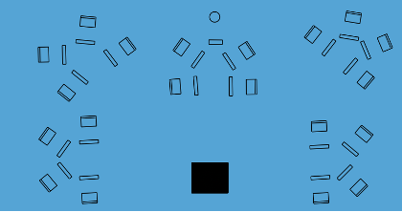
- Opposing lines (high strings vs. low strings)
- Flying “V” section formations (See Figure 8)
Figure 8: Flying “V” section formation Seating Example
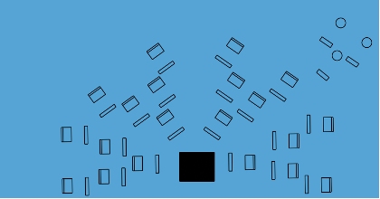
- Yoked in threes
- Prize Box (See Figure 9)
Figure 9: Prize Box Seating Example
- Shapes (e.g. trapezoid, parallelogram)
- Creative shapes (e.g. school mascot, animals)

