Chapter 34
Pedagogies for Teaching Clarinet
Supplemental Materials: Learning about the Pinky or Little Finger Keys

The pinky or little finger (fifth digit) of each hand has a very important role in clarinet playing. These fingers operate two sets of side keys on the lower joint of the clarinet.

Both the left and right little fingers must be positioned in an arc like position, using the pad of the fingertip to depress the keys.

A quick review of the registers of the clarinet will help in thinking about the use of the little finger keys. The registers are found in Table 1.

Table 1. Registers of the clarinet
Register names: | Chalumeau | (Throat Tones) | Clarion | Altissimo
Written note range: | E3 – Bb4 | (G4 – Bb4) | B4 – C6 | C#6 – Bb7

As shown in Figure 1, the left little finger operates the keys in the chalumeau register of the clarinet (see Table 1). As shown in the diagram below, the left little finger operates F/E#, F#/Gb, and E/Fb. In the clarion range (see Table 1), the register key is depressed and therefore the left little finger operates D#/Eb, C/B#, C#/Db & B/Cb.

Figure 1. Left little finger keys

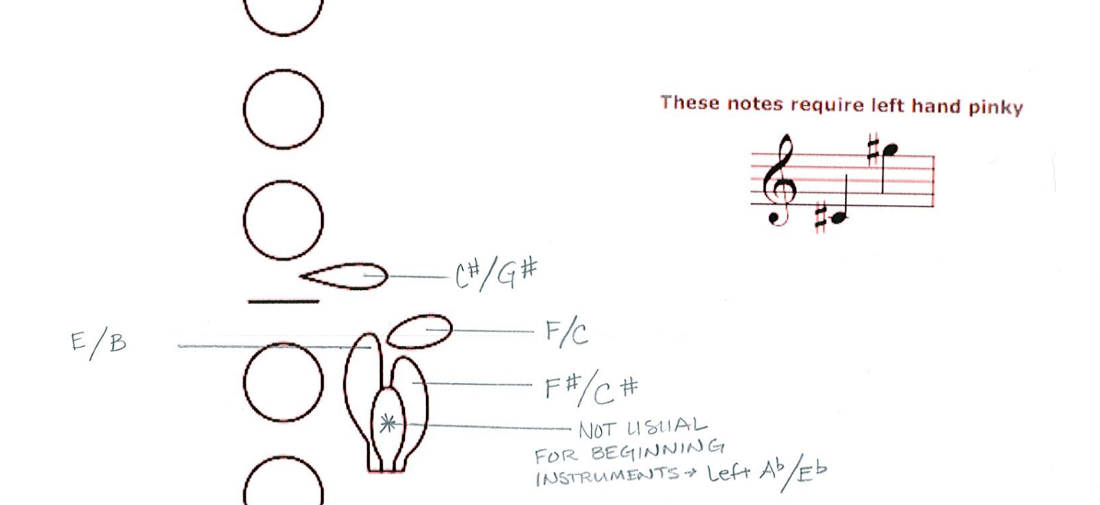

Figure 2. Right Little finger Keys

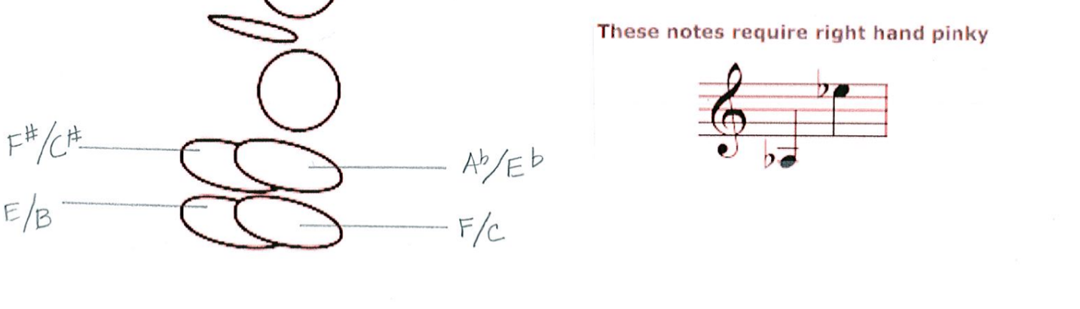
When using little finger keys are in use, it is very important that the player alternates the keys so there is no sliding across keys with the same little finger. The full instrument with little finger keys listed is in Figure 3. Making sure we teach alternate fingerings with the little finger keys ensures the player will develop accuracy and speed while playing certain passages.

Figure 3. Full Little Finger Key Chart

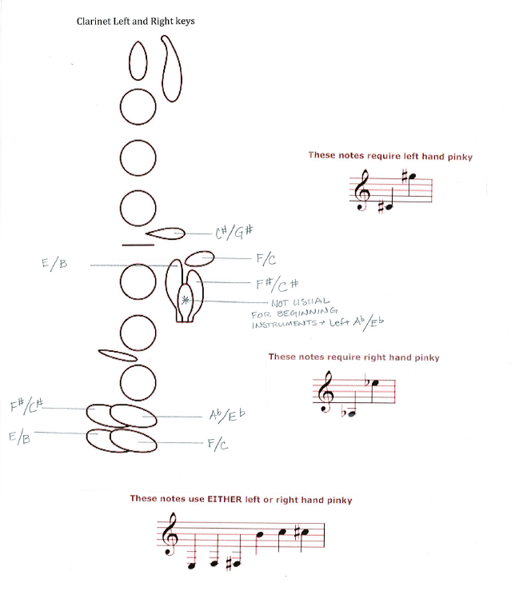

Figures 2 and 3 are appropriate exercise to assist the young player in determining which left-right or right-left movement is appropriate.

Figure 2. Sample Little finger Key Exercise I
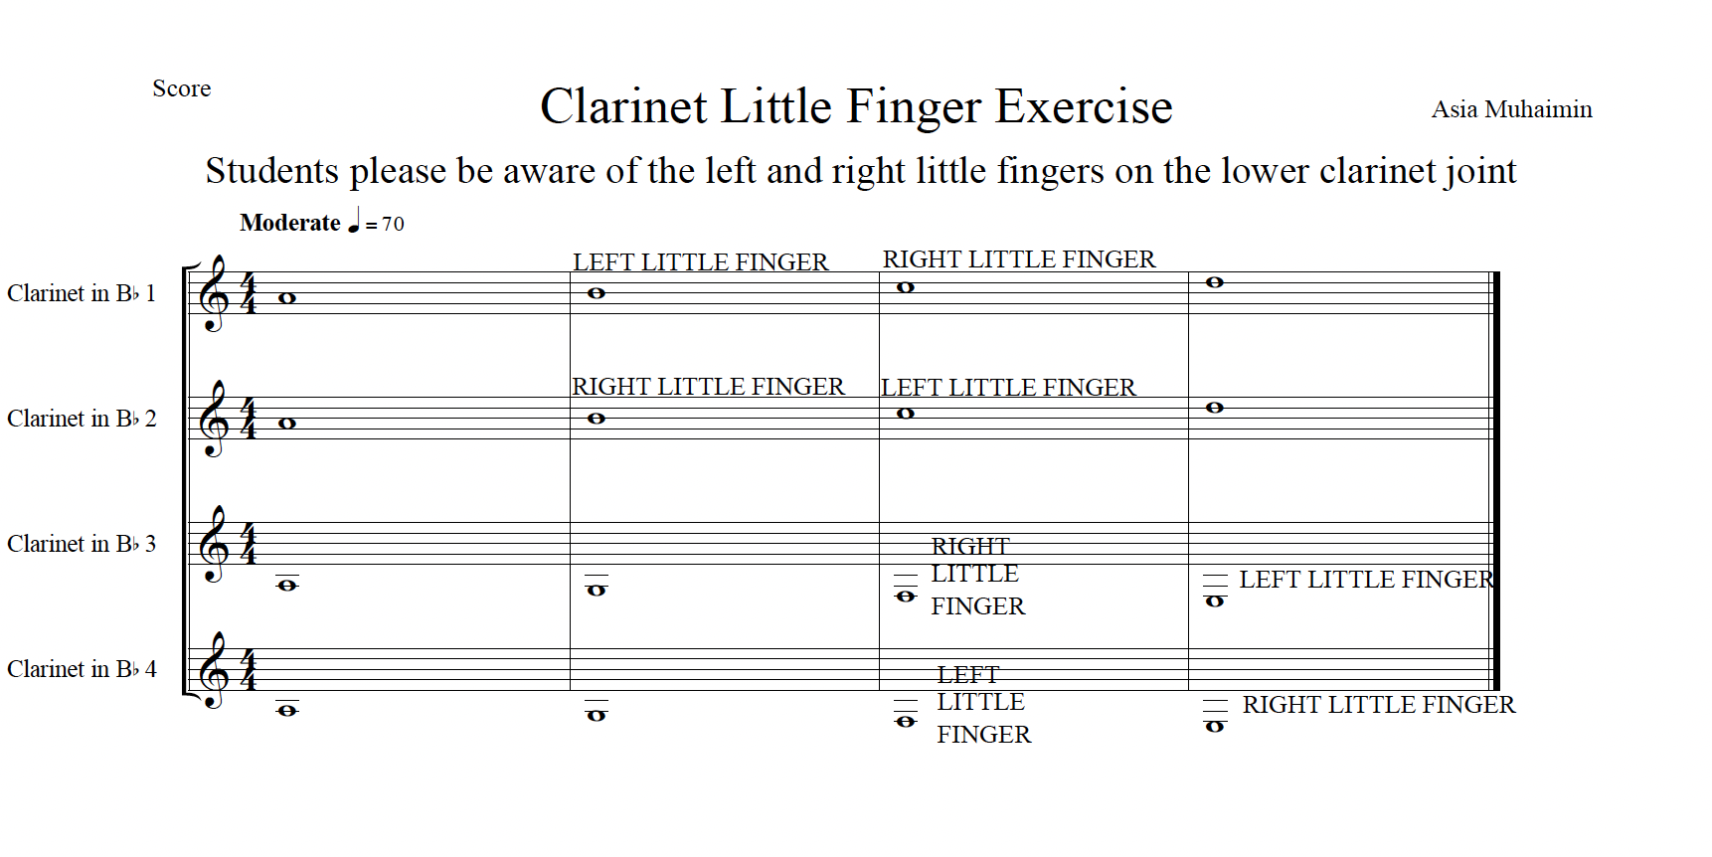
Figure 3. Sample Little finger Key Exercise II
