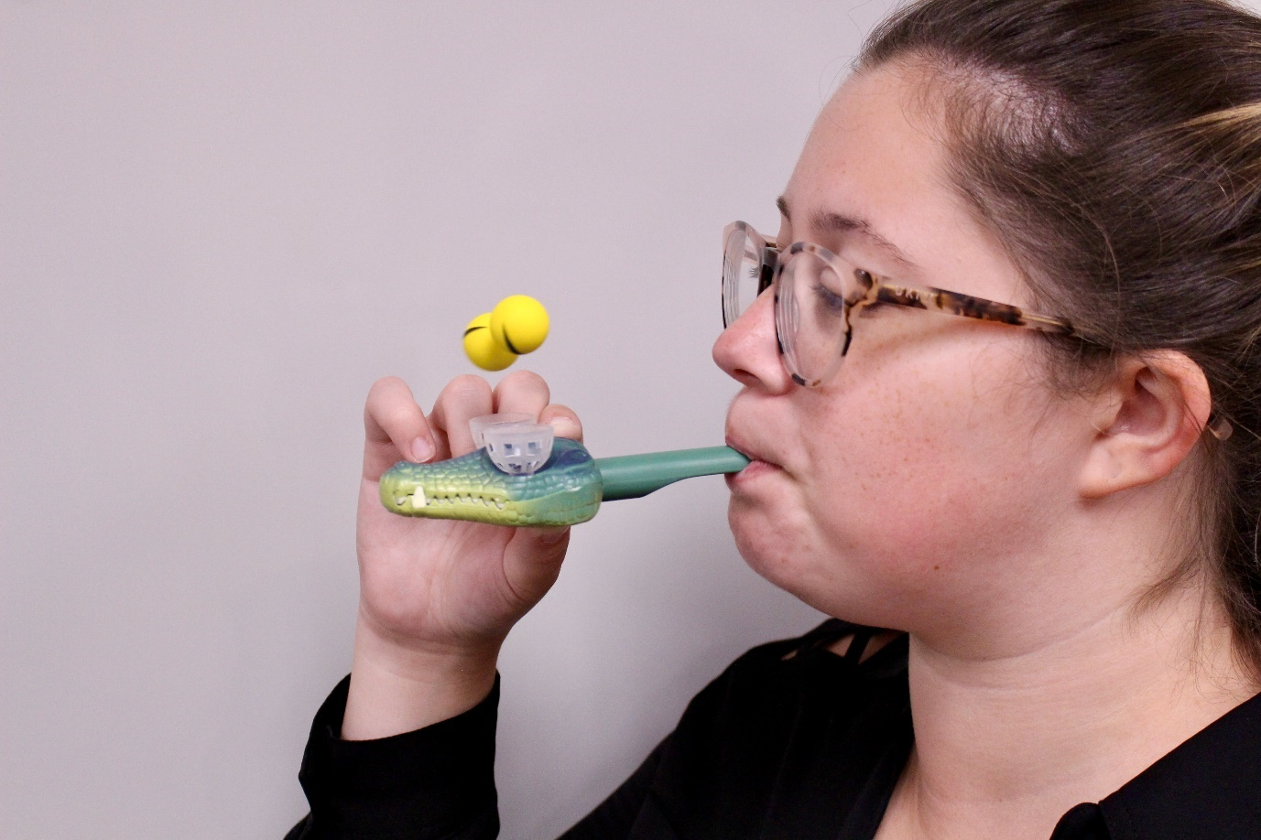

Figure 1. Blowing toys

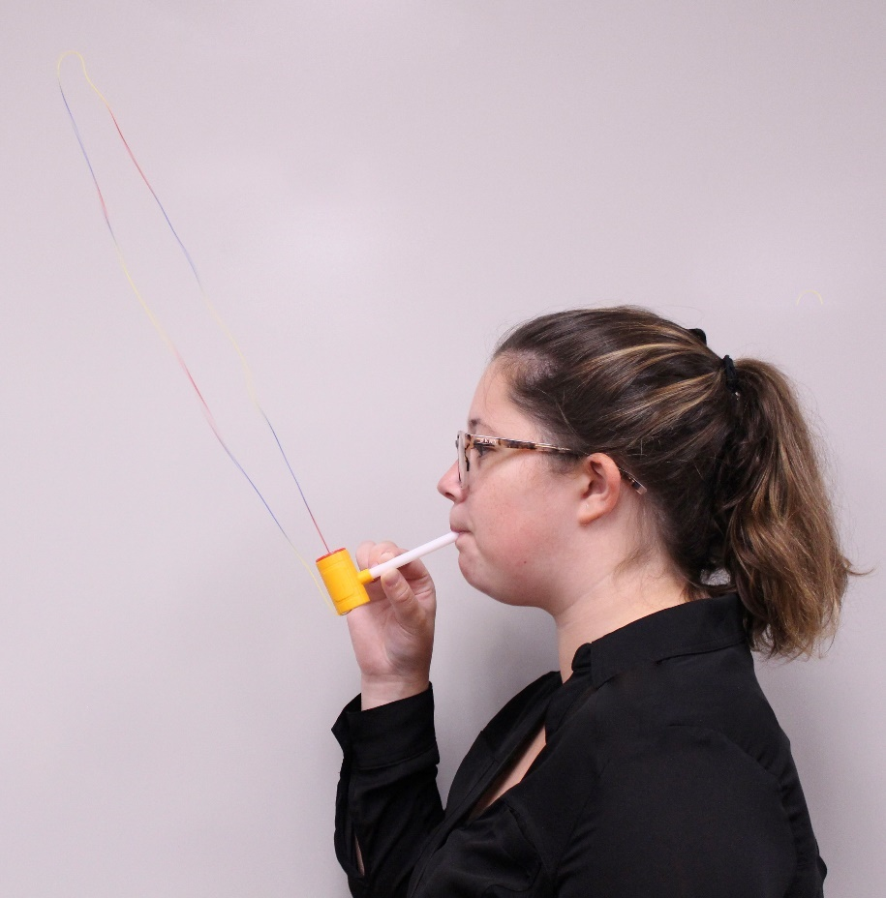

Figure 2. String toys

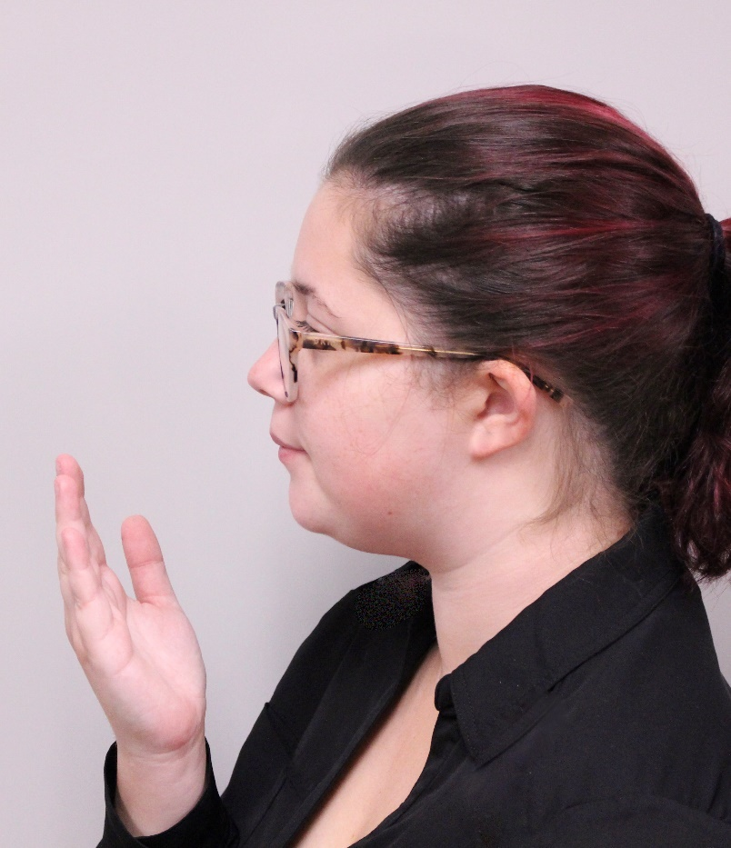

Figure 3. Hand assessing air angle and consistency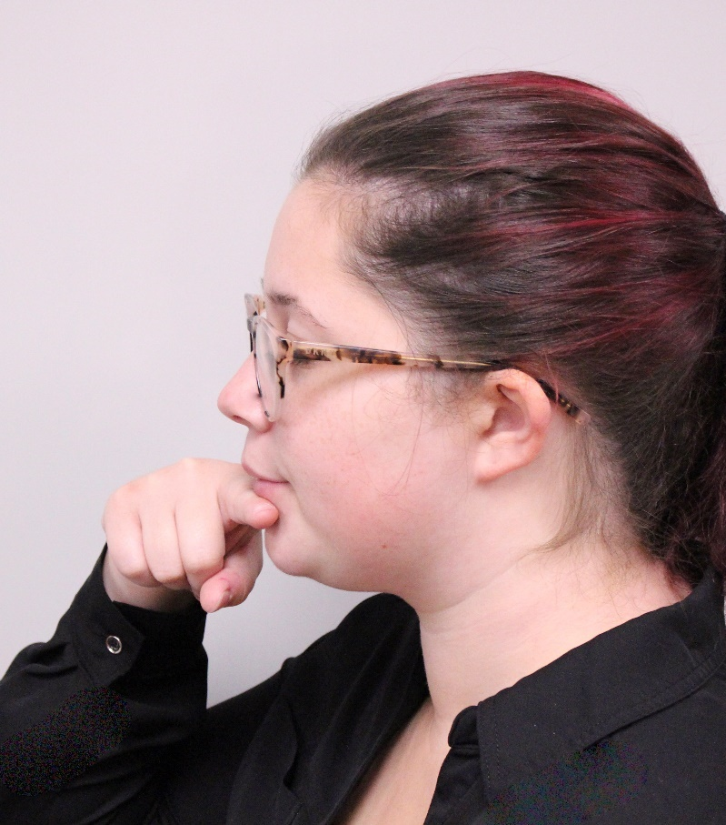

Figure 4. Finger as the lip plate

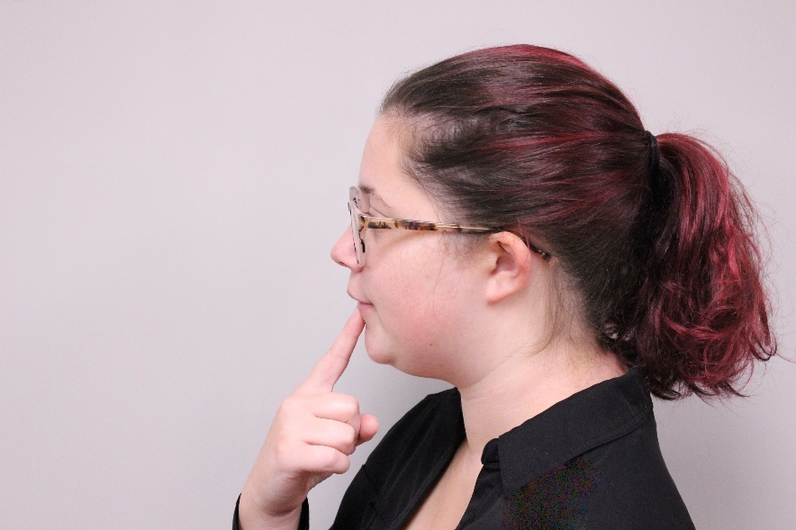

Figure 5. Finger as the angle, version 1

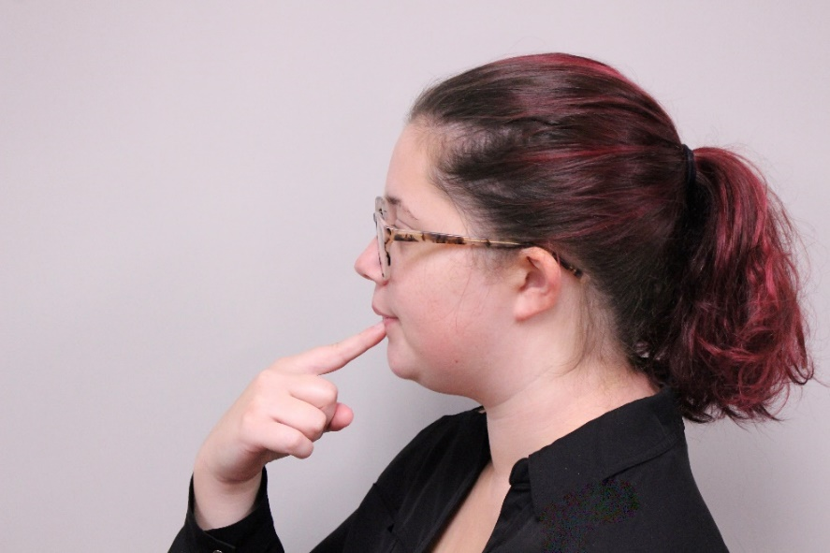

Figure 6. Finger as the angle, version 2

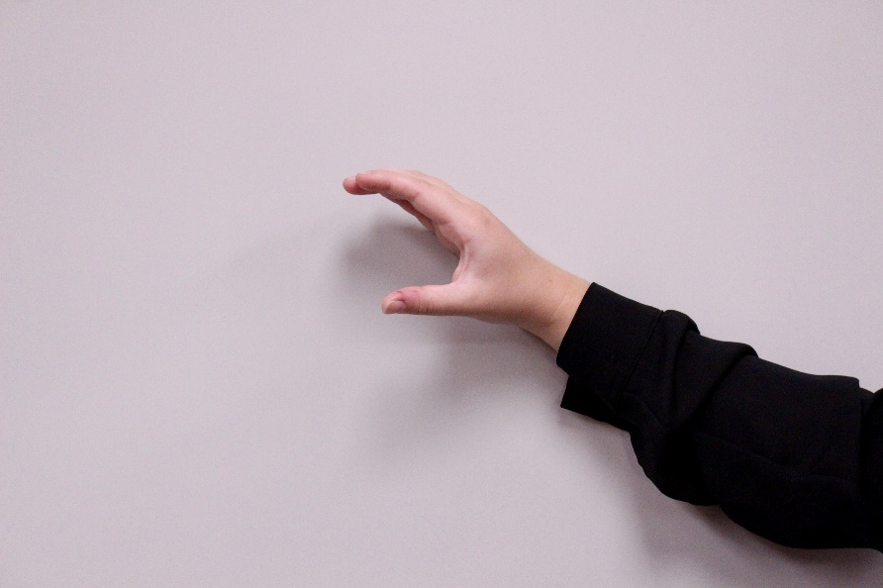

Figure 7. Visual for inside of mouth shape (open)

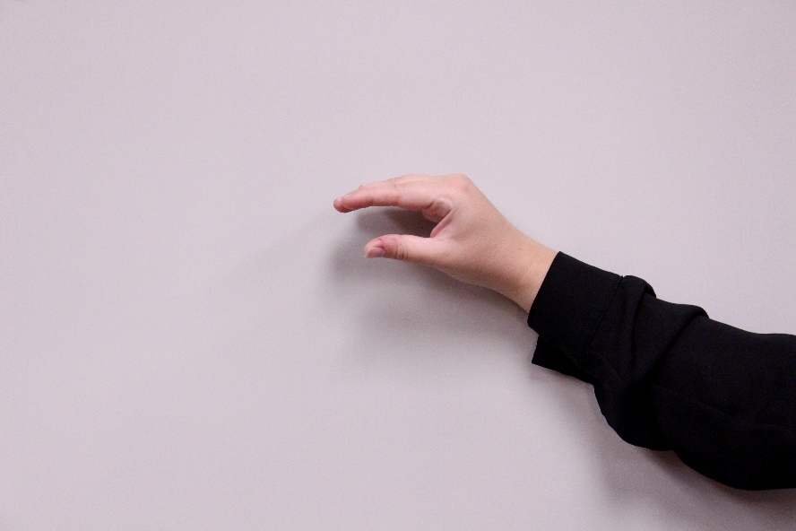

Figure 8. Visual for inside of mouth shape (insect)

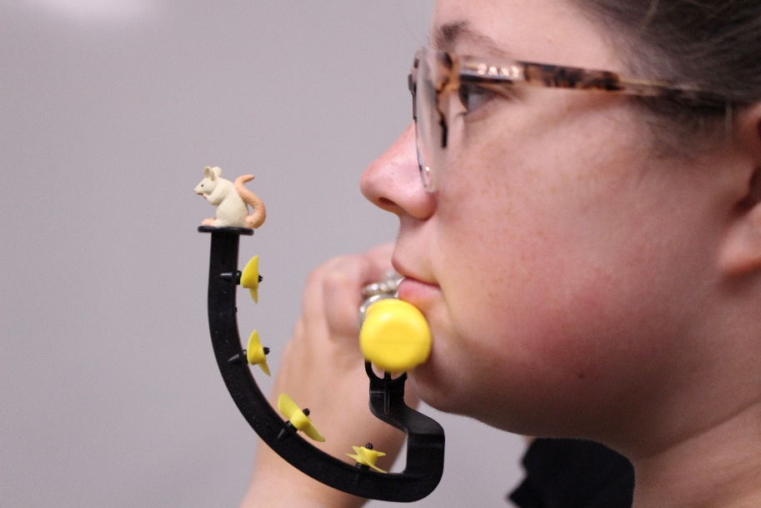

Figure 9. Pneumo pro side angle

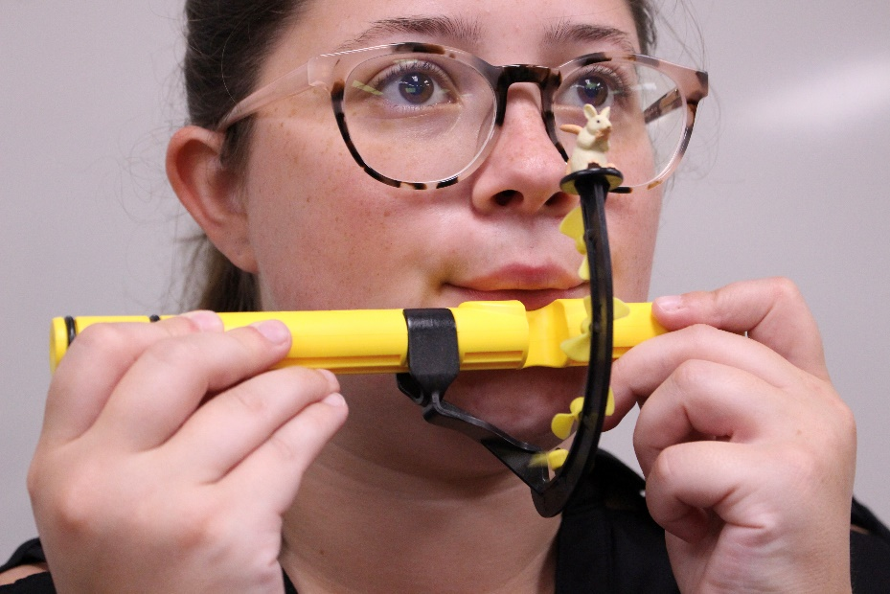

Figure 10. Pneumo pro front angle

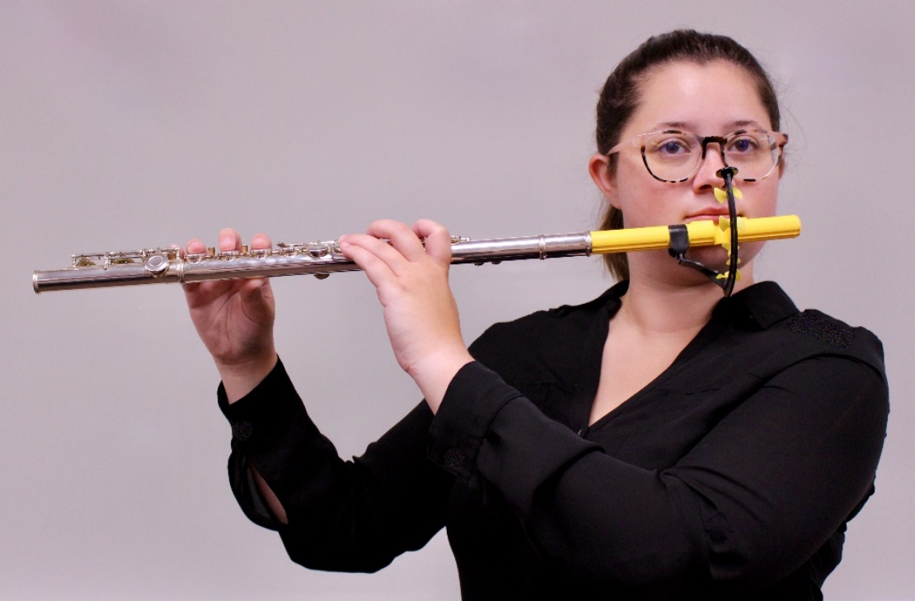

Figure 11. Pneumo pro attached to flute

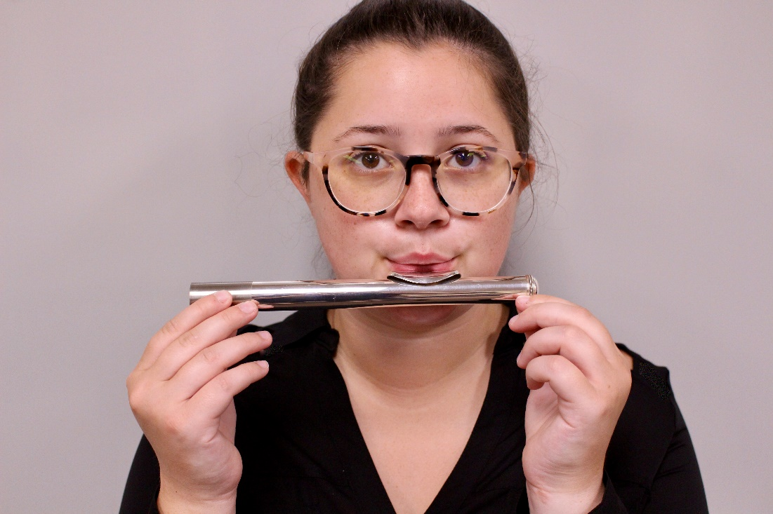

Figure 12. Open headjoint sound

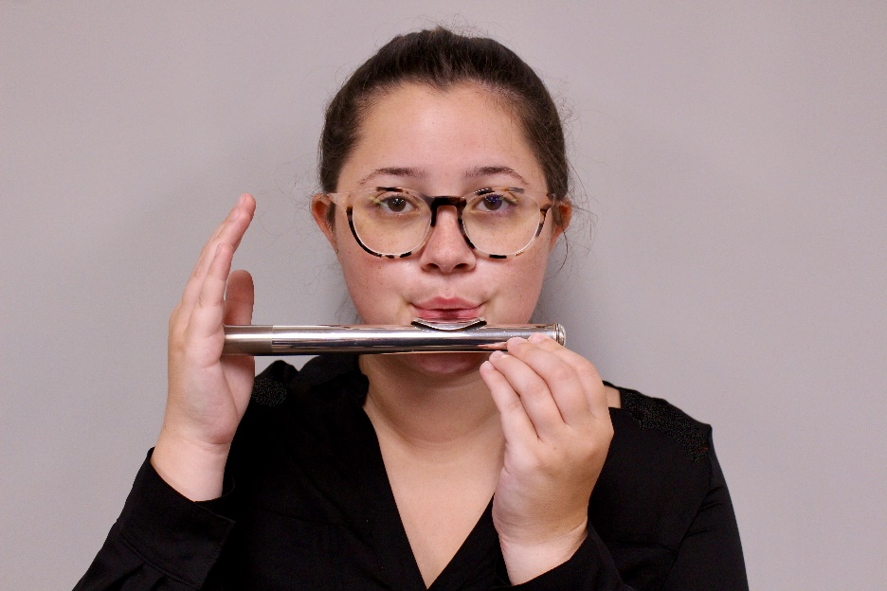

Figure 13. Closed headjoint sound

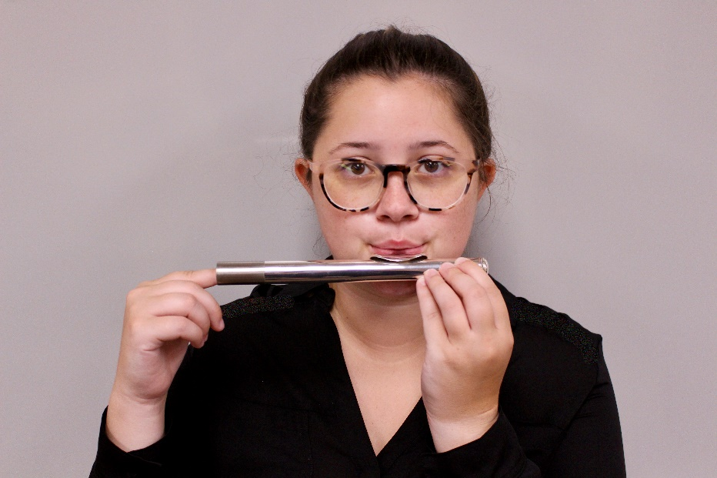

Figure 14. Sliding headjoint sound

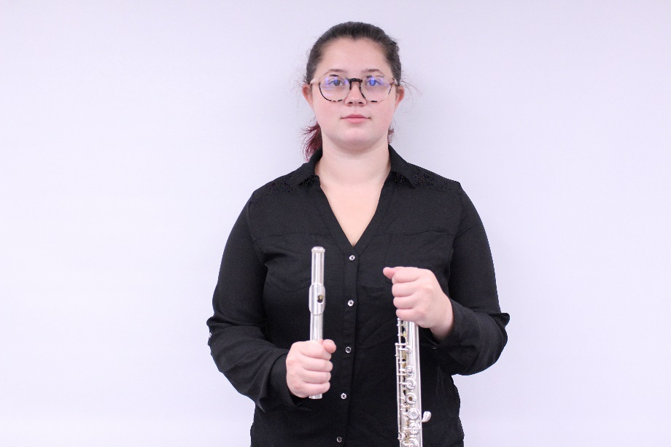

Figure 15. Flute assembly step 1

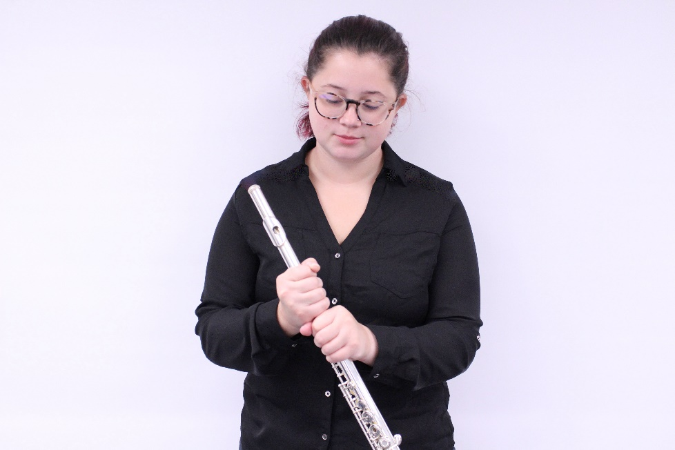

Figure 16. Flute assembly step 2

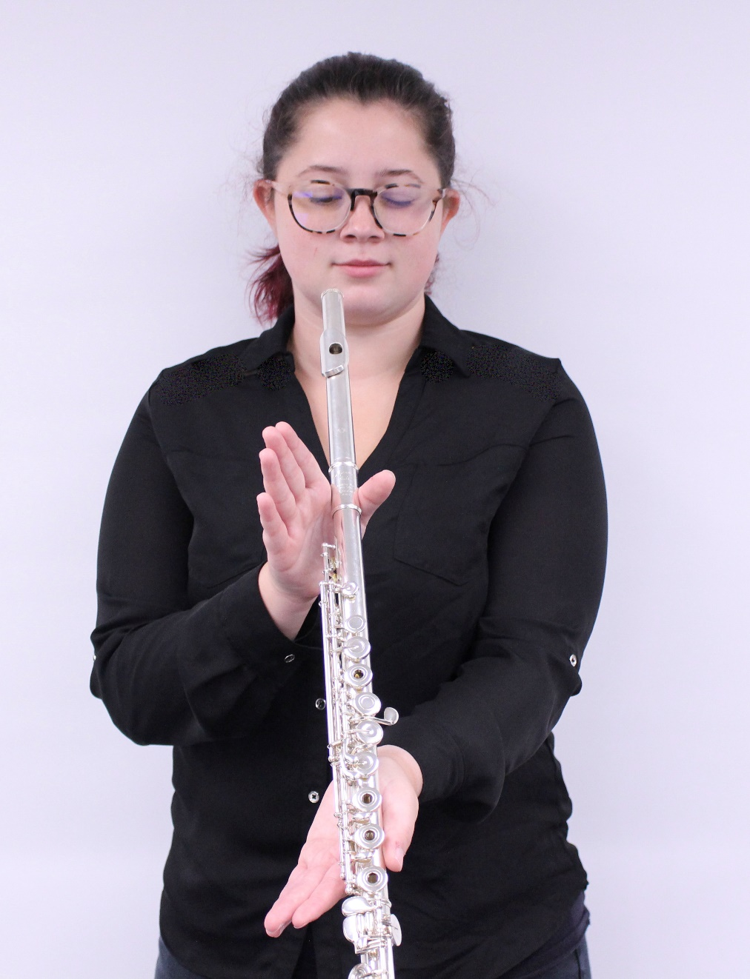

Figure 17. Alignment of the headjoint to body

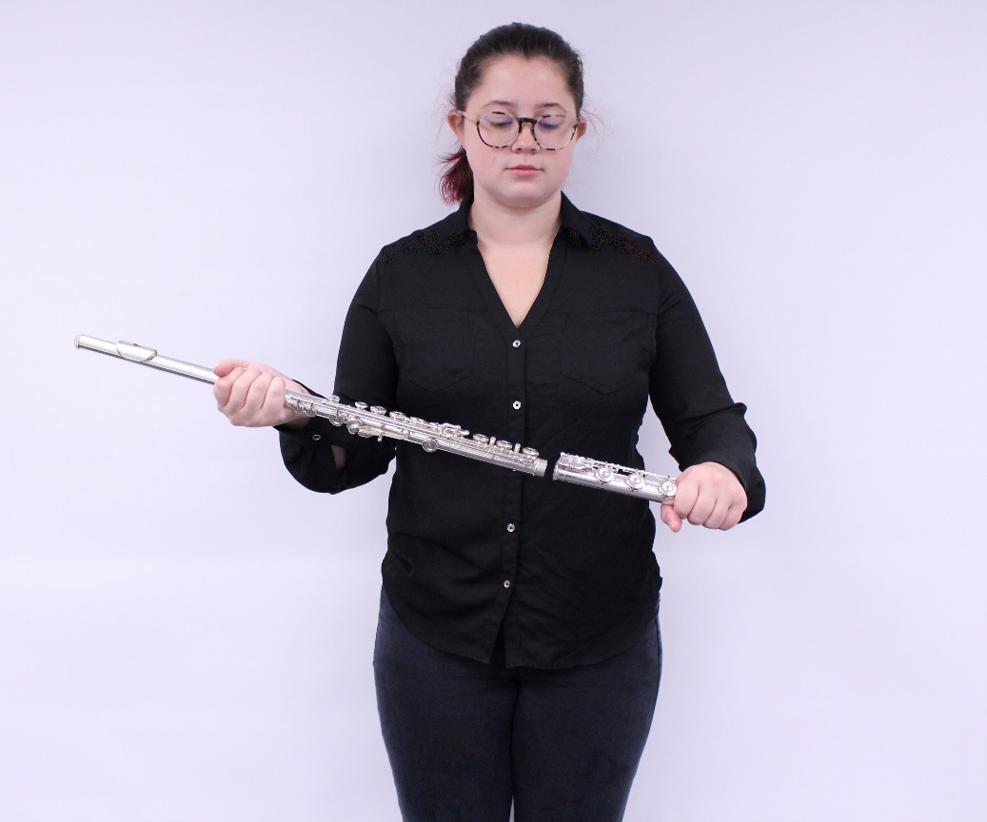

Figure 18. Flute assembly step 3

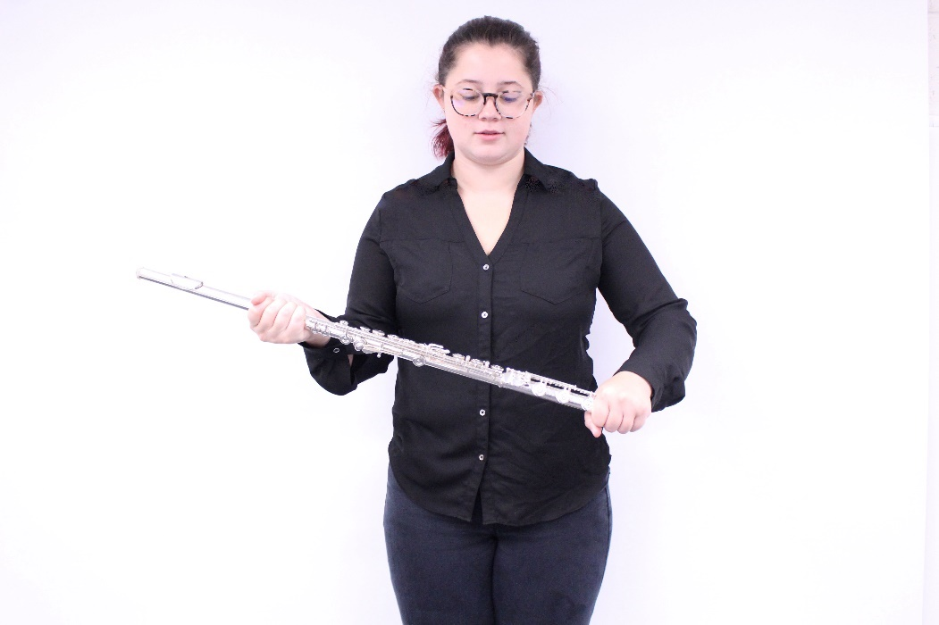

Figure 19. Flute assembly step 4

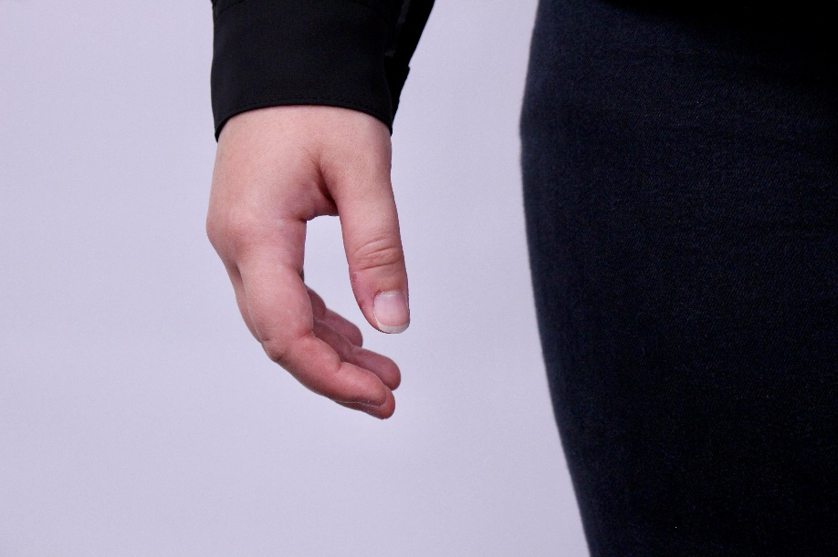

Figure 20. Natural curve of the hand

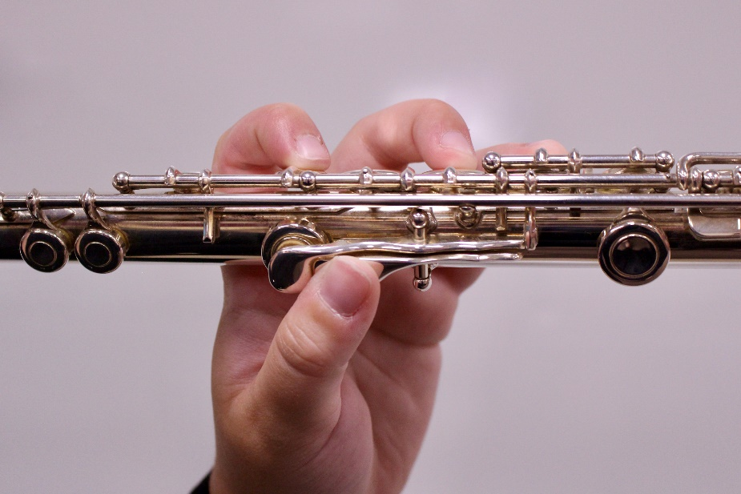

Figure 21. Left hand position

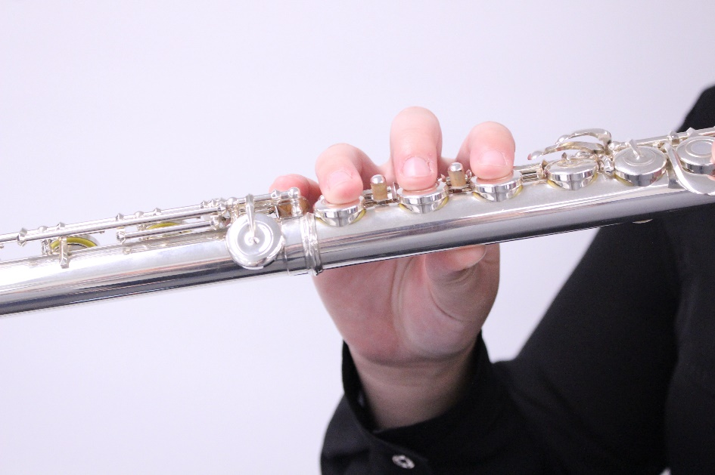

Figure 22. Right hand position

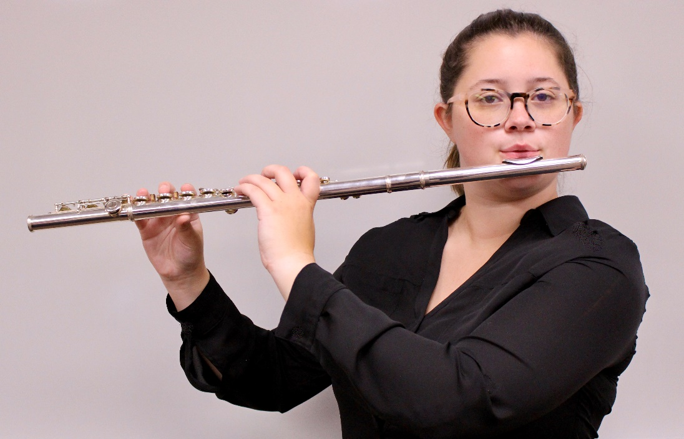

Figure 23. Full hand position