Web article 20

Modern Chemistry Techniques in Medicinal Chemistry John Spencer, University of Greenwich

Introduction. Many catalytic reactions involving transition metals are being employed in medicinal chemistry often due to their atom economy, selectivity, compatibility with microwave chemistry and functional group tolerance. Testament to the impact of so-called Heck/Suzuki/Negishi couplings, Sharpless Epoxidation, asymmetric hydrogenation and metathesis chemistry is the award of several Nobel Prizes for these seminal contributions to modern day industrial, applied and academic chemistry. Typical examples of such chemistry applied mainly to drug discovery will be highlighted hereafter.
Metathesis Chemistry. The “scrambling” of olefins can be effected by a range of catalysts.

Mechanistic studies have shown the involvement of metallocyclobutanes, which can re-open, as below (ligands omitted from metal for clarity).
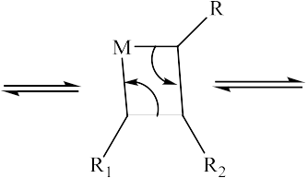

The metal-based complexes that enable such synthetically important reactions include Grubbs and Schrock catalysts.

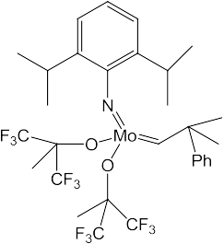

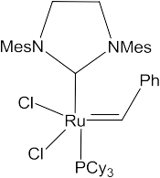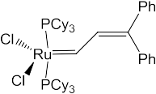One widely employed use of this reaction is ring closing metathesis (RCM), whereby large membered rings (which are difficult to construct classically due to entropy reasons) can be formed, as highlighted below. Here, ethylene and propylene gas can be generated.

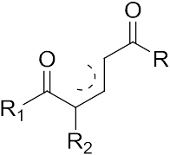Cross metathesis reactions between alkenes have been employed towards the synthesis of pyridines with excellent regioselectivity.

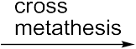

Sharpless Epoxidation. This is used for forming epoxides with excellent enantioselectivities from allylic alcohols using a titanium catalyst, a peroxide oxidant, and a chiral ester. Another related impressive application pertains to the synthesis of the proton pump inhibitor (PPI) Nexium (Patrick, 4th Ed, Figure 25.62). An alternative route involved a multistep reaction sequence leading to a racemic product followed by a resolution step.

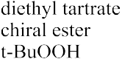

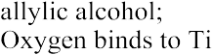

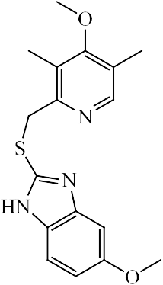

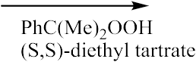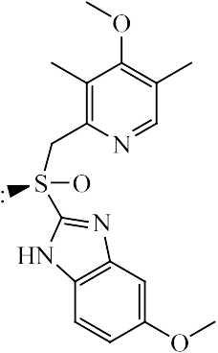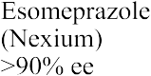Jacobsen introduced an alternative epoxidation route that did not require an alcohol directing group, an example of which is shown, where a precursor to the side chain of Taxol can be formed (Patrick, 4th Ed, Chapter 10, Figure 10.4).
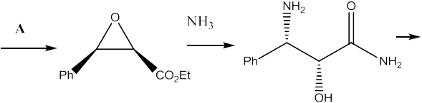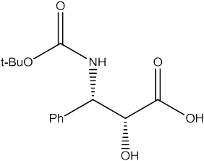

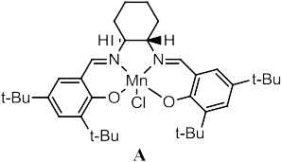

Hydrogenation chemistry. BINAP is planar chiral due to restricted rotation and Josiphos has both an element of chirality due to a stereogenic centre as well as planar chirality. Coordination of an olefin to the chiral metal complex can lead to diastereomers (different energies) in the transition state, leading to enantiomeric discrimination and an enantiomeric excess.

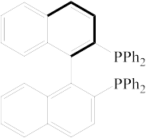

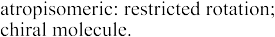

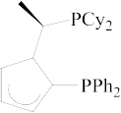Numerous examples of hydrogenation chemistry are applied to drug synthesis e.g. as in the synthesis of an insomnia drug.

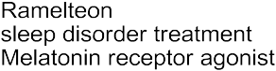

  - ckers require very little introduction given their vast use in cardiac medicine and can be synthesised by the asymmetric hydrogenation of ketones. In the example shown below, nitrogen-metal coordination is also likely to tighten up the transition state, lowering the number of degrees of freedom, and contributing to the good enantiomeric excess.
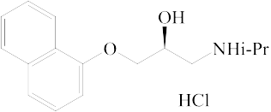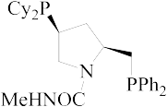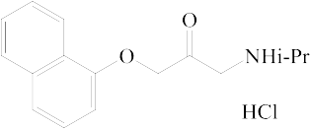

Palladium catalysis. Many palladium catalysts are readily available and stable at room temperature. Two of the most common oxidation states are Pd(0) and Pd(II) and it is the interplay between the two that makes palladium catalysis so appealing for the creation of C-C bonds.

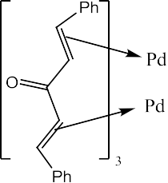

A number of reactions are known, a few of which are shown below:

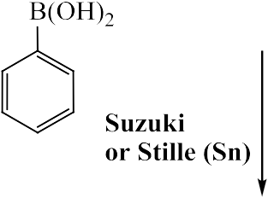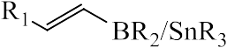Heck reactions involve the insertion of an olefin in the Pd-X bond (X=Cl, Br, I, etc). Suzuki couplings involve boronic acids as coupling partners and the regiochemistry of the reaction is controlled by the position of the boronic acid and halide coupling partners. A Stille reaction uses tin reagents (instead of boronic acids).

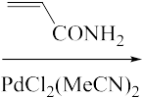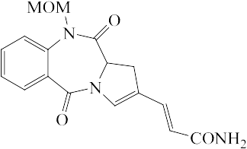

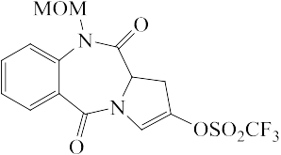

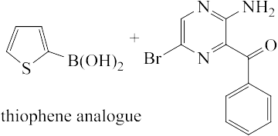

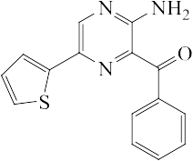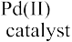A typical Suzuki reaction involves the use of a base (carbonate, hydroxide, fluoride) and the steps shown below are typical of many palladium catalysed processes: oxidative addition (Pd(0) to Pd(II)), transmetallation (transfer of a group from boronic acid to Pd(II)) then reductive elimination (C-C bond formation and regeneration of Pd(0) to restart the catalysis).

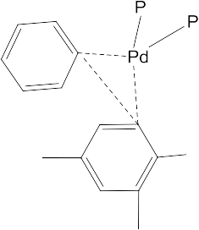

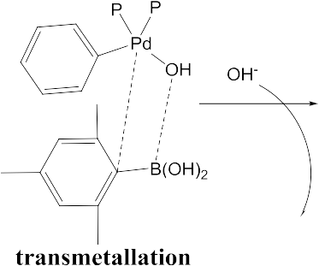The Pd catalysed coupling of a sp-hybridised carbon is known as a Sonogashira

reaction. In the example below, the acetylene couples chemoselectively via the C-Br

bond (this is the longest, weakest bond of the three halogens and the insertion of Pd(0) is favoured). The intermediate was cyclised then the resulting indole was elaborated to afford a selective 5-HT2c (serotonin) receptor agonist, useful as a probe for looking at anxiety models in animals.
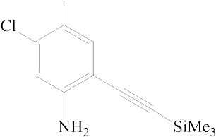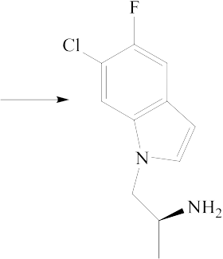

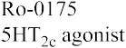

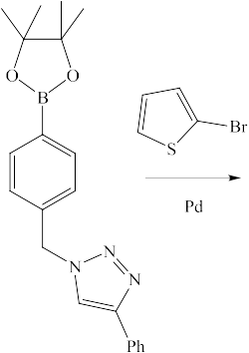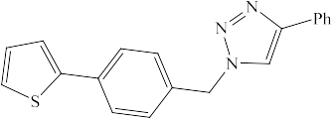Click chemistry. This is becoming increasingly appealing in materials science, medicinal chemistry, and biotechnology and involves the cycloaddition of an alkyne to an azide, catalysed by copper. A recent example highlights a diversity orientated synthesis approach (separate components of an intermediate can be elaborated leading to several reaction branching out possibilities in library generation) where both a range of 1,4-disubstituted triazoles can be formed (click) and the resulting molecules coupled with a range of halides via a Suzuki reaction.

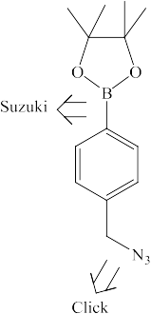

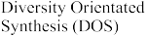

These processes are highly regioselective, as opposed to the metal-free process, which leads to mixtures of regioisomers. An outline of the mechanism is given below:

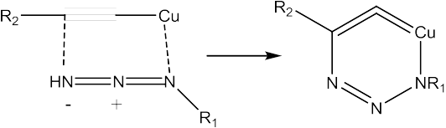

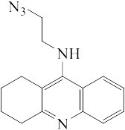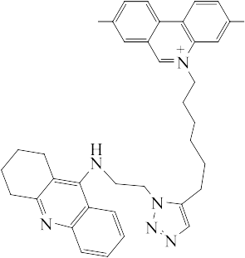A fantastic click reaction drug selection process was carried out inside an enzyme allowing it to select its own inhibitor (again, from the Sharpless group). Hence, using acetylcholine esterase as the catalyst, a series of alkyne and azide reagents capable of generating 98 combinations of click products was set up. This “equilibrium controlled sampling” process led to the 1,5- triazole product shown, which inhibited the enzyme in the nM range, preventing the formation of any other click products; library generation and medchem in an enzyme!

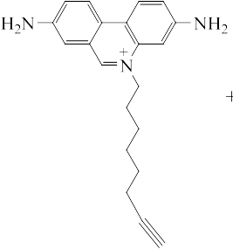

Conclusion. Medicinal chemistry is still reliant on advances in synthetic organic chemistry, which itself is influenced by advances in catalysis and the scope of such reactions. Transition metals offer the possibility of achieving reactions that are

difficult to perform using classical synthetic organic chemistry with high selectivities and applicability on a manufacturing scale.

References.

    - Nobel Prizes: http://nobelprizes.com/nobel/chemistry/

    - a) Asymmetric Catalysis on Industrial Scale: Challenges, Approaches and Solutions, Eds H.U. Blaser, E. Schmidt, 2004 Wiley-VCH Verlag GmbH & Co.
b) Yamano, T. et al. Tetrahedron: Asymmetry, 2006, 17, 184. c) Catalytic Asymmetric Synthesis: Ed. I. Ojima, VCH, USA, 1993.
    - Metathesis chemistry: Donohoe, T. et al Org. Lett. 2011, 13, 1036. D.B.

Yadav et al. Tetrahedron 2011, 67, 2991. Schmidt, B. Pure Appl. Chem. 2006,

78, 469.

    - a) Palladium in Heterocyclic Chemistry: a Guide for the Synthetic Chemist, 2nd Edition, Li, J. J., Gribble, G. W. Tetrahedron Organic Series, Vol 26. b) Palladium reagents and catalysts: New Perspectives for the 21st Century, Tsuji, T. John Wiley and Sons, USA, 2004. c) Duncton et al. Tetrahedron Lett. 2002, 43, 7581.
    - a) Sharpless chemistry: Sharpless, K. B. et al. J. Am. Chem. Soc. 1981, 103,

464. b) von Unge et al. Tetrahedron Asymm. 2000, 11, 3819.

    - Click Chemistry; Kolb, H. C., Sharpless, K. B. Drug Discovery Today, 2003, 8, 1124. Frost et al. Tetrahedron Lett. 2010, 51, 3913.

