Instructor’s Resource Manual
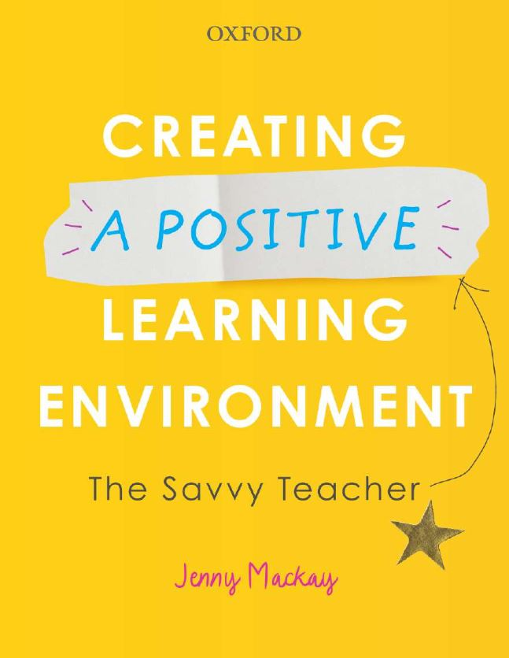 |  | Creating a Positive Learning Environment: The Savvy Teacher  Jenny Mackay
COPYRIGHT NOTICE
This instructor’s resource manual is copyright Oxford University Press 2020. It is intended for use only by lecturers prescribing Creating a Positive Learning Environment, in their courses and should not be distributed or copied for any other purpose or for use with any other text.

TUTORIAL 1

INTRODUCTION: CREATING A POSITIVE LEARNING ENVIRONMENT

Opening routine

- Today’s tip or quotation: In this introductory session you may wish to share the following which on entering the room, write or put up for all to see.
‘Continually reflect on your own experiences and learn from these—as a student yourself, as an observer in the classroom and as a teacher in a school.’

‘Tuning in’
Having observed and greeted the group, begin the session with a very brief tune in exercise; this is almost achieved in passing, but it is of infinite value in preparing the group for learning.
- Ask a question for example at the beginning of the semester: ‘How was your break, holiday? What did you do?, to which they briefly respond.
- Be interested in their responses: listen to them, acknowledge with a nod or smile, etc. then indicate the next person. Do not start a conversation.
- Take a couple of minutes to go around the group and let them respond briefly, e.g. a few words. There is no discussion—just everyone listening. Close the exercise with ‘thank you’.
Note the following:
- Whether you have 10 or 30 in your group, this is a quick, brief but powerful exercise, which enables you to gauge the mood and receptivity of students to learning.
- When students experience feeling heard by you, before having to listen to you, they tend to be far more receptive and willing to listen when it is your turn to speak.
- Plus, they are learning about emotional self-control, as you centre their focus and ease their transition into learning.
- If anyone wishes to pass, as in they have nothing to say at that moment, then that is also fine, and is possibly a quiet message to you to maybe check in with them later.
- Plus, you are building rapport across the group, which is great for when it comes to group exercises, discussions and projects.
- If you are teaching online this is also an appropriate exercise.
Introductory theme
Theme: Managing the hidden curriculum to create a positive learning environment

Tutorial activities
Topic 1: Introducing the ‘hidden curriculum’: Introduce the concept of there being two curricula in teaching—the ‘open curriculum’ and the ‘hidden curriculum’, both of which require planning and skilful management. Our focus throughout this programme will be on the ‘hidden curriculum’. See pages 2-4, 18.
- ‘Hidden Curriculum’—discussion and brainstorm: Consider the concept of the ‘hidden curriculum’—what do you think is meant by the ‘hidden curriculum’ and what aspects of teaching does it refer to? Let students lead the brainstorm and write up relevant details on the board or screen for all to see.
Note the following for incorporation into the discussion.
- the open curriculum focuses on the prescribed learning and indicates ‘what’ is to be learned and how to do this,
- the hidden curriculum focuses on all the learning that occurs throughout a lesson or day and which occurs as teacher and students interact and work together. What happens doesn’t necessarily follow to plan, but it is led by their teacher.
In other words:

- The open curriculum focuses on ‘what’ you are teaching,
- The hidden curriculum focuses on ‘who’ you are teaching.
- Both are equally important and interdependent.
- If you are unprepared with regard to ‘what’ you are teaching, the ‘who’ is going to give you numerous problems with the likelihood of many acting out behaviours.
- If you are unprepared to manage ‘who’ you are teaching, ‘what’ you are teaching is unlikely to happen as you would wish.

Our focus in these tutorial sessions is on managing ‘who’ we are teaching

- ‘My first day’—reading and small group discussion giving feedback to whole group.
  - What happened to the two teachers on their first day pp. 1–2 in ‘Creating a Positive Learning Environment’? (Have copies of these two pages available in case needed.)
  - Discuss the experiences of the two graduate teachers with the following questions to lead discussion:

    - What were their experiences?
    - What would have helped them manage better?’
    - What would you do to prepare for ‘who’ you are teaching on your first day? Discuss and make notes and put these into your Teaching File.
Tutor’s notes

Question requiring written answers

- What are the reasons for creating a positive learning environment? Consider the benefits to your students and to you as a teacher? Then outline what you would focus on and practise as a teacher to achieve that positive learning environment in your classes or classroom.

Tutor’s notes

To do

Task
In reference to ‘Today’s tip’, start two pages in your Behaviour File or Notebook to record your own observations of student behaviour, listing the positive and negative behaviours that you observe and experience during your practicum rounds in schools or whilst teaching. Start your list now, even if you’re not on practicum at the moment, writing down a few behaviours you have observed and next to each behaviour reflect on and write down possible reasons for these behaviours. Bring these observations to your next tutorial and all following tutorials to consider the management of these behaviours as you keep adding to this list.

Readings
In preparation for the next tutorial from your textbook, read Chapter 1 ‘Being Prepared: Proactive Management’.
- Read ‘Becoming a Savvy Teacher’, ‘Organising the learning space’ and ‘Planning for behaviour (pp. 1–19) and be prepared to discuss these in your tutorial session.

- Read the following Teacher’s Stories:
  - 1—‘My first day and my first class—Yay, I’m good to go!’
  - 2—‘How can I teach my students to behave?’
  - 9—‘How can I ensure the correct use of technology in class?’
  - 22—‘How can my students learn to be better organised?’

Closing routine

‘Reflection’

Question: What has been a positive for you this session and what do you want to learn more about with regard to student behaviour?

Closure: Enjoy your week! I look forward to hearing what behaviours you have observed over the coming week.

Tutor’s notes and reflections

