Instructor’s Resource Manual
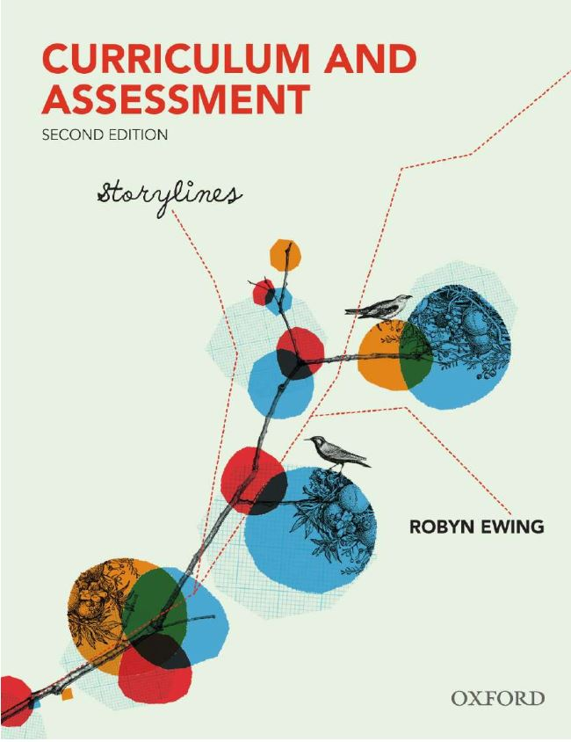 |  | Curriculum & Assessment: Storylines  Second Edition  Robyn Ewing
COPYRIGHT NOTICE
This instructor’s resource manual is copyright Oxford University Press 2013. It is intended for use only by lecturers prescribing Curriculum & Assessment, second edition, in their courses and should not be distributed or copied for any other purpose or for use with any other text.

CHAPTER 1: TOWARDS SOME DEFINITIONS OF CURRICULUM AND ASSESSMENT

Icebreakers

- What features make a story?
- How does a narrative differ from a report? From a recount? From a procedure?

Tutorial activities

- Do you think the author’s rationale for the use of curriculum ‘storylines’ makes sense?
- Draw your own curriculum or assessment concept/mindmap.
- Construct a poster depicting the kind of curriculum and/or assessment race you have run and share the major milestones with your peers.
- Describe one particular kind of assessment that you have experienced that does not fit the guidelines for authentic assessment? Could it have been structured more authentically? How?

Sample essay topics

- Define the concept of ‘curriculum’ in your own words. What elements do you consider must be part of any definition? Why?
- Which curriculum and assessment themes/issues have had the most prominence currently? Choose one and trace the storyline over the last decade or two.
- Should testing be the main assessment strategy used in schools? Why? Why not?

Short-answer questions

- People frequently interchange syllabus and curriculum. How can we delineate ‘syllabus’ from ‘curriculum’?
- Why is curriculum sometimes described as a decision-making process?
- Why is testing such an over-used assessment strategy?

