Chapter 2
Answers to Exercises
2.1 (a) Cl⁻ is the most charge dense halide compared with Br⁻ and I⁻ and hence is solvated by hydrogen bonding in the protic solvent mixture to the largest extent. As a consequence the energy expended to desolvate the respective halide guest for receptor binding is greatest for Cl⁻compared to the other two halides, and therefore forms the weakest complex.
(b) For L₁, I⁻ is less strongly solvated than Br⁻ and hence more easily desolvated for interaction with the halogen bonding bromoimidazolium units. For L₂, although the iodoimidazolium groups are better halogen bond donors than the bromoimidazoliums of L₁, the donor iodine atoms are much larger. Thus, there is insufficient space between both donor iodine atoms to bind iodide convergently by both iodoimidazolium groups. In contrast, the smaller bromoimidazolium units of L₁ allow sufficient space between them to bind I⁻ with two convergent halogen bonds.
(c) Chlorine is a very poor halogen bond donor group as it is very poorly polarisable. Hence, the receptor’s binding affinity for I⁻ should be smaller than that seen for L₃ (i.e. < 80 M⁻¹). In this case, any affinity observed will be predominantly due to host-guest Coulombic attraction.
2.2 (a) The anions and Na⁺ are bound as receptor-separated ion pairs. Due to the greater charge density of Cl⁻, there is a larger energetic penalty cost of separating it from Na⁺ compared with Br⁻, resulting in a smaller cooperativity factor.
(b) NO₃⁻ is less charge dense than NO₂⁻ and hence a weaker hydrogen bond acceptor. The urea anion binding motifs of L₄ are therefore expected to interact less strongly with NO₃⁻ forming a relatively weaker complex compared to NO₂⁻ .
(c) In the polar aprotic solvent acetonitrile, benzoate is the most basic anion amongst those listed. It is hence the strongest hydrogen bond acceptor capable of interacting with the urea motifs. Furthermore, the urea motifs are preorganised geometrically to bind with the carboxylate group of benzoate, resulting in very high binding constants. Since the binding of L₄ to benzoate is already optimal, both urea and crown ether units essentially behave as independent binding sites for anions and cations respectively, resulting in a cooperativity factor of close to 1.

2.3 (a) Like halogen bonding, the strength of chalcogen bonding increases as the polarizability of the chalcogen donor atom increases. As larger chalcogen atoms (atomic radii of S < Se < Te) are more polarisable, they will in turn result in stronger interactions. Hence the Cl⁻ binding affinity for the chalcogen bonding hosts will decrease in the order Te > Se > S in acetone.
(b) ¹H NMR spectroscopy will be useful for indicating the predominant location of anion binding, by observing the extent of perturbations of the host molecule’s proton resonances. If the largest shifts are observed for proton a located closest to the pyridinium N atom, it is likely that anion binding is dominated by electrostatic interactions with the cationic pyridinium motif. On the other hand, if the most significant shifts are seen for proton b and the methyl groups covalently bonded to the chalcogen donor atoms, anion binding is occurring predominantly in the cleft flanked by the chalcogen atoms, and most likely driven by chalcogen bonding interactions.
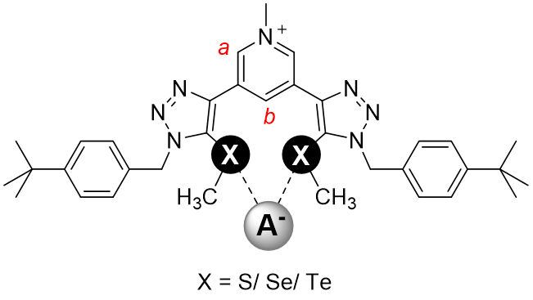
(c) Using a van’t Hoff plot, ΔG = -16.1 kJ/mol, ΔH = -12.8 kJ/mol and TΔS = +3.2 kJ/mol at 298 K, and hence binding is both enthalpically- and entropically-favoured. The exothermicity likely arises from the Te-Cl⁻ chalcogen bond forming interactions, whilst the increase in entropy may be attributed to desolvation (release of acetonitrile solvent molecules) of the host and guest upon binding.

