Chapter 3
Answers
3.1 (a) The chiral receptor contains a disubstituted chiral pyrrolidine ortho-substituted relative to the boronic acid group. The cyclic pyrrolidine structure provides the necessary rigidity to limit the conformational freedom of the chiral unit. This sets up a chiral binding site which binds to the enantiomers with different affinities, as the steric environment of the binding site inherently prefers binding of one enantiomer over the other (i.e. one guest enantiomer encounters a greater steric repulsion than the other when coordinated to the boronic acid). Hence, the enantiomers are bound with different binding energies, giving rise to enantioselectivity.
(b) The bulkier CH₂OCH₃ group is expected to sterically hinder the access of the D-enantiomer for binding to the boronic acid moiety to a greater extent than the sterically less bulky CH₃ unit. This results in a greater energetic difference during the binding of the enantiomers and hence gives larger selectivity.
(c) Phenylpyruvic acid can undergo keto-enol tautomerization, which is stabilized by conjugation to the adjacent phenyl ring. This forms a host structure akin to the α-hydroxycarboxylates which are able to bind strongly to the boronic acid receptor. However, benzoyl formic acid is unable to tautomerize, and since the ketone oxygen atom is too poor a nucleophile, it is unable to coordinate to the boronic acid group. The inability to form a strongly-coordinating 5-membered boronic ester unit energetically disfavours the binding of benzoyl formic acid.
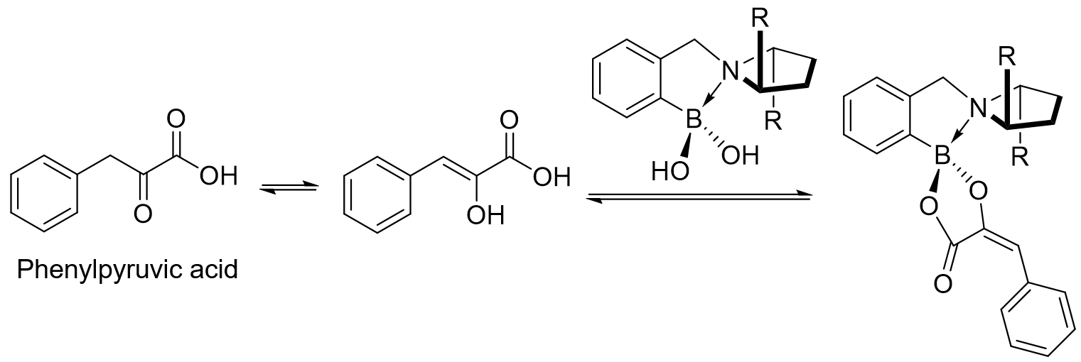

3.2 (a)
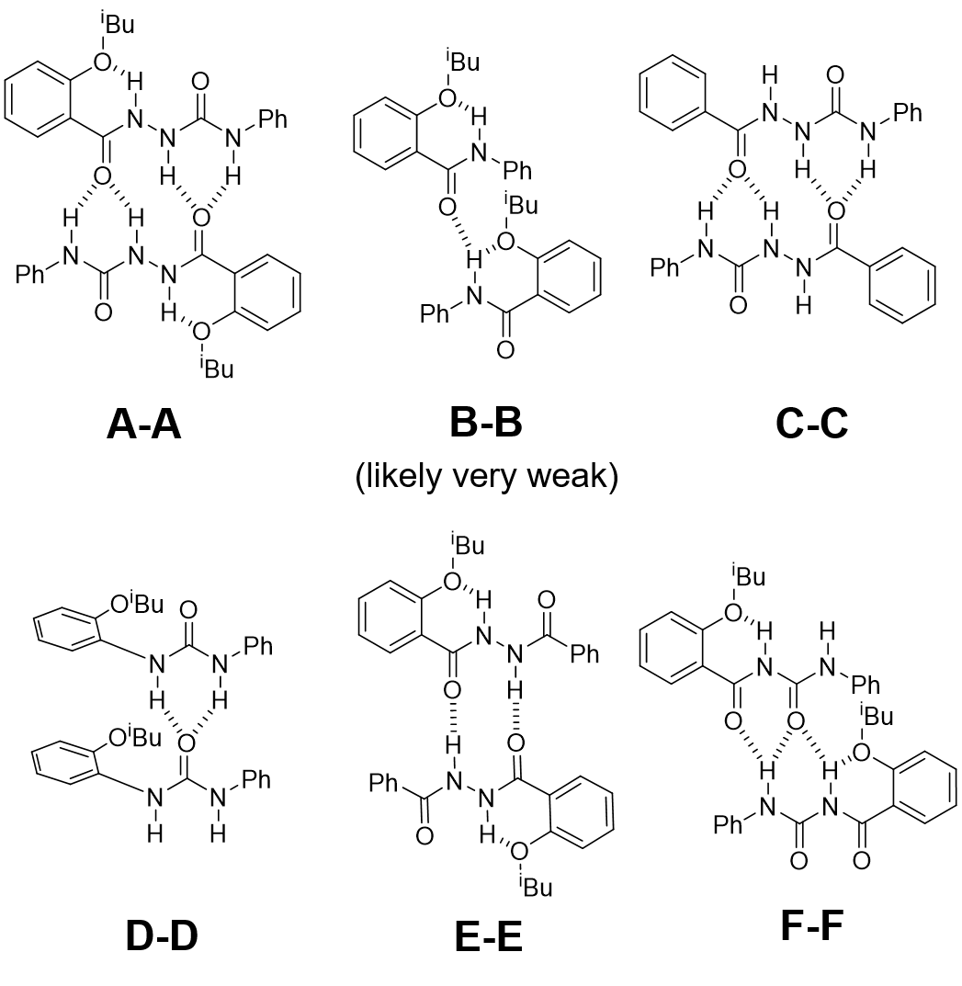
- Generally, the greater the number of hydrogen bonds possible between the two molecules, the stronger the dimerization. Comparing compounds A and C, the former possesses an ortho-substituted O^{i}Bu group which is able to form a stable 6-membered hydrogen bond with the adjacent amidourea N-H, which further preorganises the structure and reduces free bond rotations. For compound C, this is not possible due to the lack of the O^{i}Bu unit. The greater preorganization of A likely leads to stronger dimerization than C. Between compounds D and E, the latter is likely to bind more weakly to each other due to diagonal donor-donor/ acceptor-acceptor repulsions, which is not present in the urea motif of D. Hence, the compounds arranged in increasing strength of dimerization are: B < E < D < F < C < A
- H_{a} – 10.4 ppm; H_{b} – 8.3 ppm; H_{c} – 7.4 ppm. H_{a} is shifted furthest downfield due to its position within the intramolecular 6-membered hydrogen bonding ring, whilst H_{b} is more deshielded than H_{c} due to its presence adjacent to the additional electron-withdrawing H_{a}.
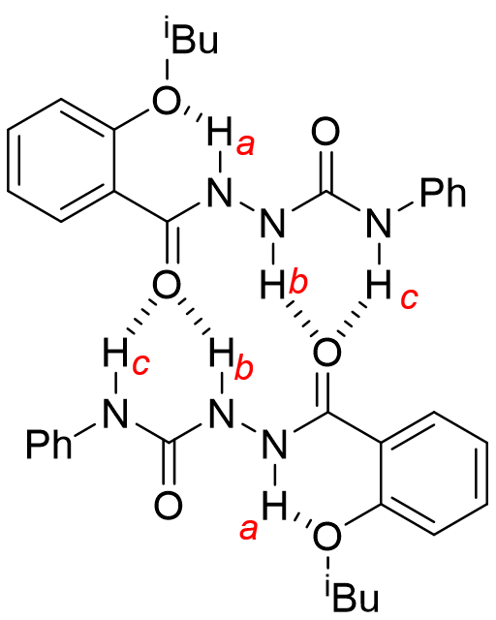
3.3. Both hydrophobic ends of the ester substrate can form inclusion complexes with one β-CD molecule, which brings the reactive ester moiety on the substrate into close proximity with the Lewis acidic Cu(II) metal centre on the bridging group. The ester carbonyl group then ligates the Cu(II) by displacing a weakly-coordinating water molecule. The ester unit then undergoes nucleophilic attack by the adjacent hydroxyl ligand on Cu(II) to break the ester linkage. Then the resulting carboxylate and phenol products dissociate from the cyclodextrin cavities making them available for binding the next ester substrate molecule.
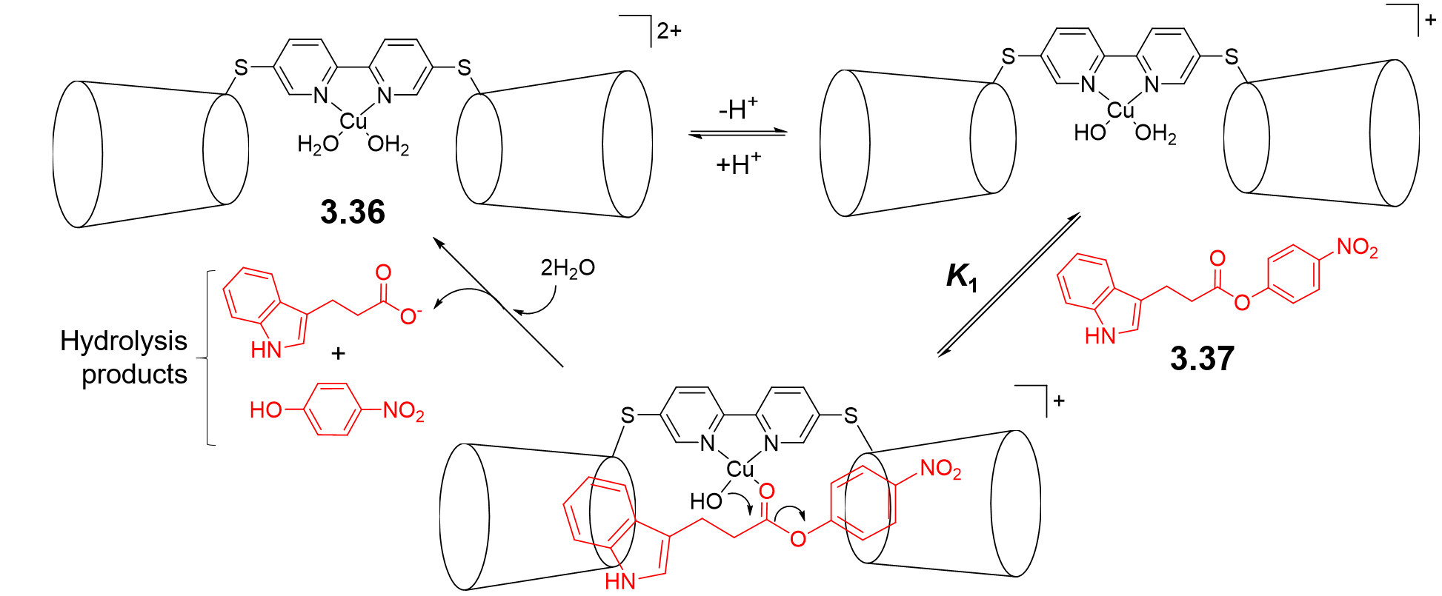
- The catalyst is designed to possess two accessible cyclodextrin cavities bridged by a short rigid linker, which preorganises its structure for inclusion of the ester substrate. As seen from the answer to (a), the ester substrate benefits from a bidentate coordination to both cyclodextrin units, while each product can only form inclusion complexes to each individual cyclodextrin. In addition, once bound, the substrate benefits from an additional coordination to the Cu(II) metal centre by the carbonyl oxygen atom, whilst this is not possible for the hydrolysed products. Together, these factors ensure that the substrate is expected to bind to the catalyst a lot more strongly than the products, allowing the former to displace the latter once hydrolysis has occurred and prevent any significant catalyst product inhibition from occurring.
- The activity of the catalyst is dependent on the stability of the initial association between the hydrophobic ester substrate with the cyclodextrin cavities. As the equilibrium of K₁ = k_{f}/ k_{b}, with K₁ being the association (binding) constant between the substrate and catalyst, and k_{f} and k_{b} being the rate constants of the forward (complexation) and backward (decomplexation) reactions respectively, a stronger substrate binding translates to a greater rate of the forward reaction relative to decomplexation. The catalyst-substrate interaction is strongest in water, as the hydrophobic effect necessary for complexation is maximized. In contrast, this interaction in ethanol is less strong due to the lower polarity of the solvent. Hence, as the substrate-catalyst association is most likely the rate-determining step of the hydrolysis, the catalysis is likely to be less efficient in ethanol.

