A Map of Language and Visual Features
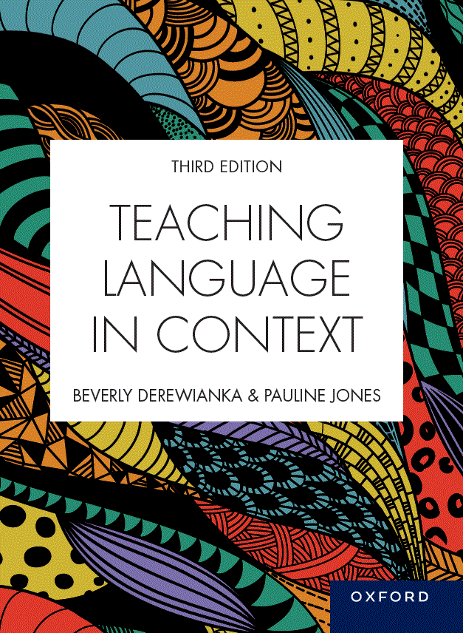 | Teaching Language in Context  Third Edition  Beverly Derewianka and Pauline Jones  Material prepared by Pauline Jones, based on content from Teaching Language in Context, third edition
COPYRIGHT NOTICE
This instructor’s resource manual is copyright Oxford University Press 2023. It is intended for use only by lecturers prescribing Teaching Language in Context, third edition, in their courses and should not be distributed or copied for any other purpose or for use with any other text.

CONTENTS
GENRE 3
REGISTER 4
Field (subject matter/topic/‘what’s going on?’) 4
Tenor (roles and relationships/‘who’s involved?’) 5
Mode (channel of communication / ‘organising coherent texts’) 6
IMAGES 7
Representation (representing an event or idea through images) 7
Interaction (creating relationships between image and viewer and between participants in an image) 7
Composition (organising the elements of an image and organising relations between images and surrounding language) 8

GENRE
How genres enable us to achieve our social purposes
Chapter 3  Procedures | Chapter 4  Stories | Chapter 5  Recounts | Chapter 6  Responses | Chapter 7  Information reports | Chapter 8  Explanations | Chapter 9  Arguments | Chapter 10  Inquiry | Chapter 11  Poetry
Purpose
To tell someone how to do something | To explore the human condition through entertainment | To tell what happened | To analyse, interpret and evaluate a text | To observe and describe a general class of things | To explain how or why, including reasons and consequences | To argue a case or to discuss an issue | To investigate, create and evaluate | To fulfill a range of purposes (e.g. to narrate, to recount, to reflect, to persuade), usually characterised by distinctive uses of spoken and written language
Examples
Simple procedures | Narrative  Anecdote  Fable  Creative response | Personal recount  Autobiography  Empathetic autobiography  Memoir  Biography  Historical recount  Historical account  Literary recount | Personal response  Review  Analysis  Interpretation  Critical response | Descriptive  Classifying  Compositional  Contrastive  Historical | Sequential  Cyclical  Causal  System  Factorial  Consequential | Hortatory exposition  Analytical exposition  Discussion | Macrogenres  Fair tests  Lab reports  Design portfolios  Investigation reports  Problem-solution reports | Rhyme  Description  Recount  Challenge  Call to action  Multimodal Poetry

