Glossary
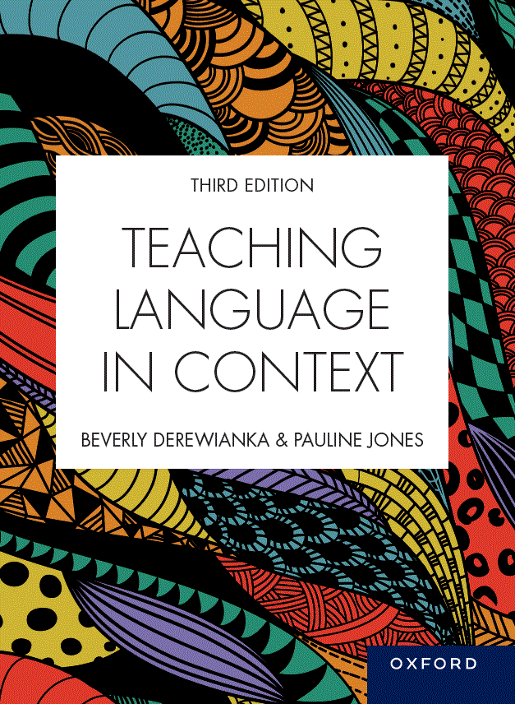 | Teaching Language in Context  Third Edition  Beverly Derewianka and Pauline Jones  Material based on content from Teaching Language in Context, third edition
COPYRIGHT NOTICE
This instructor’s resource manual is copyright Oxford University Press 2023. It is intended for use only by lecturers prescribing Teaching Language in Context, third edition, in their courses and should not be distributed or copied for any other purpose or for use with any other text.

action verb | A verb or verb group expressing a material Process of doing or happening.
adverb or adverb group | A grammatical form that has a number of functions. One of the main functions is to modify a verb (he ran fast, it flowed very smoothly).
Appraisal system | The ways in which we use language to express feelings and opinions, to engage with other voices and perspectives, and to adjust the strength of our utterances.
Attitude | Using language to share feelings, express evaluations, and judge human behaviour.
attribution | The introduction of other perspectives into a text by explicitly referring to what others say or think about the topic.
auxiliary verbs | Parts of the verb group that modify the main verb in a range of ways such as tense (e.g. she was eating) and modality (she might leave).
brainstorming | Encourages students to make links between their previous learning and new information, for example, by listing features of a character or what they know about a topic.

