A Map of Language and Visual Features
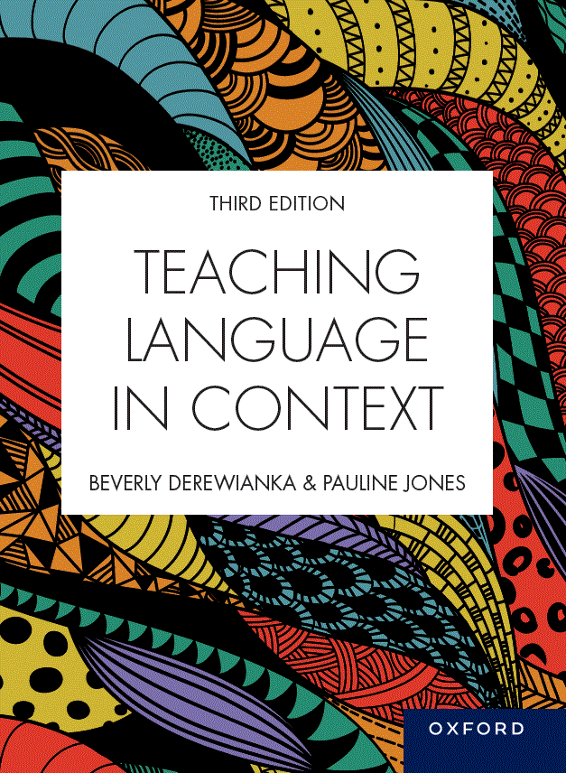 | Teaching Language in Context  Third Edition  Beverly Derewianka and Pauline Jones  Material prepared by Pauline Jones, based on content from Teaching Language in Context, third edition
COPYRIGHT NOTICE
This instructor’s resource manual is copyright Oxford University Press 2023. It is intended for use only by lecturers prescribing Teaching Language in Context, third edition, in their courses and should not be distributed or copied for any other purpose or for use with any other text.

CONTENTS
GENRE 3
REGISTER 4
Field (subject matter/topic/‘what’s going on?’) 4
Tenor (roles and relationships/‘who’s involved?’) 5
Mode (channel of communication / ‘organising coherent texts’) 6
IMAGES 7
Representation (representing an event or idea through images) 7
Interaction (creating relationships between image and viewer and between participants in an image) 7
Composition (organising the elements of an image and organising relations between images and surrounding language) 8

GENRE
How genres enable us to achieve our social purposes
Chapter 3  Procedures | Chapter 4  Stories | Chapter 5  Recounts | Chapter 6  Responses | Chapter 7  Information reports | Chapter 8  Explanations | Chapter 9  Arguments | Chapter 10  Inquiry | Chapter 11  Poetry
Purpose
To tell someone how to do something | To explore the human condition through entertainment | To tell what happened | To analyse, interpret and evaluate a text | To observe and describe a general class of things | To explain how or why, including reasons and consequences | To argue a case or to discuss an issue | To investigate, create and evaluate | To fulfill a range of purposes (e.g. to narrate, to recount, to reflect, to persuade), usually characterised by distinctive uses of spoken and written language
Examples
Simple procedures | Narrative  Anecdote  Fable  Creative response | Personal recount  Autobiography  Empathetic autobiography  Memoir  Biography  Historical recount  Historical account  Literary recount | Personal response  Review  Analysis  Interpretation  Critical response | Descriptive  Classifying  Compositional  Contrastive  Historical | Sequential  Cyclical  Causal  System  Factorial  Consequential | Hortatory exposition  Analytical exposition  Discussion | Macrogenres  Fair tests  Lab reports  Design portfolios  Investigation reports  Problem-solution reports | Rhyme  Description  Recount  Challenge  Call to action  Multimodal Poetry

REGISTER
• how a combination of field, tenor, and mode create a particular register
• the relationship between the register and our language choices in any particular situation

Field (subject matter/topic/‘what’s going on?’)
Function | Using language to represent an event or idea (Ideational function)
Form | A clause
Function | Process  to represent doings, happenings and states of being/having  • action  • sensing (thinking, feeling, perceiving)  • saying  • relating (being and having) | Chapters  2, 4, 5, 7, 10 | Participant  to represent the participants in a process  • human and non-human  • concrete and abstract  • specific and generalised | Chapters  2, 4, 5, 7, 10 | Circumstance  to represent the details surrounding a process  • where?  • when?  • how?  • why?  • etc. | Chapters  2, 4, 5, 7, 10
These functions are typically expressed by the following grammatical choices …
Resources | • verb groups (action verbs, sensing verbs, saying verbs, relating verbs)  • nominalisations  • tense/aspect | Chapters  2, 4, 5, 7, 10 | noun groups  pronouns  adjectives/ adjective groups | Chapters  4, 5, 7, 10 | adverbials  • adverbs/ adverb groups  • prepositional phrases  • noun group (uncommon) | Chapters  4, 5, 8

Function | Using language to make connections between events or ideas
Form | Sentences (combinations of clauses)
Function | to represent a single event/idea | Chapters  2, 7, 8, 10 | to connect two or more events/ideas of equal status | Chapters  2, 7, 8 | to connect two or more events/ideas of unequal status | Chapters  2, 8, 9
These functions are typically expressed by the following grammatical choices …
Form | simple sentence (a single clause) | Chapters  3, 8, 10, 11 | compound sentence (two or more independent clauses typically joined by a coordinating conjunction) | Chapters  3, 5, 7, 8 | complex sentence (an independent clause typically joined to one or more dependent clauses using a subordinating conjunction) | Chapters  3, 8, 9
 | Patterns of choices at the level of the text

Tenor (roles and relationships/‘who’s involved?’)
Function | Using language to interact with others (Interpersonal function)
Form | Various interpersonal resources
Function | to enable the exchange of information and goods/services, to negotiate interactions | Chapter  2 | Attitude  to express attitudes  • feelings (Affect)  • evaluation of qualities (Appreciation)  • judgment of human behavior (Judgment) | Chapter  2, 9, 10 | Engagement  to promote engagement  • with other points of view/perspectives  • with other possibilities  • with the audience | Chapter  2, 9, 10 | Graduation  • to strengthen or weaken commitment to a proposition  • to sharpen or blur the focus | Chapter  2. 9, 10
These functions are typically expressed by the following linguistic choices …
Resources | • the Mood system  • speech functions (questions, statements, commands, offers)  • patterns of speech functions | Chapters  2, 9, 10 | • vocabulary items and expressions that express attitudes (attitudinal noun groups, verb groups, adjective groups, adverb groups)  • patterns of attitudinal resources across a text | Chapters  2, 6, 11 | • modality  • rhetorical devices  (e.g. rhetorical questions, ‘rule of three’)  • patterns of engagement across a text | Chapters  6, 9, 10 | • boosting or lowering the strength of nouns, verbs, adjectives or adverbs  • using intensifying adverbs (very, extremely) | Chapters  6, 9, 10
 | Appraisal

Mode (channel of communication / ‘organising coherent texts’)
Function | Using language to organise and structure texts
Form | Cohesive devices
Function | to create cohesion | Chapters  2, 5, 9 | to guide the reader through the text | Chapters  2, 8, 9
These functions are typically expressed by the following linguistic choices …
Resources | • reference items  (e.g. pronouns)  - • substitution  • ellipsis  • text connectives  • vocabulary patterns across the text (lexical cohesion) | Chapters  2, 4, 5, 9, 10 | • Theme and Rheme  • Thematic patterns  • Text openers  • Paragraph openers  • Sentence openers | Chapters  2, 9, 10

IMAGES
- how images can be interpreted from a functional perspective
- how images can function to: represent ‘what’s going on’ (representation), foster interpersonal connections (interaction) and organise text (composition)

Representation (representing an event or idea through images)
Chapter 4  Stories | Chapter 7  Information reports | Chapter 8  Explanations | Chapter 9  Arguments
Using images to build the field of narratives (e.g. characters and setting).  - representation in Wind in the Willows (representing participants, processes (including vectors), settings, shapes, symbols and colour. | Using images to build the field of descriptive texts  - in particular descriptions  - in information reports (e.g. maps, diagrams, graphs)  - representing processes, participants (e.g. concrete vs abstract; everyday vs technical; animate vs inanimate) and circumstances in images  - building knowledge through both images and language working together | Using images to build the field of explanations  - abstract representations (e.g. flowcharts, systems) vs realistic images (photos, drawings)  - arrows and vectors to indicate processes and direction  - symbols, icons, numerals  - infographics (e.g. combination of images, labels, captions, headings, sub-headings) | Persuading through choice of images representing certain processes, the participants in those processes, and any surrounding circumstances.

Interaction (creating relationships between image and viewer and between participants in an image)
Chapter 4  Stories | Chapter 6  Responses | Chapter 9  Arguments
Interpersonal meanings in images:  - relationship between image and viewer in narratives  - relationship between characters in the image  - the role of colour  - the degree of realism | Expressing attitudes:  - Affect (depicting various emotions; creating a relationship between image and viewer; use of colour, shape and line; framing the image)  - Graduation (adjusting the strength of emotion in images)  - Judgement (judging the behaviour of characters through image)  - Graduation (adjusting the strength of judgement of characters through image) | How images can be used to persuade the viewer through:  - expressing emotion (Affect)  - evaluating people’s behaviour (Judgement)  - assessing qualities (Appreciation)  - adjusting the strength of attitudes (Graduation)  - engaging the viewer (gaze, social distance, alignment, tone, angle, credibility, modality)

Composition (organising the elements of an image and organising relations between images and surrounding language)
Chapter 4  Stories | Chapter 5  Recounts | Chapter 7  Information reports | Chapter 8  Explanations | Chapter 9  Arguments | Chapter 10  Inquiry | Chapter 11  Poetry
Relationships between images and language (‘visual-verbal relationships’) in narratives | Using images to organise a series of events in recounts | Various graphic organisers to illustrate the organisation of different types of information reports | Various graphic organisers to illustrate the organisation of different types of explanations | How the composition of an image can affect its persuasive power | Various graphic organisers to illustrate the organisation of different types of inquiry genres  - How information is distributed and organised multimodally in inquiry reports (given-new, ideal-real, centre-margin, framing, salience) | How poetry employs various modes and media (spoken, written and visual; moving images; songs; shape poems; digital poetry)

