Doing a Research Project SAMPLE
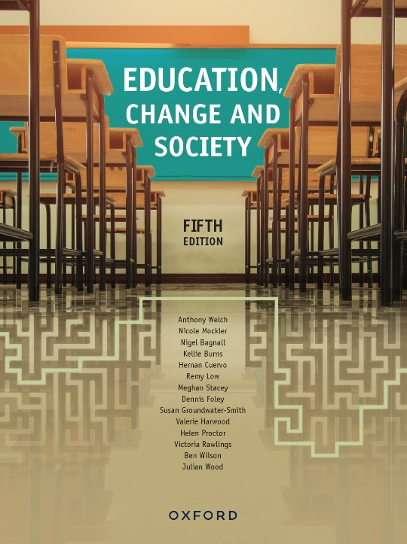 | Bonus chapter by Craig Campbell  Education, Change and Society  Fifth Edition  Edited by Anthony Welch
COPYRIGHT NOTICE
This instructor’s resource manual is copyright Oxford University Press 2023. It is intended for use only by lecturers prescribing Education, Change and Society, fifth edition, in their courses and should not be distributed or copied for any other purpose or for use with any other text.

Contents
Chapter overview 3
Why do a research project? 3
Developing a research question, choosing a partner and what the project might eventually look like 3
Searching the literature and writing a literature review 7
Assessing students’ literature reviews: feedback from an examiner 9
Big mistakes 9
Technical mistakes 10
Research methods and research results 10
Interviews 11
Questionnaires 12
Media study 14
Documentary study 15
Ethical practice in research 17
Interviews 17
Survey questionnaires 18
Writing up the project and presenting your results 18
Good luck. 19
Focus questions 19
Further reading 19

Chapter overview

After reading this chapter, you should be able to research and write by yourself, or with a partner investigator, an assignment which introduces several approaches that assist in social science-based research in education.
- How is a research question framed?
- Why is a literature review important to any research project?
- What research methods, appropriate to the research question, might be used to develop answers to the research question?
- What issues of an ethical nature need to be addressed, especially if your research involves people?
- What considerations are required as you draw conclusions and generalise from your research evidence?

Why do a research project?
There are many different sorts of assignments that a person could write as a result of studying the material in this book. This chapter supports a specific kind of research project that might be planned and conducted by students. Its purpose is to encourage a deeper personal and possibly local understanding of aspects of the topics discussed in this book.
The idea is to establish a way of thinking about the social contexts and impacts of educational activity. Included in the process are: definition of a research question; proposal construction and presentation; literature search and writing a literature review; discussion of possible research methods and the kinds of knowledge or results different methods can produce; and, finally, issues relating to the writing of a report and its presentation to a group. The ideas discussed in this section are modest; they simply support a first step in research. They introduce one of many ways of organising such an activity.

Developing a research question, choosing a partner and what the project might eventually look like
This suggested project has a very general organising statement:
Report on your research into an aspect of education and its social consequences and/or character.
The final report might look something like this:
- Title page, including:
- research question
- names of investigation team.

- Report including the following sections:
- brief introduction of research question and its significance
- short literature review
- short description of research method
- ethical issues raised in the course of the project
- results and discussion of results
- conclusion
- list of references.
This project has several sections, and therefore several phases associated with its development and writing. It is best to work through the process with a partner from a very early stage. Such partnerships support good learning as possible research questions are negotiated, and as the meaning and significance of the research results are discussed and written up.
In selecting a research question, the chapters of this book are a significant resource. It may well be that you enquire further into issues raised in a particular chapter. From a general topic area, your topic area needs to be distilled into a fairly specific question.
For example, from being interested in the theme of youth transitions from school to work, a question might eventually emerge, such as:
How do a group of young people still at school, but also employed on a casual basis at a Coles supermarket, understand the relationships between school and work?
Into such a question, you could build some possible answers (hypotheses) to be explored as a result of the research process; for example, in the supermarket scenario above, ‘That students do not develop many new understandings about the links between school and work but are simply glad of the extra cash’ or ‘That students gain significant knowledge about work and casual work in particular, and that they are likely to adjust their approach to education and work as a result’.
In the organising statement for this project, there is a key word: ‘social’. It is important to realise that this project should be based on the concerns of this book or similar. Sociology and policy studies are the main fields of educational study that sustain this book, and should help define your project topic. There is little in this book to support, for example, pedagogical or psychological research projects, such as researching the best techniques for teaching or classroom management, or trying to understand the cognitive processes involved in individual learning. Such issues are for another day and another course. At the same time, there is material in this book that would assist thinking in such research. The other thing that should probably be said is that some topics may cause problems. There are at least four issues that have caused problems for students who have conducted this kind of project over the years:
- Choosing a research question that is simply too large—you can certainly explore a big idea, but you will probably end up working on a tiny corner of it. So, formulate a question of manageable size. Most students have very limited time to do these kinds of assignments. Choose a topic that can be explored with two or three interviews, a very limited survey, or a limited documentary or media study. This also relates to being circumspect in how much you can actually show or conclude in a very small study. (This is discussed further below.) Choose an interesting research question, but one that you can explore with limited time and resources.

