Instructor’s Resource Manual SAMPLE
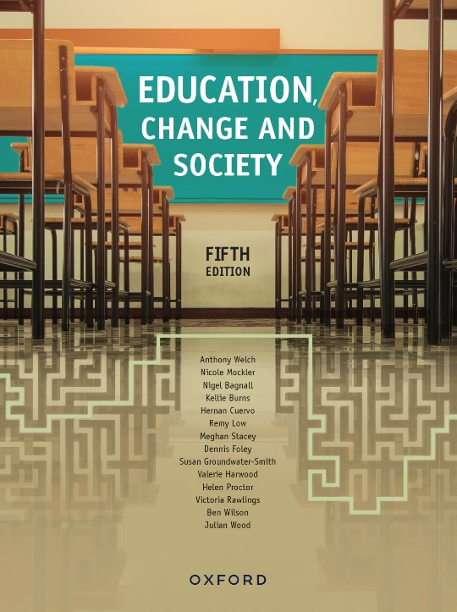 | Education, Change and Society  Fifth Edition  Edited by Anthony Welch
COPYRIGHT NOTICE
This instructor’s resource manual is copyright Oxford University Press 2023. It is intended for use only by lecturers prescribing Education, Change and Society, fifth edition, in their courses and should not be distributed or copied for any other purpose or for use with any other text.

Contents
Focus Questions 3
Pause and Reflects 7
Internet sources 17

Focus Questions

Chapter 1, page 22
- What and who are educational institutions ‘made for’?
- What and who are educational institutions ‘not made for’?
- How can we make educational institutions places where all young people can flourish?

Pause and Reflects

Chapter 2

Page 30
1 Consider each of the historical themes that constitute the curriculum of the body. Can you use the same thematic headings to list the practices or modes of regulation that defined your schooling?
2 How, if at all, did you or others you know, contest and disrupt these practices and norms?

Page 35
- Apart from sex and sexualities education, what topics are considered too risky or sensitive to talk to children or young people openly about? Do you agree or disagree with these framings? Are there any protective rationales for finding ways of teaching these topics in age- and stage- appropriate ways rather than avoiding them?
- Some adults teach children slang names for their genitalia rather than using anatomical language. How might this practice—often framed as childish or cute—make children vulnerable or unsafe?
- Do you think knowledge can be a protective factor? If so, how?
- Can you think of examples in storybooks or popular culture that position childhood as universally a period of naïvety, simplicity and innocence? How is innocence gendered in commercial culture for children?

Page 37
- Do you think Arnett’s ‘emerging adulthood’ represents another (albeit a new one) attempt to map a teleological development from childhood to adulthood or a more nuanced exploration of development across ages and stages?
- How and why is it useful to understand and analyse emergent developmental stages against historical and sociological changes, as Tanner and Arnett do?

Page 39
- How have you seen ‘well-being’ promoted in schools and other places?
- How can a concept such as well-being be usefully applied in schools and other places?
- What are some other terms and/or concepts that could be ‘defamiliarised’?

Page 42
1 What is the difference between schooling and education?
2 What are some differences between the meanings of education and schooling today? How do education and schooling overlap? What kinds of learning and teaching activities occur beyond the school (e.g. in the family, community or workplace) or through reading that is not part of a compulsory school syllabus—or online?

Page 43
School buildings
Think carefully and try to visualise some educational buildings that you are familiar with: early childhood centres, primary schools or secondary schools.
- Think about a) the most interesting and b) the most boring rooms in the schools you either attended as a child or have visited. What was it about them that made you choose them as examples?
- What kinds of meanings about being a child or adolescent or ‘growing up’ can be extracted by their architecture and also by how they are detailed and decorated?
- How might the shape, structure and layout of different kinds of school buildings shape the patterns of daily life for students?
- How might children and young people respond to these buildings behaviourally and emotionally (bearing in mind that there are likely to be many possible responses and reactions)?

Page 44
In the past, traditional endpoints of ‘youth’ have included economic independence, marriage, school completion, voting age and leaving the family home. When does adolescence end and adulthood begin? What are the variables according to social class, gender, race, culture, family situation and economics? What are the personal variables? Is it even reasonable to think about a clear-cut dividing line?
In 1973 the voting age in Australia was lowered from 21 to 18 years of age. Some have recently called for it to be lowered to 16, although popular support for such a move seems to be low. What do you think? What might change in politics if the voting age were lowered?

Internet sources

Chapter 3, page 73
Australian Bureau of Statistics: apparent retention rates, youth transitions and labour market data.
www.abs.gov.au
Brotherhood of St Laurence: has free research reports and data-sets on education, training, employment, housing and other spheres pertinent to young people.
www.bsl.org.au/research
Council of Australian Governments (COAG): extensive information on national reform agendas in early childhood, schools, education and training.
www.coag.gov.au

