SAMPLE RESOURCE
Problem Questions
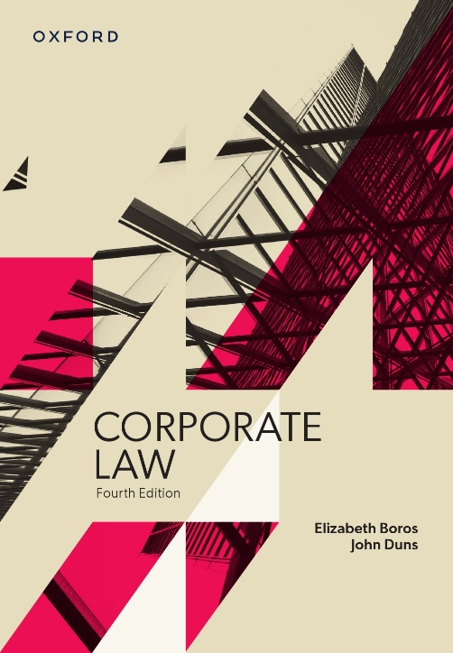 | Corporate Law  Fourth Edition  Elizabeth Boros and John Duns  Problem questions by Elizabeth Boros and John Duns
COPYRIGHT NOTICE
This instructor’s resource manual is copyright Oxford University Press 2022. It is intended for use only by lecturers prescribing Corporate Law, fourth edition, in their courses and should not be distributed or copied for any other purpose or for use with any other text.

Part 1 The Corporate Entity and its Regulation
Textbook pages 1-66

Question 1.1: Light Pty Ltd
Light Pty Ltd is one of the companies in the Heavy Industries group of companies. Light is a 100% owned subsidiary of Heavy Ltd, the holding company of the group. Light has two directors: a managing director and a chief financial officer. While the group as a whole has been doing well, Light has been having financial difficulties. Light’s financial crisis came to a head when it was revealed that it is likely to become liable for extensive damages as a result of environmental torts it has committed, and that Light is not adequately insured against the potential claims. The poor publicity to which it appears that these environmental claims will expose the whole group has resulted in other members of the Heavy Industries group placing pressure on the directors of Light. As a result, the directors decided to engage in an extensive advertising campaign to promote the group’s image. However, several months later it seems clear that the advertising campaign has failed. Light is insolvent and creditors, including the agency that handled the advertising campaign, have commenced proceedings to wind up Light.

Questions
- Heavy Ltd has sought advice on whether it is likely to be liable for Light’s environmental torts or advertising debts. Advise Heavy Ltd.
- Do you consider that in these circumstances Heavy Ltd should be liable for:
  - Light’s torts; and
  - Light’s advertising debts?
Explain.

Notes for discussion
- This requires examination of the insolvent trading provisions and perhaps a brief consideration of ‘lifting the veil’ at common law. In relation to the latter, it is rare that a shareholder will be liable for a company’s debts (see Salomon itself) and the courts will not generally lift the veil on shareholders even where, as here, the shareholder is a 100% holding company: see Smith, Stone & Knight (discussed in the textbook at 3.2.1, page 43). With regard to liability under the statutory insolvent trading provisions, Heavy Ltd faces potential liability as a ‘director’ under s 588G and as a holding company under s 588V. With regard to the former, is Heavy Ltd a ‘director’ of Light Pty Ltd? There seems to be insufficient evidence of this here (see the textbook at 3.4.1(c), page 56) so the main focus will be s 588V (and possible defences under s 588X (see 3.4.1(e), page 58)– although none appears to be raised on the facts here). The various elements of s 588V will need to be considered but, for the damages liability, a particular issue will be whether this involved the company ‘incurring a debt’. An unliquidated liability is not a debt in this context: see the discussion at 3.4.1(b), page 54. And so the tort will not fall within the provisions.

- This question raises the issues of whether (i) limited liability is appropriate where a company is 100% owned by another company and (ii) tort liability should be excluded from the insolvent trading provisions. See the discussion of the former in the textbook at 3.1.2, page 40, and note the arguably stronger claim that a tort victim has to compensation in comparison with a party claiming a breach of contract (here, the advertising agent). In relation to (ii), the rationale for confining ‘debts’ to liquidated amounts is that such claims are more likely to be under the control of directors and hence they should take responsibility for them.

