The Cell, Ninth Edition – Additional Data Analysis Problems with Answers

Data Analysis Problem 12.2 Electron Microscopic Analysis of Mitochondrial DNA

Source: Wolstenholme, D. R., and I. B. Dawid. 1968. A size difference between mitochondrial DNA molecules of urodele and anuran Amphibia. J. Cell Biol. 39: 222–228. 10.1083/jcb.39.1.222
Experiment
Mitochondrial DNA (mtDNA) was isolated from frog oocytes and studied by electron microscopy.
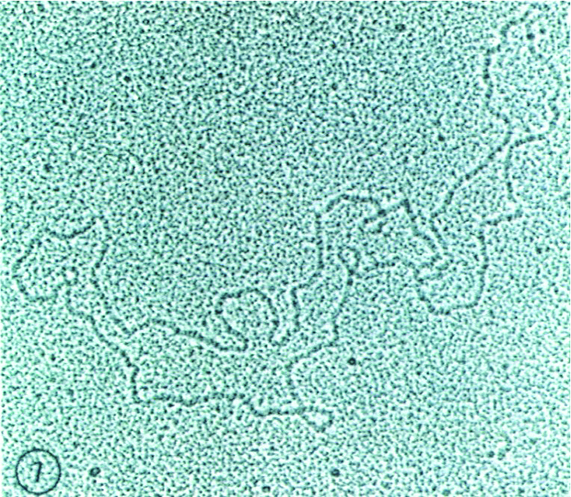

Questions and Answers

- Briefly describe the procedure for isolating mitochondria.
  - Answer: Oocytes are homogenized, and the lysate is centrifuged at a low speed, resulting in the sedimentation of the nuclear fraction. Centrifugation of the supernatant at a medium speed results in the sedimentation of the mitochondria and lysosomes. Pure mitochondrial fraction can be obtained from this isolated and resuspended pellet by centrifugation in a density gradient. The mitochondria are then lysed in a buffer containing a detergent (e.g., SDS) to disrupt their membranes. Mitochondrial proteins are precipitated by adding organic solvents (e.g., phenol, chloroform) to the lysate. After centrifugation, the mitochondrial DNA is precipitated from the top, aqueous phase using ethanol. The mitochondrial DNA pellet is treated with RNase to remove contaminating RNA molecules. Final ultracentrifugation of the sample in a CsCl gradient results in highly purified mtDNA.

- Which electron microscopy technique was used to visualize this mtDNA molecule?
  - Answer: The mitochondrial DNA was visualized by transmission electron microscopy. The DNA, whose topography caused an accumulation of heavy metal particles, appears as a dark, electron-dense line. A thin layer of heavy metal particles evenly coats the background, causing it to look granular.

- What property of the mtDNA is similar to bacterial genomes?
  - Answer: Both mitochondrial and bacterial DNAs are circular.

Data Analysis Problem 12.3 Staining of Mitochondria with a Fluorescent Dye

Source: Johnson, L. V., M. L. Walsh, and L. B. Chen. 1980. Localization of mitochondria in living cells with rhodamine 123. Proc. Natl. Acad. Sci. USA 77: 990–994.
Experiment
Rat fibroblasts were infected with a Rous sarcoma virus (RSV) strain carrying a temperature-sensitive mutation in the src gene. Cells were stained with a mitochondrion-specific fluorescent dye (rhodamine 123) at a nonpermissive temperature (39°C, which renders the src gene product inactive; A) and 30 minutes after shifting to a permissive temperature (34°C, at which the src gene product is active; B). The cells were imaged with a fluorescence microscope.
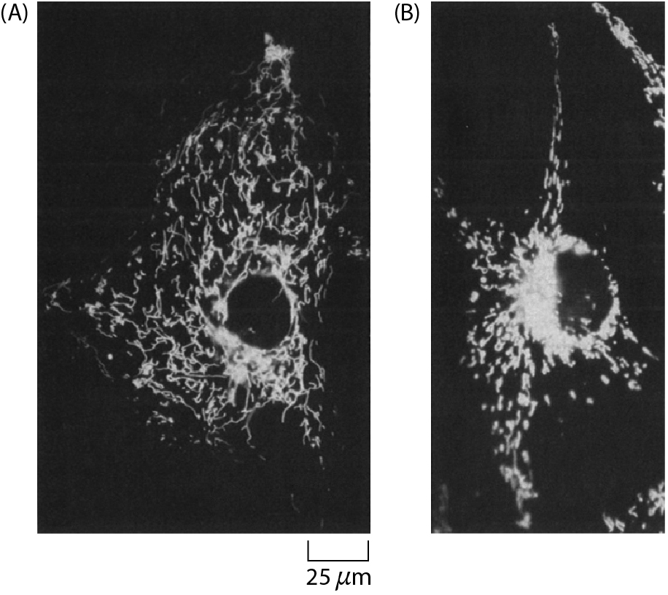

Questions
- How does the RSV src gene product affect the behavior of mitochondria?
  - Answer: At the nonpermissive temperature, when src is not active, mitochondria are randomly distributed in the cytoplasm (A); at the permissive temperature src is active and mitochondria accumulate around the nucleus of the cell (B).

- How could you confirm that rhodamine 123 stains mitochondria specifically?
  - Answer: You could label mitochondria using a fluorescently labeled antibody against a mitochondrial protein or using a mitochondrial protein fused to GFP. If this labeling of a known mitochondrial protein co-localized with the rhodamine 123 signal, it would confirm that mitochondria were stained specifically.

