SAMPLE:
Chapter 2 Instructor’s Resource Manual
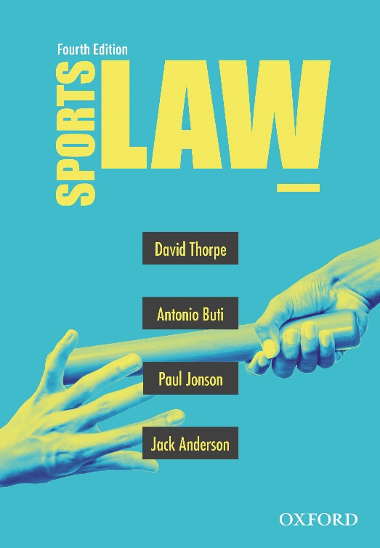 | Sports Law  Fourth Edition  Edited by David Thorpe, Antonio Buti, Paul Jonson and Jack Anderson  IRM material prepared by Liam Elphick, based on content from Sports Law, fourth edition
COPYRIGHT NOTICE
This instructor’s resource manual is copyright Oxford University Press 2022. It is intended for use only by lecturers prescribing Sports Law, fourth edition, in their courses and should not be distributed or copied for any other purpose or for use with any other text.

Chapter 2: Organisational structure and governance
Textbook pages 7–58

Chapter Summary
Governance
- Governance is the system by which organisations are directed and managed, and by which rules and procedures for making organisational decisions are set.
- The traditional position in sport is that governance is an internal matter, owing to the need for specialised knowledge and experience.
Role of government
- Despite sporting bodies desiring a solely internal governance structure, governmental departments and authorities do intervene in sporting governance issues in Australia.
- This intervention is largely through the Australian Sports Commission (now Sport Australia), which oversees the delivery of services to sport in Australia, and the Australian Sports Anti-Doping Authority, which is responsible for making and administering the rules under which athletes are tested for prohibited substances and methods.
- Furthermore, each state and territory in Australia has their own government department responsible for sport and recreation.
International governance of sports
- Internationally, various organisations are involved in sports governance, including the International Olympic Committee (IOC), International Sports Federations, and other national sports bodies.
- The most influential international sporting body is the IOC, owing largely to the universal appeal of the Olympic Games.
- The Court of Arbitration for Sport (CAS) is also important, as it provides a way of resolving sport-related disputes through arbitration.
Governance structures and processes
- Sports governance in Australia is built around three pillars: transparency, democracy and accountability.
- Good sports governance can be reflected through a strong constitution that deals with issues such as membership, voting rights, financial matters, governance groups, and alteration of rules.
Organisational structures
- Sporting organisations need to be aware of various legal and regulatory issues in deciding what corporate structure to adopt.
- There are usually three structural choices for sporting organisations: an unincorporated association, an incorporated association, and a company limited by guarantee.
Unincorporated associations
- An unincorporated association is easy to form, as it simply requires a set of persons to come together for a purpose that does not involve them making any personal profit.
- An unincorporated association is informal, and has no legal status, which can be disadvantageous as the incorporation cannot buy, sell or lease, cannot open a bank account, and may filter liability down to its individual members.
Incorporated associations
- An incorporated association requires more formal steps to be taken at the set-up stage, but constitutes a legal entity that is distinct from its members, which usually protects them from liability.
- Incorporated associations are permitted to make profits, but they cannot distribute that profit among members.
Companies
- A company limited by guarantee is the most appropriate option for a national or international sporting organisation, and Sport Australia has mandated this structure for all national sporting associations that seek Commonwealth funding.
- A company limited by guarantee has various obligations imposed by the Corporations Act 2001 (Cth), particularly in relation to directors and their duties.

Chapter Objectives
- Be able to explain why sport requires governance
- Be able to demonstrate an understanding of how sporting organisations are governed both internally and externally
- Be able to explain the three main structures a sporting organisation can take
- Be able to weigh up and determine the advantages and disadvantages of these three main structures
- Be able to develop views on the extent to which external intervention in the governance of sporting bodies should occur

Key Terms
Governance; internal structure; external intervention; rules and processes; unincorporated association; incorporated association; company limited by guarantee

Tutorial Activity
The Abernathy Discus Club is an unincorporated association set up to allow its members to compete in discus competitions each Saturday at Abernathy Park, which is owned and operated by Abernathy Council. The Club signed a contract with Abernathy Council two years ago to pay $5,000 per year for the use of Abernathy Park from 9:00am-12:00pm each Saturday, with the contract lasting for a duration of four years. This contract was signed by Johan Anderson as the ‘nominated trustee’ of the Club, however Johan was never nominated as a trustee of the Club through any formal Club process or governance structures.
Abernathy Council are approached by Abernathy Shotput Club to request use of Abernathy Park each Saturday at the same time as the Discus Club use the park. Abernathy Shotput Club offer $10,000 per year for the use of the park. Abernathy Council are very short on cash and want to see if there’s a way to cancel their existing contract with Abernathy Discus Club, so they can take up this new opportunity.
Can Abernathy Council successfully argue that as Abernathy Discus Club is an unincorporated association, it was not possible for them to enter into a binding legal agreement?
A marking guideline has been provided at the end of this IRM to help determine the quality of student answers.

Short Answer and Revision Questions
1. Why might a sporting body choose to be a company limited by guarantee instead of an incorporated association?
- Sport Australia now requires that sporting bodies seeking Commonwealth funding be set up as companies limited by guarantee.
- Replaceable rules found in the Corporations Act 2001 (Cth) provide an easier basic framework to govern a sporting organisation and one which is inherently up to date with the law, unlike a constitution (under an incorporated association) which may require constant updating to keep it up to date with the law.
- Clear and onerous duties are imposed on directors under the Corporations Act 2001 (Cth) which make it more difficult for an individual or set of individuals to unlawfully take advantage of the sporting organisation for personal gain or profit.
2. Should governments be involved in regulating sports governance?
- Sporting bodies would argue no, because specialist knowledge is required considering the ‘niche’ nature of sporting bodies.
- Governments would argue yes, for various reasons: a desire to achieve international sporting success, encourage greater physical fitness in citizens, ensure drug use in sport is regulated and minimised.
- A weighing of these factors should lead to the conclusion that some government regulation is necessary, though the ideal extent of this regulation is unclear.
3. Is it fair that members of an unincorporated sporting association might be liable if something goes wrong?
- The benefit of an unincorporated association structure is that it is easy to set up, but this brings with it disadvantages, such as the potential for liability to be allocated to members.
- Unincorporated associations can nominate trustees to be the legal representatives of the organisation, which more deliberately allocates liability to one or more particular members rather than all members as a whole.

Marking Guidelines
Marking guidelines | Mark range
 | 1 | 2 | 3 | 4 | 5 | 6 | 7 | 8 | 9 | 10 | Total
1.Understanding of subject matter
Does the answer present an understanding of the relevant legal issues?
Are key legal issues focused on, and minor issues addressed in less depth?
2.Structure
Is there a clear structure around an argument that answers the question posed?
Does the answer flow naturally from section to section?
3.Relevant use of authorities
Are arguments supported by relevant use of primary sources (case law, legislation) and/or secondary sources (books, book chapters, journal articles, online articles) where relevant?
Are adequate comparisons and contrasts drawn with relevant case law, fact patterns or other scenarios?
4.Cogency of argument
Have counter-arguments been addressed such that the answer presents the strongest possible argument in response to the question?
Are the arguments offered both critical and analytical and is there a clear and persuasive conclusion?
Should policy considerations underpin some aspects of the discussion?
5.Use of language
Does the answer provide accurate grammar, spelling and punctuation?
 |  |  |  |  |  |  |  |  |  |  | Total

Scale | Grade | Scale | Grade | Scale | Grade | Scale | Grade | Scale | Grade
100  99-95  94-90  89-85 | High Distinction  (HD) | 84-80  79-75 | Distinction  (D) | 74-70  69-65 | Credit  (C) | 64-60  59-55  54-50 | Pass (P) | 49-40  <40 | Fail  (F)

