SAMPLE:
Chapter 3 Answer Guide
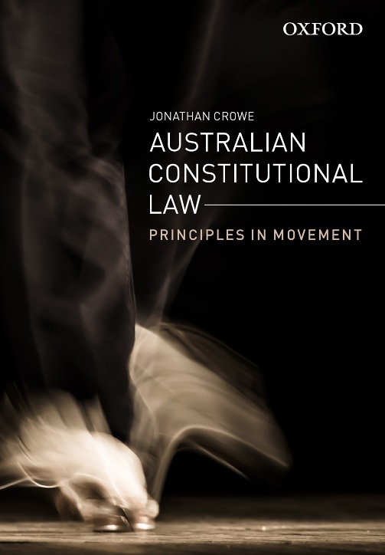 | Australian Constitutional Law: Principles in Movement  Jonathan Crowe  Discussion questions by Jonathan Crowe
COPYRIGHT NOTICE
This resource is copyright Oxford University Press 2022. It is intended for use only by lecturers prescribing Australian Constitutional Law in their courses and should not be distributed or copied for any other purpose or for use with any other text.

Chapter 3: Interpreting Legislative Powers
Textbook pages 50-70

Question 1
- How does the Australian Constitution divide legislative powers between the Commonwealth and the states?
- What is the process for determining whether a statute falls within the power of the Commonwealth Parliament?
- How is this different from the process for assessing the validity of a state law?

- See the discussion at pp 50-3 of the textbook. The Commonwealth and state parliaments each have their own areas of power under the Australian Constitution. These powers fall into three categories: exclusive powers, concurrent powers and residual powers.
  - Two main questions arise in assessing the validity of state and Commonwealth laws. The first question is whether the legislation is within the power of the parliament that enacted it. A distinction must be drawn here between the Commonwealth, which relies upon enumerated powers, and the states, which enjoy residual powers.
    - To be valid, a Commonwealth law must fall within one of the powers given to the Commonwealth in the Constitution. The constitutionality of Commonwealth legislation can be assessed using a three-step process. The first step is to identify the legislation’s subject matter. This is known as characterising the law. The second step is to identify the constitutional head of power that potentially supports the law (most often found in s 51) and determine its scope. The third step is to ask whether the legislation is sufficiently related to a head of power to count as a law ‘with respect to’ it.
    - The states, by contrast, have plenary powers (meaning general powers to make laws for the ‘peace, welfare and good government’ of the state). These powers are not limited by subject matter.
  - The second question that arises in evaluating legislation is whether the law violates any constitutional prohibitions or immunities. A law may be within the subject matter power of the parliament that enacted it, but be unconstitutional if it violates some other aspect of the Constitution.
    - For state laws, this includes assessing issues of inconsistency with Commonwealth legislation under s 109.

Question 2
- What impact has the Engineers’ Case (1920) 28 CLR 129 had on the balance of power between the Commonwealth and the states?
- Has the case had positive or negative consequences overall for constitutional government in Australia?

- The Engineers’ Case concerned a union award for engineers that was endorsed by a Commonwealth industrial relations tribunal. The question arose as to whether the award was binding on the states as employers.
  - One issue was whether the award was supported by the arbitration power in s 51 (xxxv). On the face of it, the law was supported by the power. However, the question arose whether the power should be limited to preserve the autonomy and powers of the states.
- The High Court in Engineers rejected the idea of implied limitations on Commonwealth powers arising from the ‘reserved powers’ of the states. Rather, Commonwealth powers are to be read in a plenary fashion and given their widest possible effect.
- This view of Commonwealth powers heralded a new approach to characterisation. The High Court would no longer enquire into the dominant or true subject matter of a law. Rather, it would ask whether there is a reasonable chararacterisation of the law that places it within a Commonwealth head of power.
  - In other words, the High Court shifted from ‘dominant characterisation’ to ‘multiple characterisation’.
- The majority of judges held that s 51 must be interpreted using two guiding principles: the sovereignty of the Imperial Parliament and the doctrine of responsible government. These principles dictate a broad and expansive interpretation of federal powers. It up to responsible government to keep power in check.
  - It follows that the Commonwealth arbitration power in s 51(xxxv) should be read literally, as covering all disputes extending across state borders. This includes disputes involving the states as employers.
- The effect of the Engineers’ Case has undoubtedly been to expand Commonwealth power at the expense of the states. Students should reflect upon the pros and cons of this development. Centralised power may be more efficient in some ways, but it also concentrates power in one level of government.

Question 3
How does the approach to constitutional interpretation in the Engineers’ Case differ from that employed in earlier High Court decisions such as D’Emden v Pedder (1904) 1 CLR 91 and R v Barger (1908) 6 CLR 41?

- The central question in D’Emden v Pedder was whether federal salaries were subject to state stamp duties. Tasmania sought to levy duties on Commonwealth officers. The Commonwealth refused to pay.
  - The High Court in D’Emden held unanimously that states could not be permitted to burden the federal government’s payment of salaries to its officers by taxing the receipts. The Tasmanian statute was therefore read down to exclude the Commonwealth.
  - The case is relevant here because it shows that the early High Court interpreted the Constitution in light of the federal distribution of powers, and was concerned to protect both Commonwealth and state governments from infringements on their autonomy and finances.
    - The High Court was therefore willing to read down both Commonwealth and state powers to protect the other level of government from interference with its functions.
    - The majority of judges in Engineers did not overrule D’Emden, but reinterpreted it as resting on the supremacy of the Commonwealth under s 109, rather than on implied limitations on state powers arising from the federal nature of the Constitution.

- R v Barger concerned a Commonwealth law imposing a special tariff on agricultural machinery used by factories that did not grant their workers certain minimum conditions. The legislation was challenged on two grounds: first, that it was outside the taxation power in s 51(ii) of the Constitution; and second, that it discriminated between the states, which is expressly prohibited in s 51(ii).
  - A majority of the High Court, comprising Griffith CJ, Barton and O'Connor JJ, struck down the law on both grounds.
    - The Commonwealth can use a tax to achieve an end not solely related to taxation. The legislature’s motives are, in this sense, irrelevant. However, the Constitution reserves certain powers for the states. It must be read as a whole. The Commonwealth cannot use taxation to interfere with areas of state power.
    - The majority of judges therefore concluded that the legislation was not properly viewed as a law ‘with respect to’ taxation. Isaacs and Higgins JJ dissented. Isaacs J’s dissent previewed the majority judgment that he later authored in Engineers.
  - Barger is an example of the use of dominant characterisation and ‘reserved powers’ reasoning to read down Commonwealth powers and protect the states. The case was overruled in Engineers.
    - Students should be encouraged to reflect upon the two approaches to characterisation and constitutional interpretation more broadly and consider which they find more compelling.

