SAMPLE
Chapter 3 Discussion Questions
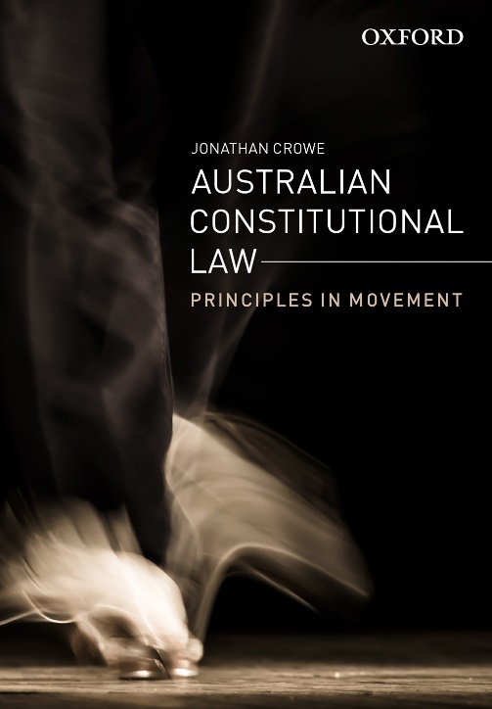 | Australian Constitutional Law  Jonathan Crowe  Discussion questions by Jonathan Crowe
COPYRIGHT NOTICE
This instructor’s resource manual is copyright Oxford University Press 2022. It is intended for use only by lecturers prescribing Australian Constitutional Law in their courses and should not be distributed or copied for any other purpose or for use with any other text.

Chapter 3: Interpreting Legislative Powers
Textbook pages 50-70

Question 1
- How does the Australian Constitution divide legislative powers between the Commonwealth and the states?
- What is the process for determining whether a statute falls within the power of the Commonwealth Parliament?
- How is this different from the process for assessing the validity of a state law?

Question 2
- What impact has the Engineers’ Case (1920) 28 CLR 129 had on the balance of power between the Commonwealth and the states?
- Has the case had positive or negative consequences overall for constitutional government in Australia?

Question 3
How does the approach to constitutional interpretation in the Engineers’ Case differ from that employed in earlier High Court decisions such as D’Emden v Pedder (1904) 1 CLR 91 and R v Barger (1908) 6 CLR 41?

