Instructor’s Manual
Introduction to Corrections, First Edition
Joycelyn Pollock

Chapter 2: Crimes and Criminology

Chapter 2 may seem out of place in a corrections class, but it sets the scene for why we do what we do with offenders. First, we look at how crime is measured, and then at rates over the decades. It would be helpful to pull up Crime in the United States to show students how to go about finding this information. Victimization survey results can be found by going to the Bureau of Justice Statistics. Then, a very quick review of criminological theories is given. If students have not had a criminology class, this review should be sufficient to understand how correctional policies are supported by theories of why people commit crime.

CHAPTER OUTLINE

- Measuring Crime
  - Three Crime Measures
- Decades of Declining Crimes
  - What Caused Crime Rates to Fall?
- Crime Correlates
- Criminology and Corrections
  - The Classical and Positivist Schools of Criminology
  - Biological Theories of Crime
  - Focus on History: Positivism at Bedford Hills
  - Psychological Theories of Crime
  - The Chicago School of Criminology
  - Cultural Deviance Theory
  - Economic Opportunity and Strain Theories
  - Social Control Theories
  - Labeling Theory
  - Summary of Crime Theories and Correctional Policies
- Are There Different Types of Criminals?
  - Focus on the Offender: Drugs and Economic Strain

CHAPTER SUMMARY

- Three measures of crime are the Uniform Crime Reports (reports to police collected and presented by the FBI), arrest numbers (also provided to and collected by the FBI), and victimization surveys. The third measure of crime comes from the National Crime Victimization Survey and is available on the Bureau of Justice Statistics website.
- All measures of crime have recorded major declines since about the mid-1990s; property crime began falling even earlier.
- Researchers estimate that incarceration affected crime declines by only about 10 percent. Increased police numbers, community policing, and decreased use of alcohol in the population at large were also influential. Other explanations have been offered, but there is little evidence that these have had any appreciable influence. These include aging baby boomers, stabilization of drug markets, “zero tolerance” policing, reduction of exposure to lead-based paint, and increased numbers of abortions beginning in the late 1970s.
- The most frequent arrests are for drug violations and, of those, marijuana possession is the most frequent drug violation. There are many more property crimes than violent crimes.
- Young men are responsible for most crimes, except for forgery/fraud and embezzlement, where arrests are about evenly divided between men and women.
- Whites account for over 70 percent of all arrests. Blacks are disproportionately arrested, especially for violent crimes, compared to their percentage of the population; however, arrests of Hispanics are roughly proportional to their percentage of the population. We must always keep in mind that the number of arrests, as a measure of crime, is problematic because it also measures the decisions of formal actors (police) in decisions to arrest.
- Crime theories explain crime as based on rational choice (the classical school of criminology and rational choice theory) or on individual differences (the positivist school of criminology, biological theories, psychological theories, general theory of crime, and general strain theory).
- Sociological theories of crime look at elements of society as criminogenic (the Chicago School of criminology, social disorganization and social support theories, cultural deviance theory, and strain theory).
- Some theories point to both individual differences and societal factors (e.g., social bond theory, learning theory, and differential association theory).
- Each type of theory supports some type of correctional response; for instance, rational choice theory supports deterrence policies such as longer terms of prison for more serious crimes; social bond theory promotes after-school and athletic programs; and strain theory dictates that crime can be prevented by increasing economic opportunities, and so on.

LECTURE OUTLINE

I. Measuring Crime

- Crime rates have declined substantially from their highs in the 1980s.
- What the corrections system does with offenders should have some relationship with why it is thought they commit crimes.

a. Three Crime Measures

  - Three key measures of crime are used: (1) crime reports made to the police; (2) arrests by police; and (3) victim surveys.
  - The Uniform Crime Reports (UCR), available through the Federal Bureau of Investigation, is an annual collection of local crime reports and arrest data.
    - Reports began in 1929; now ~98 percent of police agencies cooperate
    - Crime reports for jurisdictions by rates per 100,000 people for eight index crimes: murder and non-negligent manslaughter; forcible rape; robbery; aggravated assault; burglary; larceny-theft; motor vehicle theft; arson
  - Violent crime reports to police peaked in the early 1990s, then began to decline, while property crime peaked earlier and declined throughout the 1990s and 2000s. (See Figure 2.1)

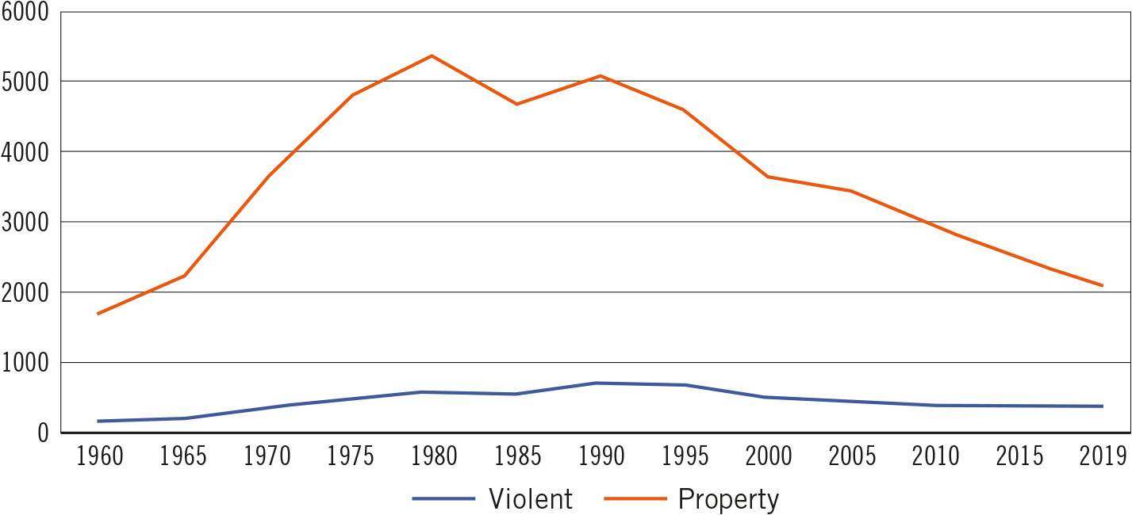
FIGURE 2.1 Reported crimes, 1960–2019. Author created from UCR Data Online analysis tool, https://www.bjs.gov/ucrdata/Search/Crime/Crime.cfm

  - Issues of UCR and arrest figures:
    - Dark figure of crime
    - Issues in accuracy (some police departments downgrade citizens’ reports in official reports)
    - Only report arrests of index crimes and these are affected by police actions
  - Arrests for homicide are almost half what they were in the mid-1990s; robbery arrests are less than half, as are several other crime categories. Can be attributed to either less crime or less effective police, but victim reports and reports to police have declined as well. (See Table 2.1)

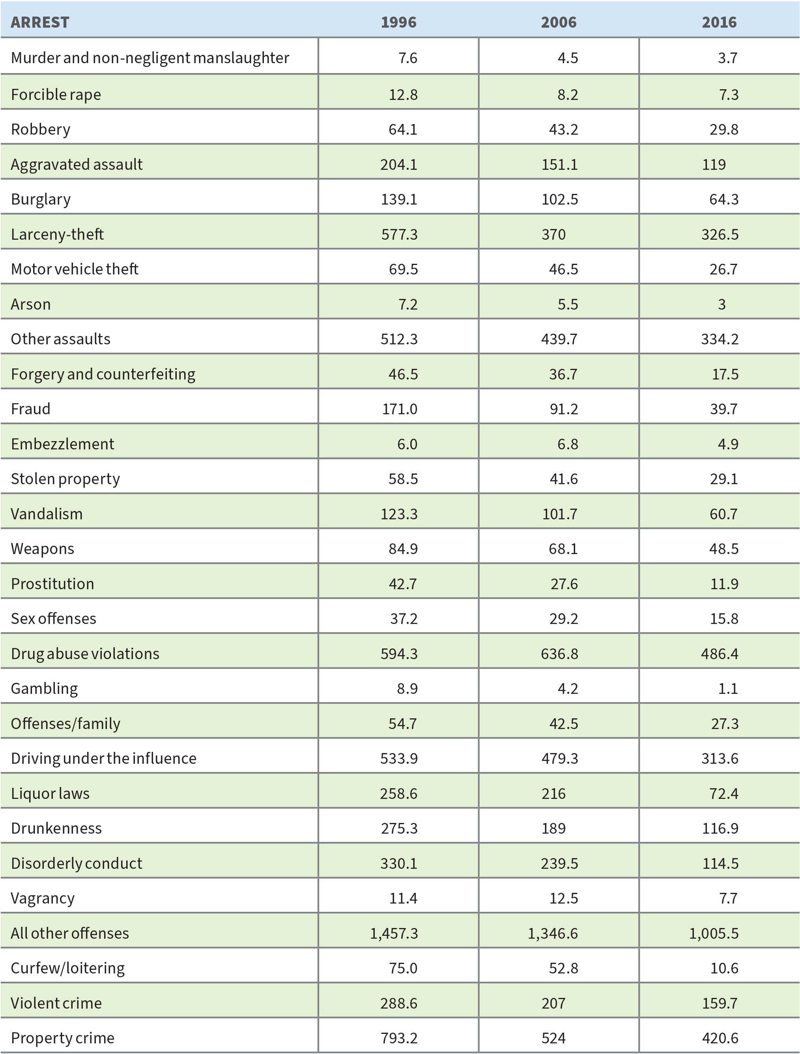
TABLE 2.1 20 Year Arrest Trends (Number of Arrests per 100,000). Source: FBI, “Crime in the United States,” 1996 (Table 30), 2006 (Table 33), 2016 (Table 19).

  - Drug arrests account for the largest number of arrests (except for “other” category). (See Figure 2.2)
  - Possession of marijuana accounts for 32 percent of total drug violation arrests. (See Figure 2.3)

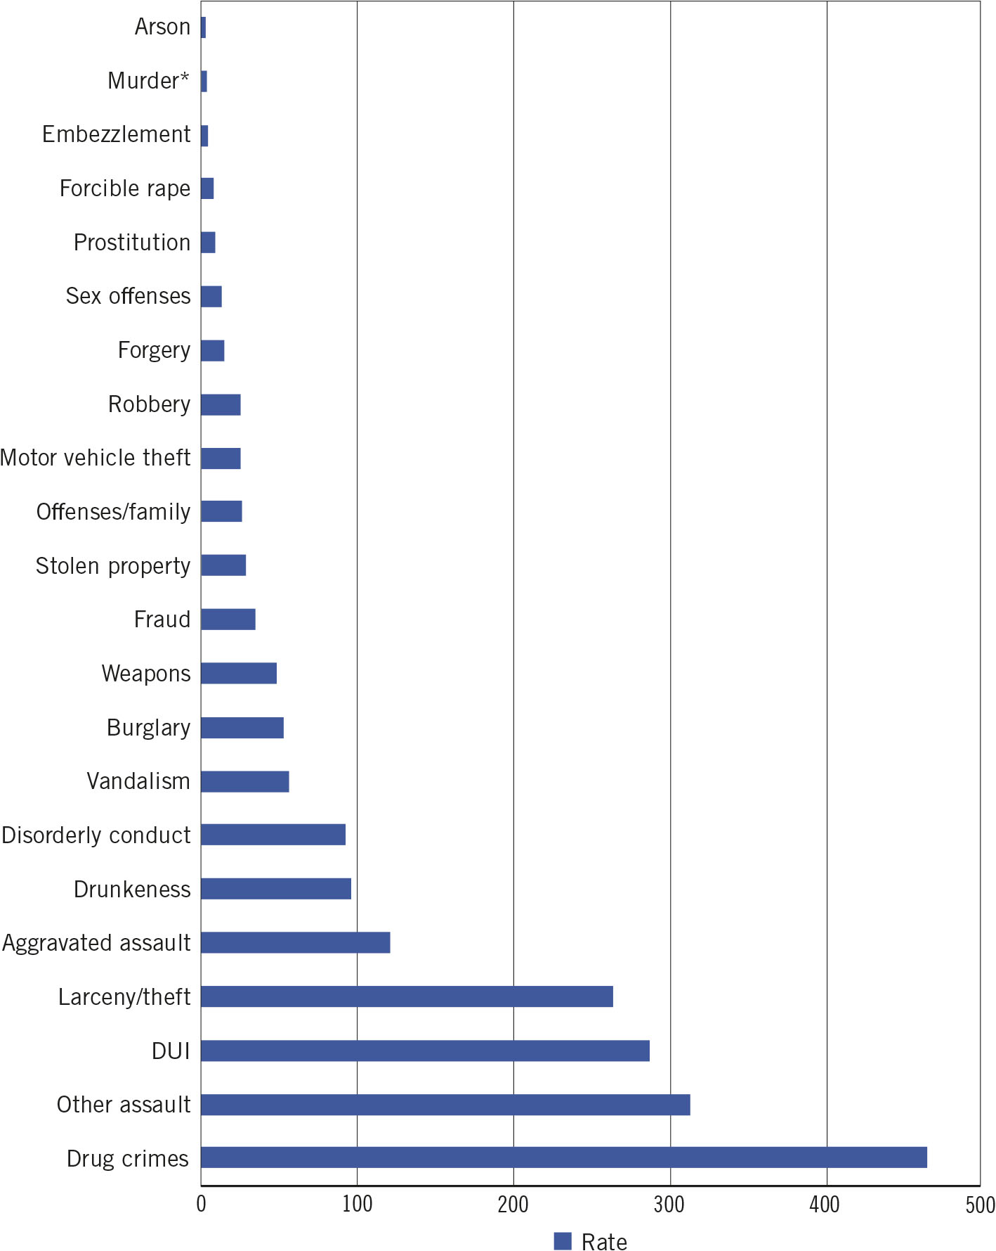
FIGURE 2.2 Selected 2019 arrests (rate per 100,000). Author created from FBI, “Crime in the United States, 2019, Table 30,” https://ucr.fbi.gov/crime-in-the-u.s/2019/crime-in-the-u.s.-2019/topic-pages/persons-arrested.

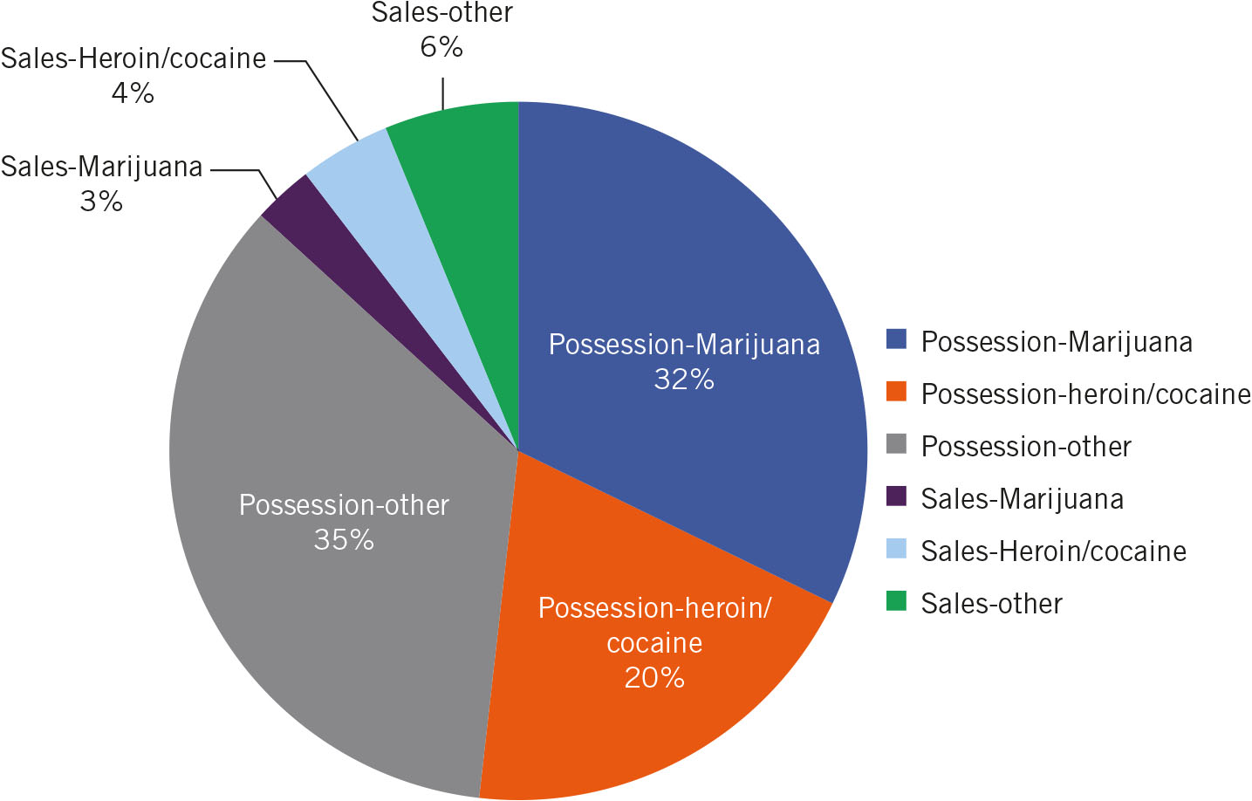
FIGURE 2.3 Percentages of drug arrests. Author created from FBI, “Crime in the United States, 2019,” https://ucr.fbi.gov/crime-in-the-u.s/2019/crime-in-the-u.s.-2019/topic-pages/persons-arrested.

  - National Crime Victimization Survey (NCVS): random sample of households selected and surveyed; excludes homicide, arson, commercial crimes, crimes against children under age 12, and victimless crimes such as drug crimes, gambling, or prostitution.
  - NCVS showed declines for roughly the same period during which the UCR and arrest data reported declines. (See Figure 2.4)

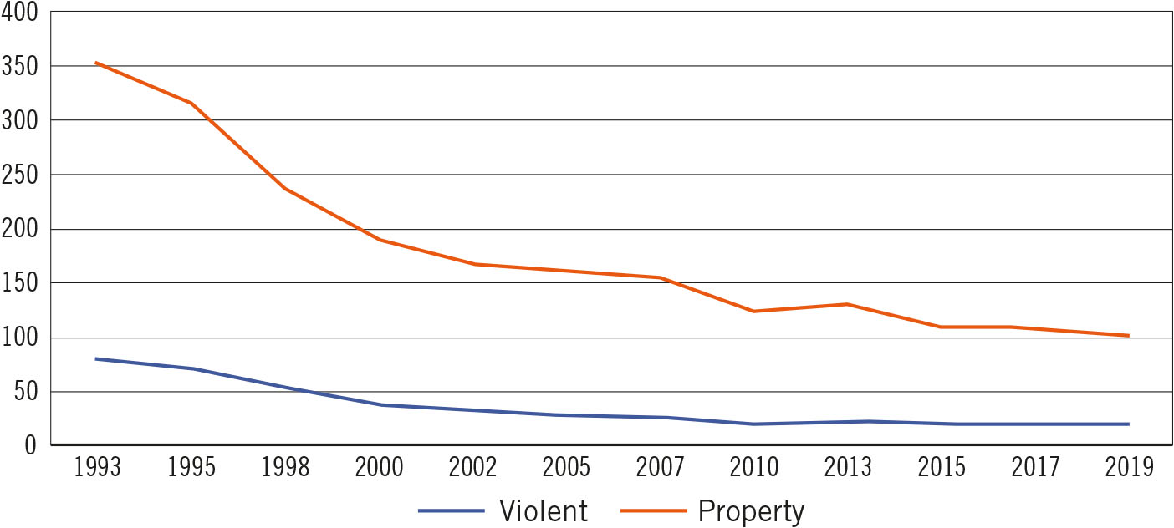
FIGURE 2.4 Victimization rates 1993–2016. Author created from “Violent victimization rates, and property victimization rates,” Bureau of Justice Statistics data analysis tool, https://www.bjs.gov/index.cfm?ty=nvat.

II. DECADES OF DECLINING CRIMES
- Reports to police, arrests, and victimization surveys have all shown dramatic declines over the past 30 years but over half of respondents in national polls persist in thinking that crime is worse. (See Figure 2.5)

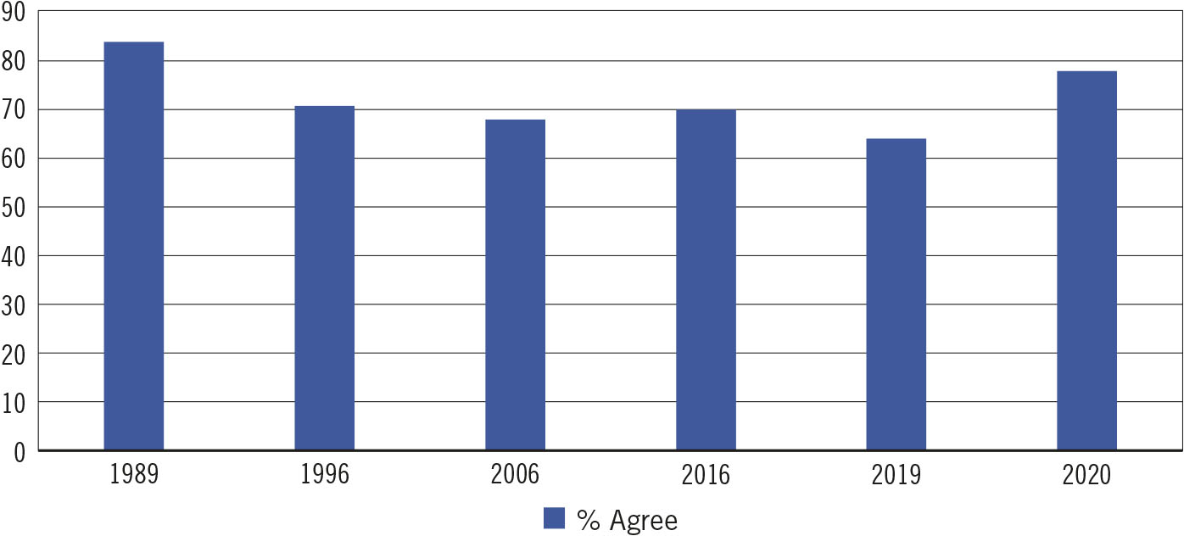
FIGURE 2.5 Percent agreement that “Crime is higher than a year ago.” Author created from Gallup Poll, http://news.gallup.com/poll/1603/crime.aspx.

- Crime spikes have been occurring in some cities but no pattern. (The instructor may want to pull up more recent crime statistics to see if 2020 spikes have continued).

a. What Caused Crime Rates to Fall?

  - Crime decline was influenced by higher incarceration in the 1990s but hardly at all in the 2000s.
  - Factors identified as potentially affecting the crime decline in the 1990s (not necessarily supported by research findings):
    - Aging birth cohort of Baby Boomers
    - Stabilization of drug markets
    - Community policing
    - “Zero tolerance” policing
    - Home health care and pre- and post-natal health services
    - Violence prevention programs in schools
    - Reduction of exposure to lead-based paint
    - Increased numbers of abortions in the late 1970s and 1980s
  - Brennan Center for Justice study: in the 1990s, the following factors each affected about 5 to 10 percent of the crime drop:
    - Increased incarceration
    - Increased numbers of police
    - Decreased alcohol consumption
  - Other factors accounted for between 5 to 7 percent of the crime drop:
    - Growth in income
    - Decreased unemployment
    - An aging population
  - Not supported:
    - Right-to-carry laws
    - Use of the death penalty
    - Decreased crack use
    - Decreased lead in gasoline
    - Legalization of abortion
  - In the 2000s, decreased alcohol consumption, growth in income, and the introduction of CompStat were estimated to affect the crime decline by about 5 to 15 percent each.
  - Not supported: an aging population, decreased crack use, right to carry laws, decreased lead in gasoline, increased police numbers, legalization of abortion and the use of the death penalty

III. CRIME CORRELATES

- Crime correlate: factor that is statistically associated with crime
- Sex:
  - 72% of all adults arrested in the US were male (2019)
  - Males accounted for 79% of violent crime arrests and 62% of property crime arrests (See Table 2.2)

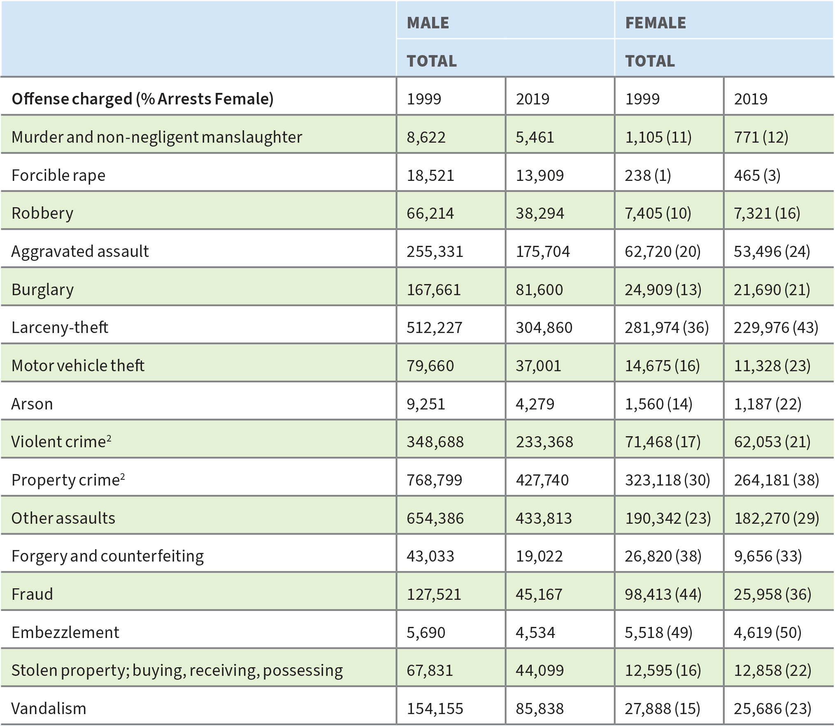
TABLE 2.2 Arrest Trends by Sex, Adults Only, 1999, 2019. Source: FBI, “Crime in the United States, 1999,” Table 42, accessed February 1, 2021, https://ucr.fbi.gov/crime-in-the-u.s/1999/99sec4.pdf; “Crime in the United States, 2019,” Table 42, accessed February 1, 2021, https://ucr.fbi.gov/crime-in-the-u.s/2019/crime-in-theu.s.-2019/topic-pages/tables/table-42.
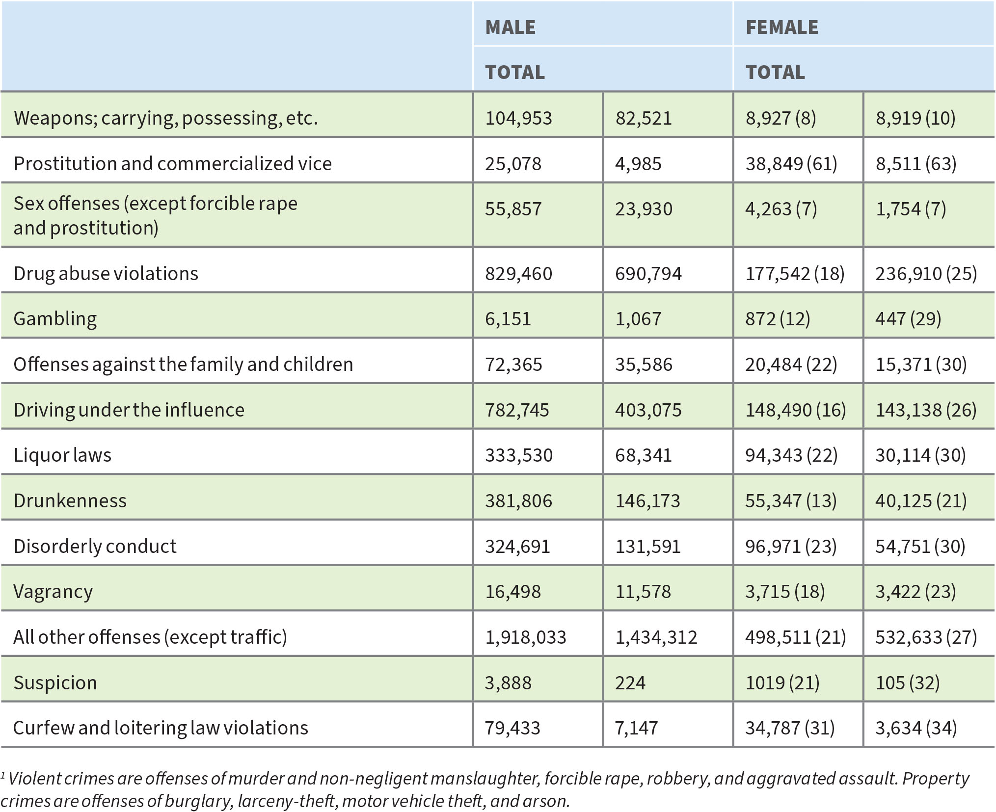
TABLE 2.2 (CONTINUED) Arrest Trends by Sex, Adults Only, 1999, 2019. Source: FBI, “Crime in the United States, 1999,” Table 42, accessed February 1, 2021, https://ucr.fbi.gov/crime-in-the-u.s/1999/99sec4.pdf; “Crime in the United States, 2019,” Table 42, accessed February 1, 2021, https://ucr.fbi.gov/crime-in-the-u.s/2019/crime-in-theu.s.-2019/topic-pages/tables/table-42.

- Age:
  - Maturation effect – drop in arrests in people over 35. (See Figure 2.6)

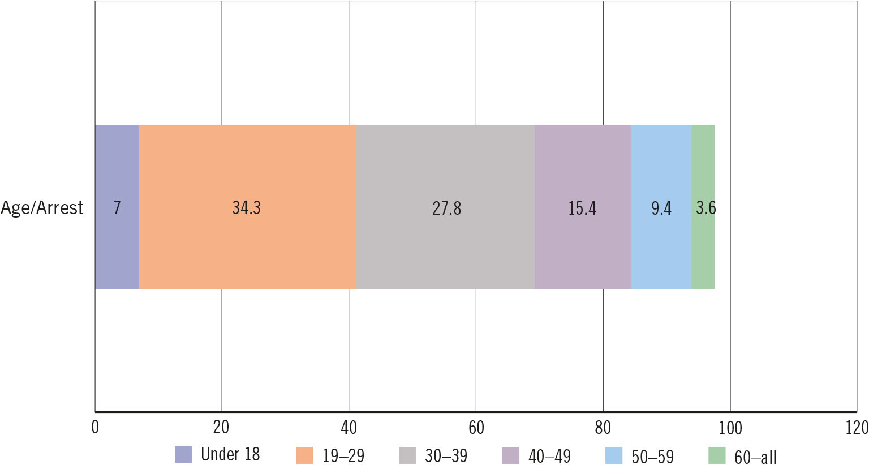
FIGURE 2.6 Arrest/percentage by age. Author created from FBI, “Crime in the United States, 2019, Table 38,” https://ucr.fbi.gov/crime-in-the-u.s/2019/crime-in-the-u.s.-2019/tables/table-38.

- Race/ethnicity:
  - Blacks represent about 27% of all criminal arrests except for violent crimes in which they represent closer to 37% (while Black people represent about 13% of the US population).
  - Arrests of Hispanics – 17% for property crime arrests, 25% for violent crime (about 18% of the US population). (See Figure 2.7)

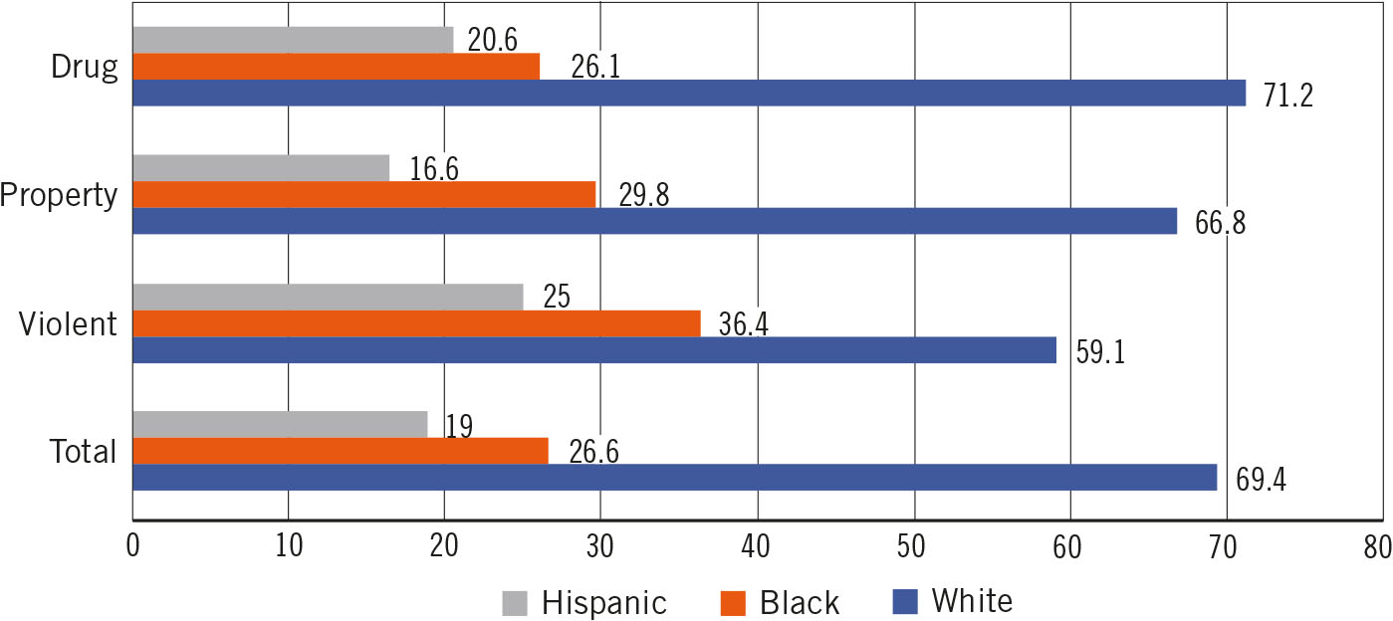
FIGURE 2.7 Arrest/percentage by race. Author created from FBI, “Crime in the United States, 2019, Table 43,” https://ucr.fbi.gov/crime-in-the-u.s/2019/crime-in-the-u.s.-2019/tables/table-43.

IV. CRIMINOLOGY AND CORRECTIONS

- Criminology – the study of criminals; criminological theories propose why individuals choose to commit crime, and why crimes occur in certain areas

a. The Classical and Positivist Schools of Criminology

  - Classical school of criminology –
    - 1700s: philosophers Cesare Beccaria (1738–1794) and Jeremy Bentham (1748–1832) assumed that men were rational and operated with free will. Therefore, laws promising punishment for offenses should deter criminal choices.
      - Women at the time were legal property of husbands and fathers and any crimes committed by females were attributed to these men; women perceived as less rational than men
    - Bentham’s hedonistic calculus proposed that the justice system set punishment as slightly more punitive than the perceived profit (or pleasure) of the crime contemplated. Effective punishment - swift, certain, and proportional
    - Modern theories: rational choice theory (underlying premise is that anyone might commit a crime if he or she thought that it could be committed with benefit and no risk of punishment) and deterrence theory.
    - Correctional implications – deter individuals from choosing to commit crime in the first place by making targets less appealing. Deterrence – threat of punishment
  - Positivist school of criminology –
    - 1800s: Cesare Lombroso (1825–1909); influenced by Darwinian theory; championed the idea of “born criminals”
  - Important difference between the classical and positivist schools – positivists saw criminals as different from law-abiding people. (Instructor may want to discuss the Focus on History box and its implications for eugenics.)

b. Biological Theories of Crime

  - Biological elements – levels of neurotransmitters in the brain, specifically dopamine and serotonin, which lead to behavioral effects
    - Other factors that may affect criminal decision-making include testosterone (associated with aggression), oxytocin (associated with trust), and monoamine oxidase (associated with sensation-seeking and impulsivity).
    - Testosterone, oxytocin – men commit more crime than women, especially violent crime
  - Biological theorists also agree that socialization and post-natal influences dramatically affect the potential for criminality. For instance, attentive parenting, specifically interaction and communication with a child, may positively affect the development of neural functioning.
  - Constant stress (from neglect or abuse) eventually “shuts down” the body’s normal responses to stress and the autonomic nervous system becomes nonreactive to fear and anxiety (this occurs with both boys and girls, but there may also be sex differences in reactivity).

d. Psychological Theories of Crime

  - “Big Five” personality traits: openness, conscientiousness, extraversion, agreeableness, neuroticism.
    - Of these, extraversion, impulsivity, aggressiveness, sensation seeking, and others have been associated with delinquency/criminality.
  - Psychological traits are influenced by the biological factors, e.g., lower serotonin levels are associated with negative emotionality and impulsivity.
  - Psychopathy and sociopathy largely replaced by “antisocial personality disorder” diagnoses
  - Hare’s Psychopathy Checklist: superficial charm, grandiose sense of self-worth, pathological lying, conning/manipulativeness, lack of remorse or guilt, parasitic lifestyle, poor behavioral controls, early behavior problems, impulsivity, juvenile delinquency, etc.
  - Delinquency, criminality – traits of low self-control/impulsivity, stimulus-seeking, and negative emotionality (a feeling that one has been mistreated)
  - Correctional policy implication of Lombroso’s idea of “born criminals” – merely incapacitation; later eras, a positivist approach – anything done to reform or change an offender that focuses on individual reasons for criminal choices (e.g., addiction, personality traits, learning disabilities).

e. The Chicago School of Criminology

  - Chicago School of criminology – 1930s, crime occurred more often in “interstitial zones” of the city, mixed zones of residential, commercial, and industrial activity characterized by low home ownership, property damage, graffiti, high rates of alcoholism, domestic violence, and mental health problems.
  - Social support theories – strong families and other social organizations (such as school and neighborhood associations) reduce crime/delinquency.
  - Social disorganization theories – lack of informal social controls from low socioeconomic status, residential mobility, racial heterogeneity, family disruption, weak or nonexistent local social organizations, weak local friendship networks, low organizational participation, and unsupervised teenage groups can all increase rates of delinquency and crime.

f. Cultural Deviance Theory

  - Cultural deviance theory – criminal culture was transmitted in the interstitial zone, criminality is acceptable
  - Differential association – those who grew up learning that criminal behavior was appropriate would be criminal and those who grew up with the notion that law-abiding behavior was appropriate would be law-abiding.
    - Frequency, duration, priority, and intensity of these associations affected the likelihood of delinquency
    - Social learning – modeling (we learn by patterning our behavior after those we look up to) and reinforcement (we adopt values and behaviors that are rewarded)
  - Correctional implications of cultural deviance theory and differential association theory – increase the number and intensity of prosocial messages and relationships (e.g., gang intervention, Big Brother/Big Sister program, “midnight basketball” programs, or mentoring programs)

g. Economic Opportunity and Strain Theories

  - Anomie theory, strain theory, or opportunity theory/strain-opportunity theory – being blocked from using legitimate means to achieve financial and social success leads to strain and normlessness (anomie) and some type of adaptation: conformity, ritualism, retreatism, rebellion, or innovation.
  - Differential opportunity theory – those who have access to legitimate economic opportunities group together (e.g., Boys Club), those who have access to illegitimate opportunities (e.g., organized crime or gang activity) group together; however, some are blocked from both avenues and group together to engage in uncontrolled criminal activity.
  - Correctional implications – Johnson’s “war on poverty” programs, education, vocational training, and job placement programs in prison or in the community
  - General strain theory – strain occurs whenever (a) individuals fail to achieve positively valued goals, (b) there is a removal of something that is positively valued (e.g., through divorce or death), or (c) there are negative/noxious experiences (e.g., victimization, child abuse); each leads to anger or frustration, and can lead to delinquency/crime if coping skills or resources are unavailable
  - Correctional implications – reduce their strains or improve their coping abilities, cognitive behavioral programs

h. Social Control Theories

  - Social control theory/social bond theory – most of us are controlled by our bonds to society through attachment, commitment, involvement, and belief. Weak attachments result in delinquency.
  - General theory of crime – crime caused by low self-control
    - Critics claim this does not explain white collar crime, organized crime, or the crime differential between men and women
  - Correctional implication of social control theory is to increase bonds, youth programs, sports, youth groups at church, parenting programs or family stabilization programs, enhanced visitation programs and support programs for achieving stable employment and family reunification
  - Correctional implications of the general theory of crime – develop self-control in offenders through some form of program or living situation in which they can gradually develop good habits.

i. Labeling Theory

  - Labeling theory – everyone commits primary deviance (small offenses early in life), but only some get labeled and stigmatized; the deviant commits secondary deviance in reaction to this labeling and stigmatization after the deviant label is incorporated into one’s identity.
  - Correctional implication – don’t stigmatize primary deviance

j. Summary of Crime Theories and Correctional Policies (See Table 2.3)

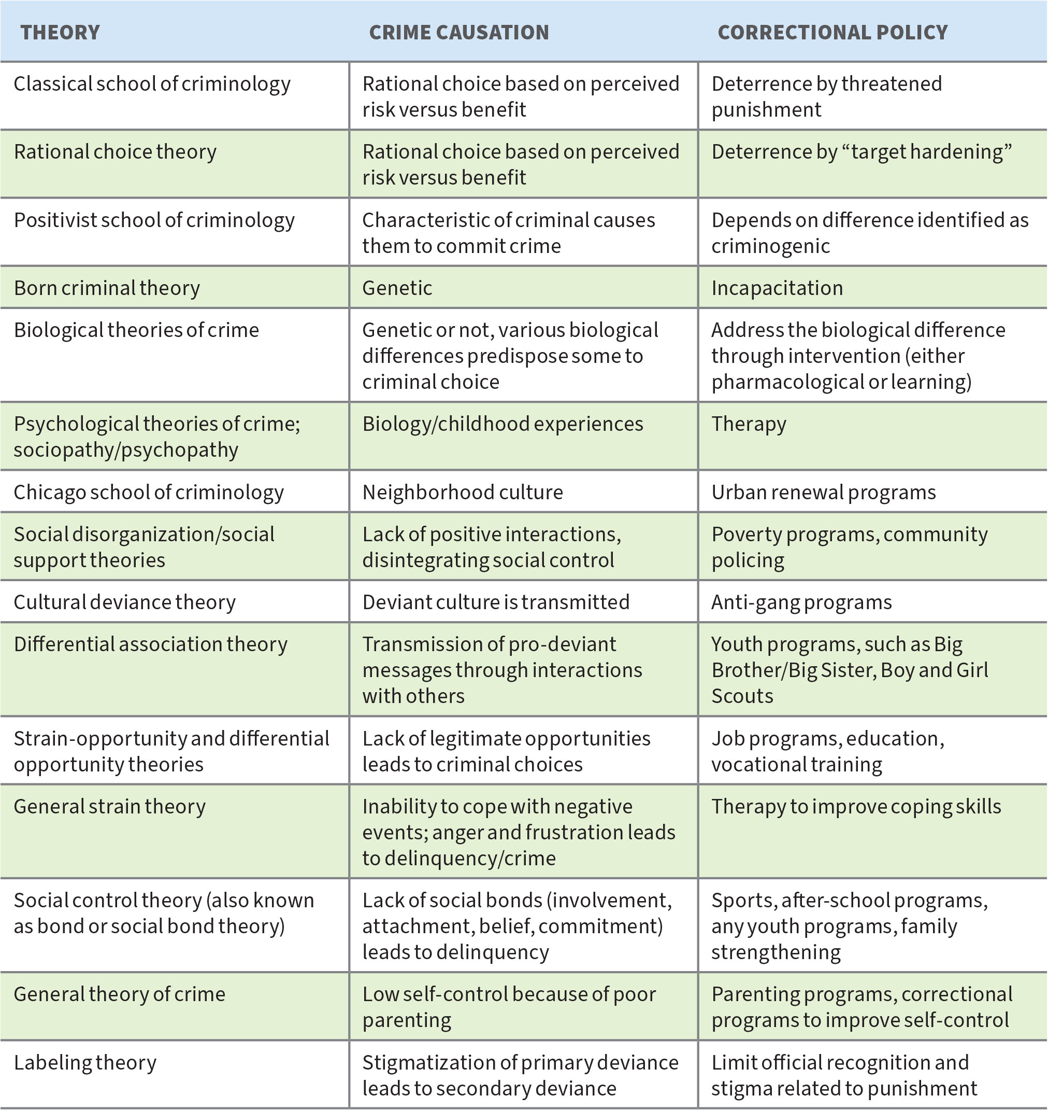
TABLE 2.3 Crime Theories, Causations, and Correctional Policies

V. Are There Different Types of Criminals?

- Longitudinal research – follows cohorts over many years
- Variables that predict a higher risk of criminal activity:
  - In childhood: many siblings, poverty, one-parent household, poor supervision and harsh and erratic parenting, criminal parents, school problems, delinquent friends
  - In adulthood, a lack of bonds (job, marriage, school)
  - Characteristics of those who were more likely to be offenders included: difficult temperament, hyperactivity/impulsiveness, risk-taking, overt or covert conduct problems, overt or covert aggressiveness, withdrawal, poor peer relationships, academic problems, association with deviant peers, difficulty mastering tasks and trouble negotiating conflict
  - Most move out of delinquency as they got married and/or became employed or joined the military; but small number of offenders who began their crimes early and became chronic offenders who did not reduce their criminal activities as they got older.
- Gender-specific pathways research – girls subject to childhood victimization that leads to running away, high-risk sexual activity, early pregnancy and single motherhood, drug use, and crime
- Integrated theories look at a wide range of factors, including biological and environmental. These theories are also life-phase-specific. (Instructor may want to use the Focus on the Offender box in a discussion and ask students to determine which theory best explains his decision to commit crime and what correctional option might be best suited?)

KEY TERMS

anomie normlessness

Chicago school of criminology 1930s sociologists who observed that crime occurred in interstitial areas of the city

classical school of criminology Bentham and Beccaria believed that people could be deterred from crime by adjusting the legal system; they assumed crime was a rational decision.

CompStat developed by the NYPD, utilized up-to-date crime statistics to inform division commanders and encourage accountability

crime correlate factor that is statistically associated with crime

criminology study of crime and criminals

cultural deviance theory the premise that crime is normal in some communities

dark figure of crime incidents of crime that are unreported to police

deterrence theory the premise that people will not commit crime if the perceived punishment is greater than the perceived reward

differential association theory the premise that delinquents receive more messages supportive of delinquency through associations with delinquent/criminal family and friends

differential opportunity theory the premise that some groups of boys had access to legitimate opportunities, some to illegitimate opportunities, and some to neither leading to uncontrolled delinquency

general strain theory the premise that individuals who are subject to strains (economic and person) and do not have coping skills, will experience anger and frustration that will lead to delinquency/criminality

general theory of crime the premise that crime results from low self-control

hedonistic calculus Bentham’s idea that the individual weighs the potential punishment against the potential pleasure or profit from a criminal act and decides accordingly

labeling theory the premise that we all commit primary deviance, but only those who are stigmatized and change their master identity go on to commit secondary deviance

longitudinal research following a cohort for a long period of time

maturation effect the observation that crime declines dramatically after the age of 35

National Crime Victimization Survey (NCVS) survey that goes to households to collect information about crime victimization

positivist school of criminology school of thought from the 1800s that perceived criminals as different (biologically) from law-abiding citizens; can also be used to describe any scientific approach that looks for causes

rational choice theory the premise that committing crime is a rational decision, criminals weigh whether they can escape punishment and decide accordingly

social control theory the premise that people don’t commit crime because of bonds to society, e.g., attachment, commitment, involvement and belief; if these are weak, delinquency results

social disorganization theory the premise that areas in a community that have no elements of social organization (church, home ownership, community clubs, etc.) and show signs of neglect (overgrown lots, abandoned buildings) also have more delinquency/criminality

social support theory the premise that when there are church, social groups, strong families, these provide support and reduce delinquency/criminality
strain-opportunity theory the premise that crime results when there are no legitimate means to success; if they don’t have legitimate access

symbolic interactionism the idea that our self-concept is shaped by what we perceive others to believe

Uniform Crime Reports (UCR) FBI collects reports of crime and produces this report titled “Crime in the United States” yearly

PROJECTS

- Visit the Bureau of Justice Statistics data analysis tool online. Go to “Custom Tables” and create a table of victimization rates for the last five years for violent or property victimization using at least two variables.
- Browse the news for the last week or so, find a story about a criminal and determine which, if any, of the theories presented in this chapter explain why the person made criminal choices.

WEB LINKS

Bureau of Justice Statistics

FBI: Crime in the U.S. 2019

Video: The Criminal Mind: The relationships between criminology and psychology - Professor Gwen Adshead (closed captions available)

