Chapter 17:
Testbank – short answer questions
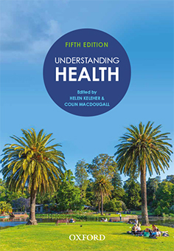 | Understanding Health  Fifth Edition  Edited by Helen Keleher and Colin MacDougall  IRM material prepared by Colin MacDougall, based on content from Understanding Health, fifth edition
COPYRIGHT NOTICE
This instructor’s resource manual is copyright Oxford University Press 2022. It is intended for use only by lecturers prescribing Understanding Health, Fifth Edition, in their courses and should not be distributed or copied for any other purpose or for use with any other text.

Chapter 17 Environment, climate change and health
Textbook pages 298–320
1 Give examples of the growing research on the negative effects of climate change on mental health.
The answer should draw on elements from pages 301 to 303.
2 What is the Anthropocene and how is it changing?
The Anthropocene is a new geological epoch characterised by the colossal human impact on climate and other Earth systems. These protective, atmospheric and climate systems are the ecological determinants of health which, until recently, were relatively stable for the previous 11,000 years. Human activities are driving changes in ecosystem structure and function through sociocultural changes caused by rapid population growth and unplanned urbanisation, unfettered economic growth and industrialisation. Humans are a subsystem within the broader ecosystem and are expanding at a rate that is disproportionate to other supporting ecosystems, which have fixed. The Anthropocene and resulting breaches of planetary boundaries create the most significant threats to population health of this century (Hancock et al. 2016; Patrick et al. 2019).
3 What is the link between climate action and sustainable energy? Give examples.
The answer should draw on the section ‘Sustainable energy’ on pages 310 to 311.
4 How might the process of taking action on climate change improve the health of professionals and community members working together?
The answer should draw on figure 17.5 in the section ‘Taking action is good for health’ on pages 315 to 316.

