Of the People: A History of the United States, 5/e
Michael McGerr, Jan Ellen Lewis, James Oakes, Nick Cullather, Mark Summers, Camilla Townsend, Karen M. Dunak
Study Guide
Introduction
Each section of the Study Guide approaches the chapter’s material from a different angle, helping you assimilate what you’ve read
Chapter Outline
The outline can be used to take brief notes from the chapter, as you read, or as you prepare for an exam. A common approach is to jot down the main idea for each section and sub-section. Or, you could coordinate the relevant lecture or lectures with the chapter: Use the right-hand column to flesh out the chapter’s material with relevant points from the lecture.
Quizzes
Each chapter has three sets of questions, covering the main reading of the text section-by-section, the chapter’s Features (American Landscape, American Portrait, Struggles for Democracy), and the materials to be found in the companion sourcebook.
Timeline
Along with the graphic organizers, the timelines provide a different approach to the chapter’s materials. Selected events are provided in chronological order. Use the timeline to sketch in connections between these events, considering the following: causal relationships; parallel developments; counterpoints to the main lines of development, and changes in the direction of events.
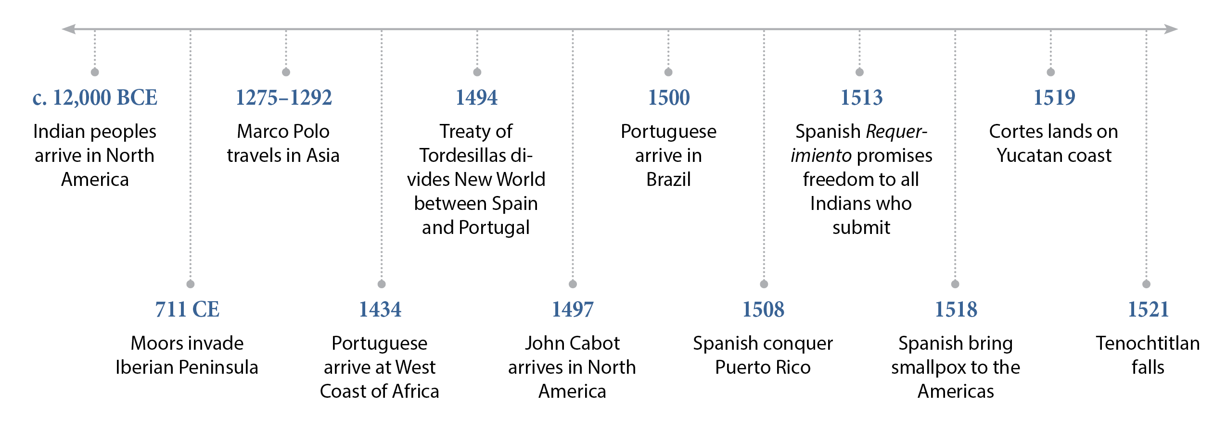
In the Answer Key, suggestions are provided for completing the timelines. Here’s an example:
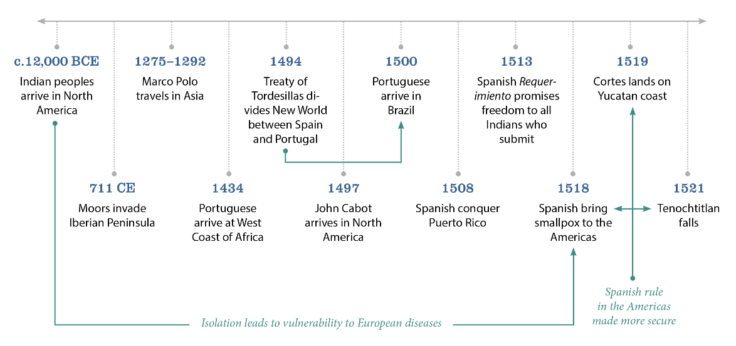
Graphic Organizer
The chapter sections have already been filled in, and bubbles for the sub-headings are provided. Some suggestions are provided to get you started. Lines between bubbles should be labeled to explain the connections between major ideas. In some chapters, where major themes cut across the entire chapter, hexagons have been added. For instance, in this graphic organizer from Chapter 5, slavery and commerce form threads running through the entire chapter.
Key words fall into one of three categories: people, places, ideas. You may wish to use different colored pens or pencils to indicate each type of term. In the example below, key words are in bold.
Finally, include the features (American Portraits, American Landscapes, Struggles for Democracy, and America and the World), placing them in their historical context.
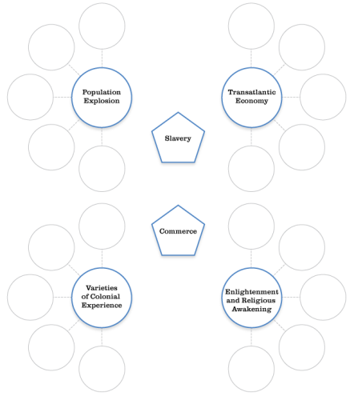
Below is an example of how you could complete this organizer (annotations are in red.)
Organizing all of the major components of the chapter this way will help you see the big picture.

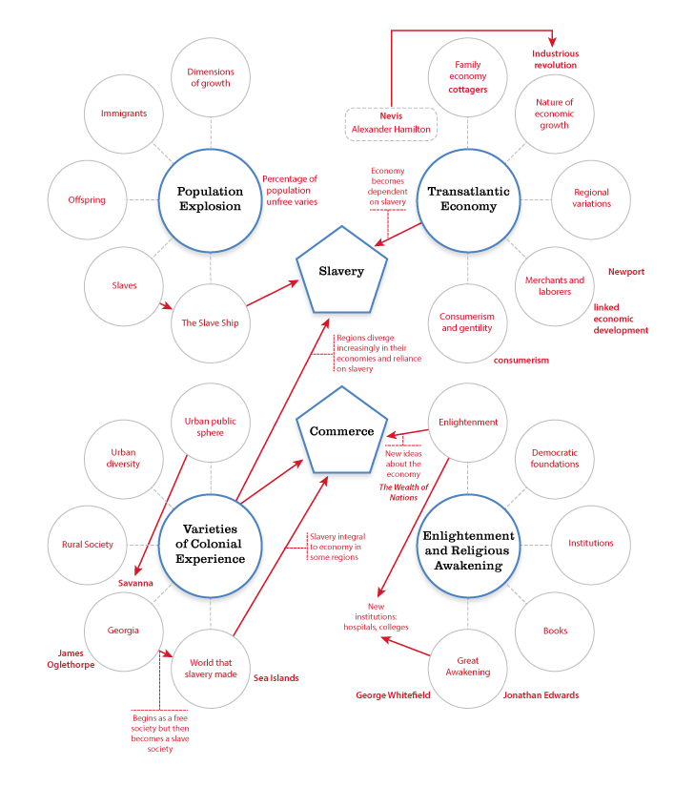

Of the People: A History of the United States, 4/e
Chapter 15
Reconstructing a Nation
1865–1877

CHAPTER OUTLINE | NOTES
- American Portrait: John Dennett Visits a Freedmen’s Bureau Court
- Wartime Reconstruction
  - Lincoln’s Ten Percent Plan Versus the Wade-Davis Bill
  - The Meaning of Freedom
  - Experiments with Free Labor
- Presidential Reconstruction, 1865–1867
  - The Political Economy of Contract Labor
  - Resistance to Presidential Reconstruction
  - Congress Clashes with the President
  - Origins of the Fourteenth Amendment
- Congressional Reconstruction
  - The South Remade
  - The Impeachment and Trial of Andrew Johnson
  - Radical Reconstruction in the South
  - Achievements and Failures of Radical Government
  - The Political Economy of Sharecropping
  - The Gospel of Prosperity
  - A Counterrevolution of Terrorism and Economic Pressure
  - America and the World: Reconstructing America’s Foreign Policy
- A Reconstructed West
  - The Overland Trail
  - The Origins of Indian Reservations
  - The Destruction of Indian Subsistence
- The Retreat from Republican Radicalism
  - Republicans Become the Party of Moderation
- Reconstructing the North
  - The Fifteenth Amendment and Nationwide African
  - American Suffrage
  - Women and Suffrage
- The End of Reconstruction
  - Corruption Is the Fashion
  - Liberal Republicans Revolt
  - “Redeeming” the South
  - Struggles for Democracy: An Incident at
  - Coushatta, August 1874
  - The Twice-Stolen Election of 1876
  - Sharecropping Becomes Wage Labor

COMMON THREADS
Consider these questions for Chapter Fifteen:
- In what ways did emancipation and wartime Reconstruction overlap?
- When did Reconstruction begin?
- Did Reconstruction change the South? If so, how? If not, why not?
- How did Reconstruction affect the West?
- What brought Reconstruction to an end?
QUIZZES

Section Questions
Wartime Reconstruction
- When did reconstruction begin?
  - during the Civil War
  - prior to declaration of war
  - immediately after the Confederacy surrendered
  - a year after peace was declared
- Which of these was a feature of all of the reconstruction plans?
  - abolition
  - land for former slaves
  - stiff punishments for Confederate leaders
  - seizure of plantations
- Which of these was a major challenge to employing former slaves in the South?
  - lingering legal restrictions
  - poor or nonexistent skills
  - transportation
  - the survival of plantations
Presidential Reconstruction, 1865–1867
- When did southern legislatures begin restricting black freedom?
  - after planters’ lands had been restored
  - prior to their state’s readmission
  - as soon as they met
  - when Reconstruction had ended
- In what respect was presidential Reconstruction presidential?
  - It required the president’s approval.
  - It was led by the president.
  - It was opposed by Congress and the Supreme Court.
  - It was the legacy of Lincoln.
- Which of these best describes Johnson’s attitude towards the South during this period?
  - ambivalent
  - partisan
  - harsh
  - evenhanded
Congressional Reconstruction
- Which of these was a test for readmission to the Union?
  - enfranchisement of blacks
  - renunciation of the Confederacy
  - ratification of the Fourteenth Amendment
  - freedom for war prisoners
- What motivated Johnson’s impeachment.
  - blocking Reconstruction
  - emancipation
  - harsh treatment of plantation owners
  - his foreign policy
- Compared to presidential Reconstruction, congressional Reconstruction was a move in what direction?
  - to the center
  - to the left
  - to the far right
  - to the right
A Reconstructed West
- The Overland Trail is best described as ________.
  - a trail originating in Chicago and passing due West to California
  - two trails beginning in Chicago and Kansas City
  - a trail linking the Old Northwest to the Northwest
  - several trails crossing the US to the West Coast

- Which of these was NOT an important factor in the US victory over Plains Indians?
  - US troops developed a policy of attacking Indians in winter quarters.
  - Each Indian tribe worked alone.
  - Buffalo were being killed off.
  - US troops beat Indians in every battle
- Which of these was the goal of the Dawes Severalty Act?
  - end the Indian way of life
  - preserve Indians’ traditional migration patterns
  - protect settled but not migratory Indians
  - educate Indians
The Retreat from Republican Radicalism
- In the 1860s, Democrats ________ radical Reconstruction.
  - initiated
  - fought against
  - were willing to tolerate
  - supported
- Grant’s presidential campaign signified ________.
  - a turn towards radical Reconstruction
  - greater support for the northern agenda
  - a more conciliatory attitude towards the South
  - the triumph of Reconstruction
- What was the central question in the 1868 election?
  - Should the southern states be readmitted?
  - What direction should Reconstruction take?
  - Should slaves be emancipated?
  - Can states nullify federal laws?

Reconstructing the North
- The Fifteenth Amendment concerned ________.
  - race and voting rights
  - ending slavery
  - Confederate states
  - women’s right to vote
- In which of these regions did women first gain the right to vote?
  - New England
  - the Old Northwest
  - the Pacific States
  - the Rocky Mountain West
- Following the Civil War, the fight for women’s rights ________.
  - was over
  - became much more radical
  - picked up where it had left off
  - gained its key goals
The End of Reconstruction
- In the 1860s and 1870s, government corruption was ________.
  - a nation-wide problem
  - confined to state governments
  - most common in the industrialized regions
  - rampant among southern legislatures
- The Slaughterhouse cases ________ the Fourteenth Amendment.
  - limited
  - overturned
  - upheld
  - expanded
- Compared to the elections of the 1850s, the presidential election of 1876 was decided ________ along sectional lines.
  - much more
  - much less
  - about the same
  - not at all

Feature Questions
American Portrait: John Dennett Visits a Freedmen’s Bureau Court
- Most of Dennet’s work concerned ________.
  - labor disputes
  - property rights
  - voting
  - lynchings
- Which of these best expresses the power of the Freedmen’s Bureau in relations between former slaves and white southerners?
  - powerless
  - limited
  - prejudiced towards former slaveowners
  - prejudiced towards former slaves
America and the World: Reconstructing America’s Foreign Policy
- What made Cuba less attractive to American imperialists?
  - the Monroe Doctrine
  - the end of the Civil War
  - Spain’s power
  - abolition
- Seward’s goals were a(n) ________ the goals of of manifest destiny.
  - renunciation of
  - triumph of
  - end to
  - expansion of

Struggles for Democracy: An Incident at Coushatta, August 1874
- Louisiana’s White League supported ________.
  - the Democratic Party
  - the Ku Klux Klan
  - Reconstruction
  - the Fourteenth Amendment
- In the Nast cartoon, African Americans hope for ________ but face ________.
  - voting rights; re-enslavement
  - land; work
  - legal rights; limited freedoms
  - education; lynching
Primary Sources Questions
15.1 Petroleum v. Nasby [David Ross Locke], A Platform for Northern Democrats (1865)
- Which of these best reflects this perspective of this supposed letter?
  - Blacks will both take whites’ jobs and be unable to support themselves.
  - Attacks on blacks are justified.
  - Democracy cannot survive with black emancipation.
  - Vilifying blacks is a distraction to real political issues.
15.2 Mississippi Black Code (1865)
- These laws are ________ racist.
  - apparently, but not actually
  - openly
  - subtly
  - constitutionally
15.3 Sharecropping Contract Between Alonzo T. Mial And Fenner Powell (1886)
- In what way did this differ from slavery?
  - Food is included.
  - The landowner provides tools.
  - The laborer gets half the crops.
  - The work is different.
15.4 Joseph Farley, An Account of Reconstruction
- Which of these is in favor of treating this account as reliable?
  - It was recorded not long after the events took place.
  - The narrative was written down as a diary while these events took place.
  - The narrator was an eyewitness.
  - The recorder has verified the statements.
15.5 A Southern Unionist Judge’s Daughter Writes the President for Help (1874)
- This letter was written during which of these post-war phases?
  - Redemption
  - presidential Reconstruction
  - congressional Reconstruction
  - radical Reconstruction
15.6 Red Cloud Pleads the Plains Indians’ Point of View at Cooper Union (1870)
- Which of these is the “Great Father” referred to by Red Cloud?
  - the US president
  - the Christian God
  - Jesus
  - his God
TIMELINE
Use the events below to develop your understanding of the relationship between events covered in this chapter. See the Introduction and the Answer Key below for suggestions for annotating the timelines to show linkages between events.
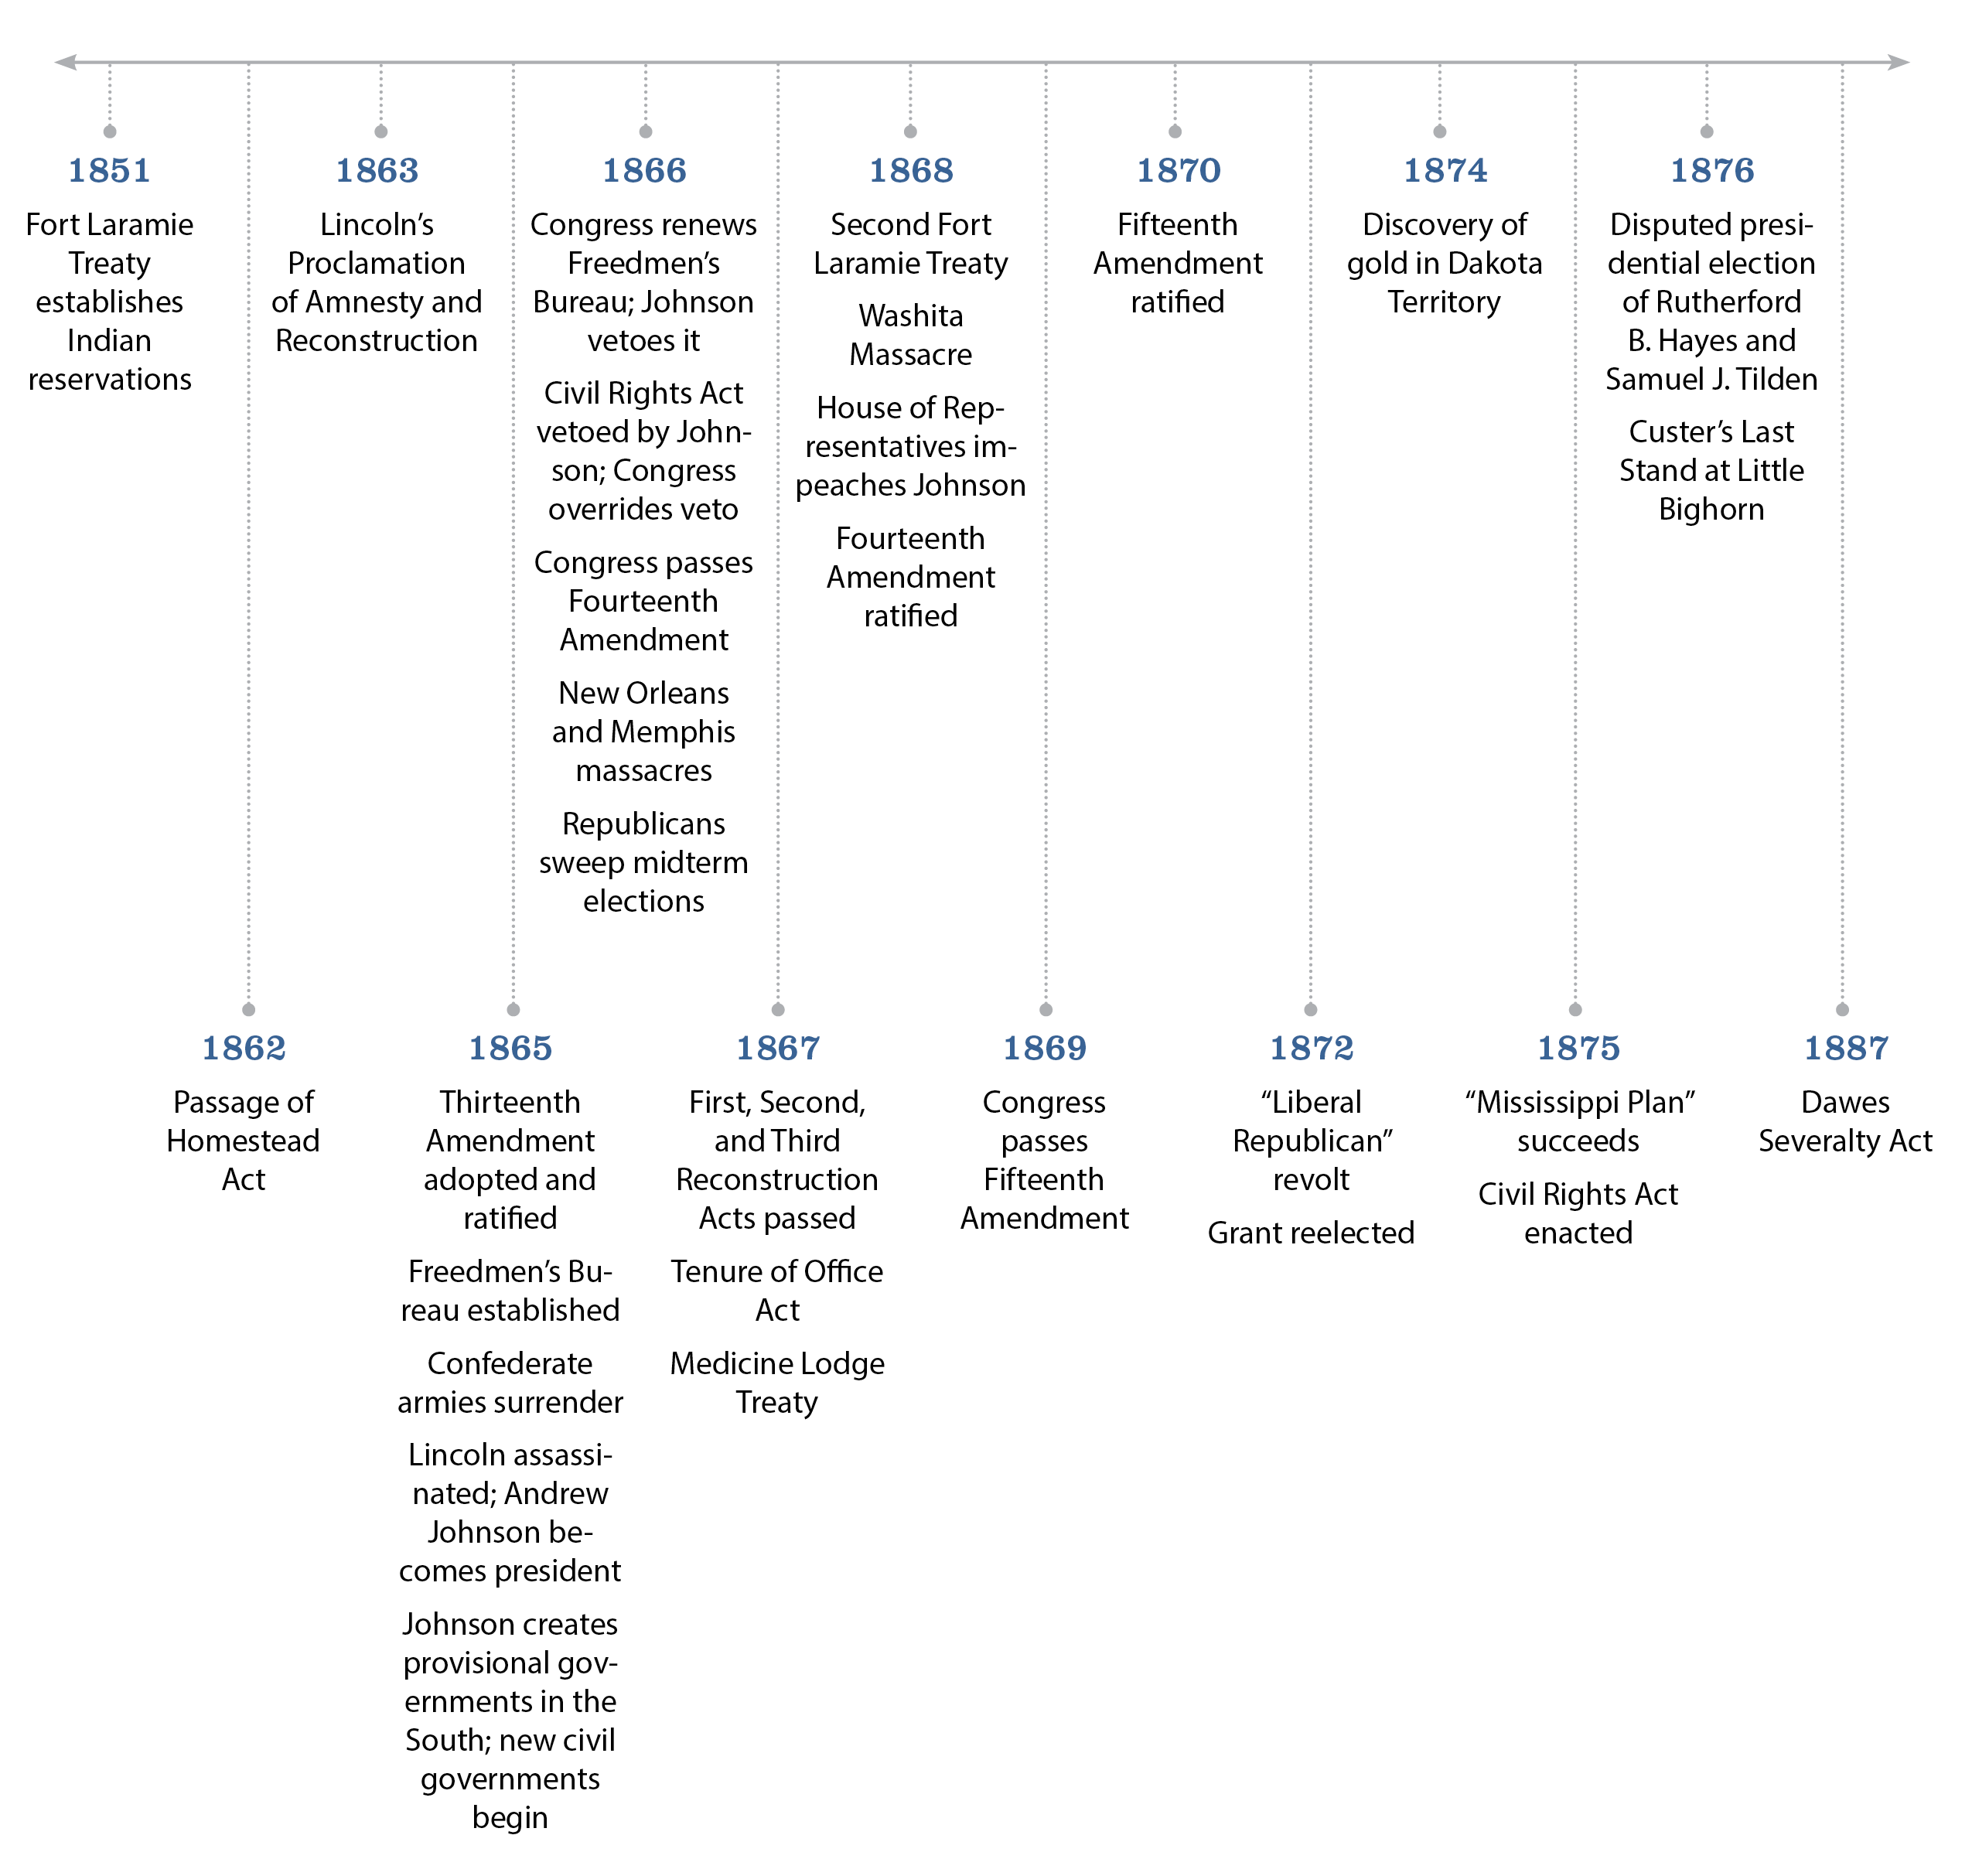

GRAPHIC ORGANIZER
See the Introduction for suggestions on working with graphic organizers. The chapter sections have already been filled in below.
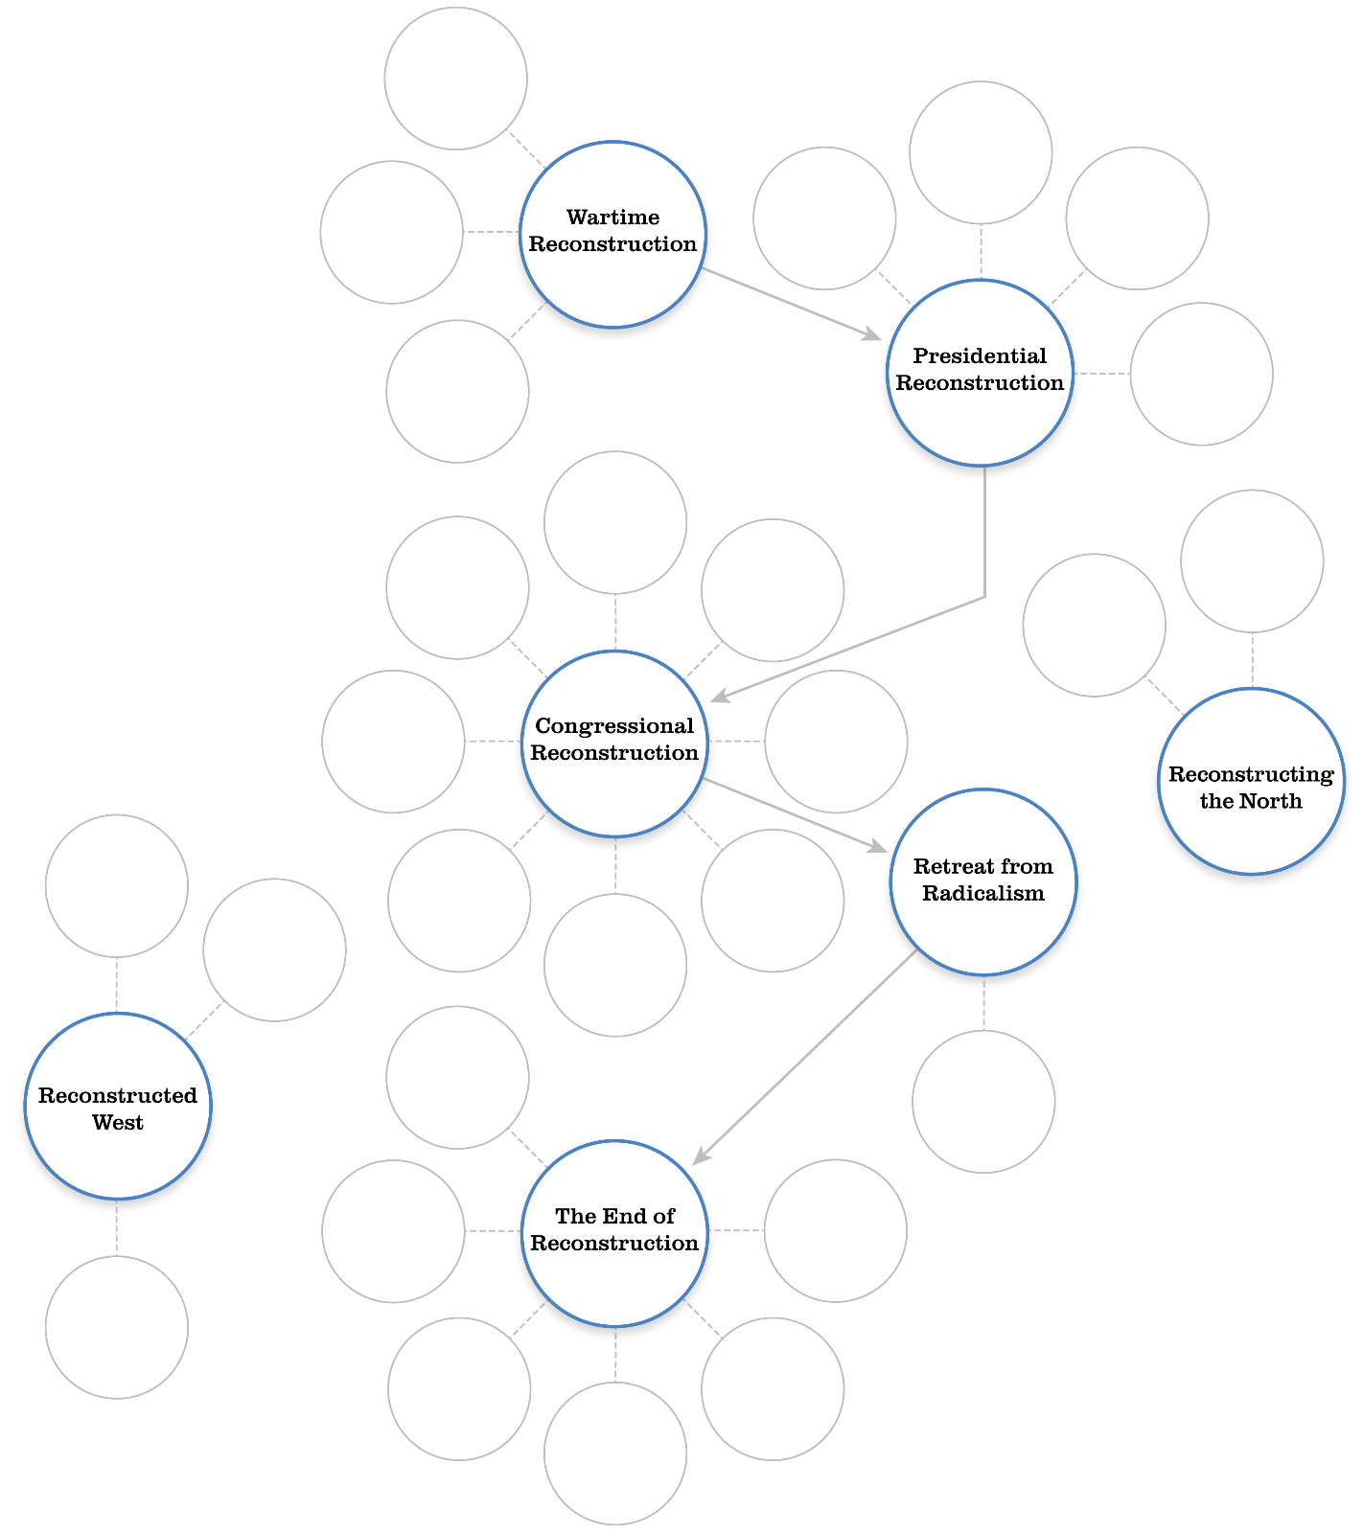

Key Words
Place these key words in the graphic organizer above, focusing on the significance of each in context. (Note: More than one term can be placed inside a circle). Key words fall into one of three categories: people, places, ideas. You may wish to use different colored pens or pencils to indicate each type of term.

Banks, Nathaniel
Black Codes
Dennett, John
Fifteenth Amendment
Fort Laramie
Fourteenth Amendment
Freedmen’s Bureau
Grant, Ulysses S.
Greeley, Horace
Homestead Act
Howard, Oliver Otis
Johnson, Andrew
Liberal Republicans”
Massacre at Wounded Knee, South
Dakota
Overland Trail
Red Cloud
Redemption
Reservations
Sharecropping
Sitting Bull
Stanton, Elizabeth Cady
Ten Percent Plan
Tenure of Office Act
ANSWER KEY
Chapter Questions

- a
- a
- d
- c
- b
- b
- c
- a
- b
- d
- d
- a
- b
- c
- b
- a
- d
- c
- a
- a
- c
- a
- b
- d
- d
- a
- d
- d
- b
- c
- c
- a
- a

Suggested timeline annotations
