Instructor Syllabus Guide

Welcome to Oxford Learning Link Direct! To help you get started with Oxford Learning Link Direct, we’ve provided language for you to copy and incorporate into your syllabus.

Digital Material for Your Text

This course requires access to the digital resources that accompany your Oxford text. Your will access this material from within our school’s learning management system, but they will require activation.

Follow these three simple steps to activate your access to the Oxford digital course materials:

Step 1: Navigate
- First, login to your institution’s learning management system (LMS) and access your course.
Step 2: Activate Access
- The Oxford University Press resources will look a lot like the other resources in your course; however, the first time you encounter one that’s protected you’ll be asked to Activate your Access.
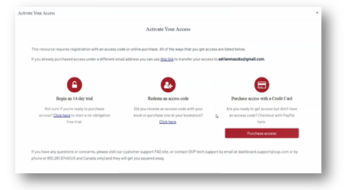
- When prompted to activate your access, you will have three options:
- “Redeem an Access Code” - If you select this option, you’ll be prompted to enter the code you received with the purchase of your book or through your bookstore and then hit “Redeem”. You’ll then have access for the duration of time denoted with the code.
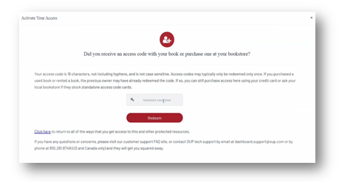
- “Purchase access with a credit card” - If you select this option, you’ll be prompted to checkout with PayPal. You will notice that much of the information has been populated for you already.
    - When you’ve finished entering your information, click “Continue”.
    - You’ll then see a purchase summary screen. Continue on to purchase access through PayPal.
    - Note that PayPal account is NOT required for this process. You may choose to use one or checkout as a guest.

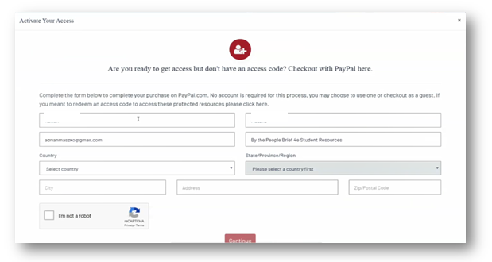
- “Begin a trial” -
  - If you select this option, you will have full access to your Oxford course material for the duration of the trial length specified on the screen. After the completion of the trial period, you will be prompted to redeem an access code or purchase access in order to continue accessing protected content.
    - Oxford will automatically count down the days of your free trial
    - All of your work during the trial period will be saved!
Step 3: Use
Return to your course in your institution’s LMS; then, try opening the same resource that had been locked before. Notice that it’s no longer locked!

Technical Support
If you run into any issues registering for, accessing, or working with the Oxford materials, please contact the Oxford University Press Support Team at:
- Website: https://oup.softwareassist.com/
- Email: LearningLinkDirect.Support@oup.com
- Phone: 855-281-8749

I will not accept technical difficulties with Oxford content as an excuse for missed work unless you provide a support case number as evidence that you have reached out to Oxford’s Digital Support team for assistance.

