Chapter 4 Handouts

NAME: __________________________________

Think of BOTH of your Sociocultural Membership Identity & Personal Identity:

WHO AM I? I am . . .

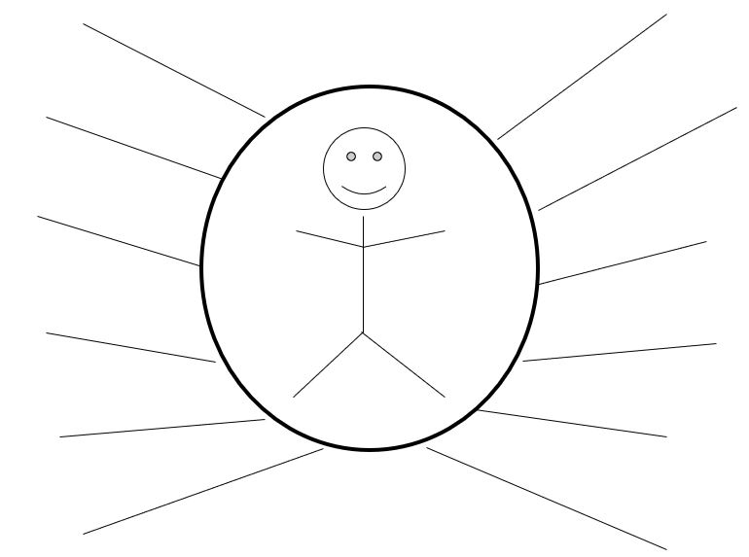

NAME: __________________________________

WHO AM I? Identity Dialogue

1. In reviewing the figure, which one personal identity is the most important to you? WHY??
2. In reviewing the figure, which one sociocultural membership or relational role identity is the most important to you? If you did not list any, think of one here & answer. WHY??
3. With all the 12 self-description labels named on the Figure, which one identity description are you most proud of? Why??
4. Which one identity are you least comfortable with? Why??
5. Think of how a particular self-description label (on the Figure) shaped how others form first impressions of you. How did others perceive you based on this label or their initial impressions? How did that make you feel?
6. If someone wanted to find out more about who you are, how should they approach you? How should they begin? What are the best ways to get to know you?
(continue on next page if needed)

Instructions: After answering the questions, please pair up with a partner, and feel free to share whatever you are comfortable in sharing and keep private whatever you are not comfortable in revealing. Try to listen for both similarities and differences in your identity dialogue. What is one insight you have learned by talking to your partner?

First-Person Stories: What’s in a Name?

First Story: I have a brother-in-law from Italy, whose name is Maurizio. In his first few years of being in the United States, he always used to introduce himself as Maurice, thinking that it was easier for other people to pronounce. Over time, my family became accustomed to calling him Maurice. However, a few more years passed, and my brother-in-law had second thoughts about his name. He really wanted to change Maurice back to his full Italian name, Maurizio. He wants people to respect his Italian heritage. Unfortunately, he is having no luck. Most of his friends and family have learned to call him Maurice and are too used to the habit. He feels frustrated but he has no idea what to do.

Second Story: Maurizio’s predicament really resonated with me. My first name is Marietta and I’ve never introduced myself as “Mary” or “Mari” because it just sounds so ordinary. I do not identify with the name “Mary” at all because it's not me. However, time and time again, people always try to shorten my name even if I've clearly introduced myself as “Marietta.” They might see it as trying to enter an informal level of conversation with me, but honestly, I like my full name and prefer the whole thing. I have a strong identification with my name—Marietta. I like the sound “Marietta,” and I like to feel unique, like a real individual. It’s really annoying when people whom I don’t really know try to shorten my name all of the time, because it feels like they are rejecting my uniqueness. I think this feeling of frustration could be a minor version of what my brother-in-law, Maurizio, has gone through. When people shorten my name to Mary, it feels as if they have erased my unique identity! It feels like they don’t really listen carefully and they really don't care about the first thing that matters to you the most—i.e., your true name.

NAME:_____________________________

Interactive Probes for “What’s in a Name?”
(Ask yourself and probe your classmates’ reactions)

1. To what extent can you relate to Maurizio’s and Marietta’s stories?
2. Does your name has special meaning to you? What does it mean? Do you like or not like your name? Why?
3. Do you know the story and history behind your name—i.e., who named you, why did they name you this special way?
4. Do your teachers or friends have a hard time pronouncing your name? Do you have a middle name? What is it? If your name has some cultural significance, please share that with a classmate.
5. If you could change your name to anything else or if you could have a foreign name, what would that be? Why?
6. Do you have any advice for Maurizio and Marietta in terms of how to get people to call them by their real names?
(continue on next page if needed)

