**Codebook for James Bond movie data**



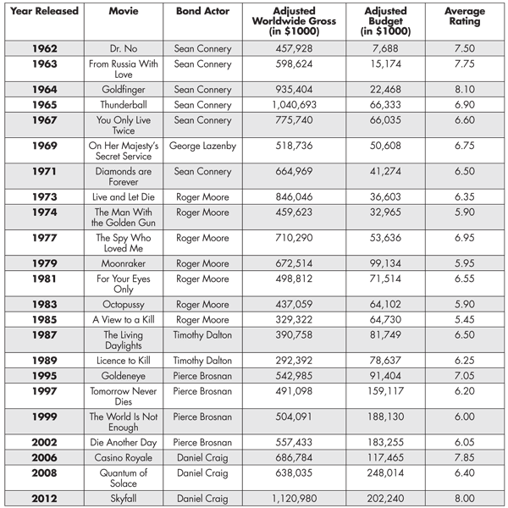

**Reference**

http://chance.amstat.org/2014/04/james-bond/