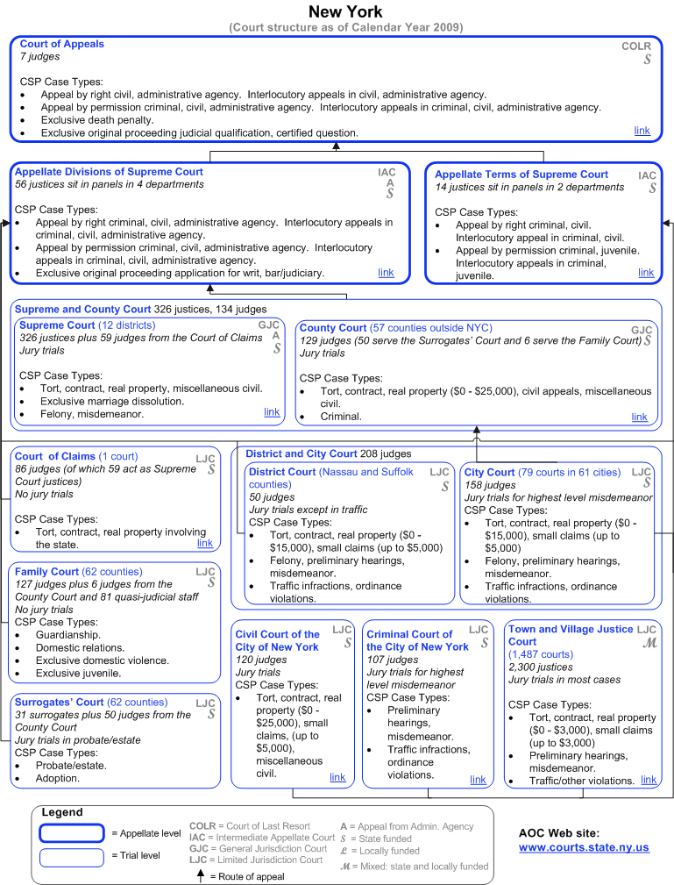

Source: http://www.courtstatistics.org/Other-Pages/State_Court_Structure_Charts/New-York.aspx

