5
GLOBAL AND REGIONAL GOVERNANCE

COVID-19 and Global Public Goods

Public goods have tended to be underprovided by the market due to their two enduring qualities of being non-rival, and non-exclusive goods and services (Moon, Rottingen, Frenk, 2017). These two qualities allow for the free rider dilemma, where individuals or entities can enjoy the goods without contributing to their supply (Samuelson, 1954). Traditionally, governments fill the role of providing these goods by taxing domestic citizens, and then using that money to provide public necessities such as roads, policing, and maintaining national parks. In some societies this includes public health services. Taxes may help to override the free rider problem, as everyone has to pay their fair share to enjoy the good (Brown, Susskind, 2020).
Global public goods(GPGs) share the same qualities as public goods but differ in the sense that they are not geographically confined and are truly transnational because they do not “stop” at borders. Global public goods are even more difficult to maintain than public goods because there is no global government or entity which has the power to “tax” nation-states in order to supply the good. State sovereignty creates a situation where free riding is easy and common. The idea of state sovereignty emerged from the treaties that made-up the Peace of Westphalia in 1648. States are sovereign and autonomous and other states are forbidden to intervene legally in the domestic affairs of another state. So, without states agreeing to collective action and the sharing of sovereignty, how is the global community able to effectively respond to truly transnational issues such as climate change, refugees, terrorism and now the global pandemic?
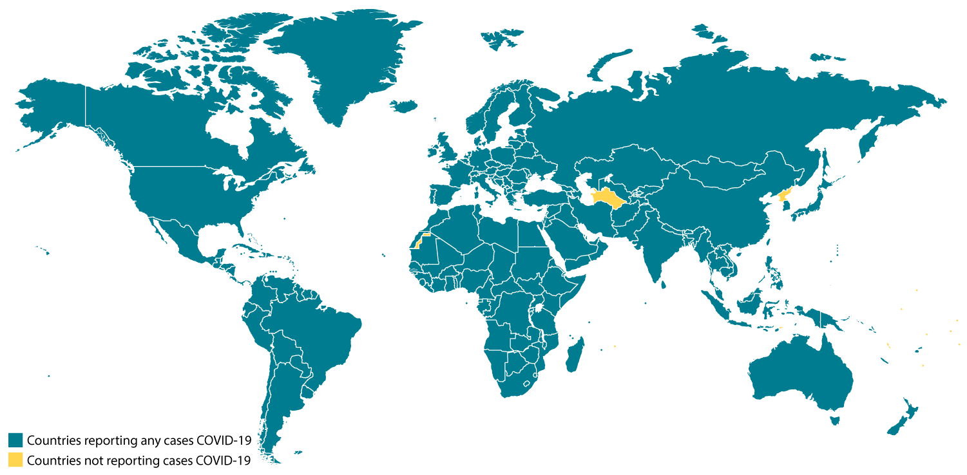
The COVID-19 pandemic is a global crisis as it has affected nearly every country on earth (see image 1.1)(CDC 2020). It should be viewed globally in a similar light to terrorism and climate change. Efforts at mitigating or responding with effective public policy is the global public solution we are all seeking to secure. Gordon Brown, the former British PM (2007-2010), and Daniel Susskind, a fellow at Oxford University, highlight how “the response to the COVID-19 pandemic makes clear how difficult it is to efficiently supply GPGs. In the absence of sufficient cooperation, the international community has failed adequately to provide many of the GPGs associated with controlling this infectious disease” (Brown, Susskind, 2020). Gordon and Susskind argue that tackling this global problem requires global solutions. To highlight their point, they argue that there is a “weakest-link” problem in regard to some GPGs. The “weakest-link” is defined as the amount of public good supplied depends on the smallest contribution made from the weakest actor or provider . In the case of the current or any pandemic, “so long there is a single country that fails to control the disease within its own borders, it’s possible the virus could spread beyond the borders and around the world” (Brown, Susskind, 2020). Thus, even if COVID-19 becomes controlled within the wealthier developed countries of the North, as long as there are outbreaks in the Global South there will be “weak-links” accompanied with major shocks within the global supply chain. Brown and Susskind are attempting to highlight that there is economic incentive for all nation-states to define these transnational issues as a global issue requiring collective global responses rather only considering narrow and potentially ineffectual domestic responses. The global economy is truly interdependent and autarky or self-reliance is really not an option for nation-states who seek stability and prosperity. The same can be said for any effort aimed at responding to truly global problems. One nation-state’s policies will not effectively respond to these challenges.
A significant number of global leaders representing over 100 public and private actors from around the world presented a letter to the leaders of the G20 member states urging a collective response to COVID. The letter is an economic call to action asking for an immediate 8 billion dollars for WHO and vaccine funding, a further 35 billion which will be required to support poorer populations, and an additional 500 to 600 billion dollar fund created through the IMF among many other suggestions (Brown, 2020). They argue these drastic economic measures are needed to keep this global recession from becoming a global depression. It has been signed by 189 world leaders including heads of state, ministers of foreign affairs, health experts, and heads of many prominent NGO’s. Those who signed this document are pushing for multilateral efforts and a strengthening of the global institutions charged with responding to health and human security issues. They urge all leaders to loosen the constraints-real or imagined-imposed by the traditions and practices of national sovereignty. In a time of heightened nationalism, growing isolationism, and a populist anti-government movement spreading across the world, maybe it will take a global pandemic to reinvigorate the idea that global problems require global responses. Moreover, it might alert all citizens to the need to create a global system of innovative institutions that might manage these challenges.

Written by Daniel Rainey with Steven L. Lamy

Discussion Questions

- What is a global public good? What are some examples beyond a collective response to the COVID pandemic?
- How does the principle of sovereignty interfere in our efforts to respond collectively to events and issues that threaten global well-being?
- What is the weakest-link problem? Would this help us understand the slow pace of climate change action?
- Could these situations prompt world leader to reform existing global institutions?
- How might the member states reform WHO so it is more effective in responding to future global health crises?

