7
HUMAN RIGHTS AND HUMAN SECURITY

The Summer of 2020: From Local to Global Social Justice

On May 25, 2020 the world watched in horror as two videos emerged of George Floyd, a black man, being choked by a white police officer, Derek Chauvin, for seven minutes and forty-six seconds, for allegedly using counterfeit money. Three other police officers watched as Floyd repeatedly begged for his life screaming “I can’t breathe”, which proved futile as he later died at a medical center. This terrible act of injustice being caught on video camera, re-ignited the Black Lives Matter Movement in the United States, as Floyd seemed like just the most recent in a never-ending line of young black men and women to be killed unjustly by the police. Protests and riots broke out across the country calling for deep structural change, and sometimes defunding, of America’s police forces. For the Black Lives Matter movement, the mistreatment of young black men and women at the hands of police is representative of a much larger problem in America today: systemic or structural racism.
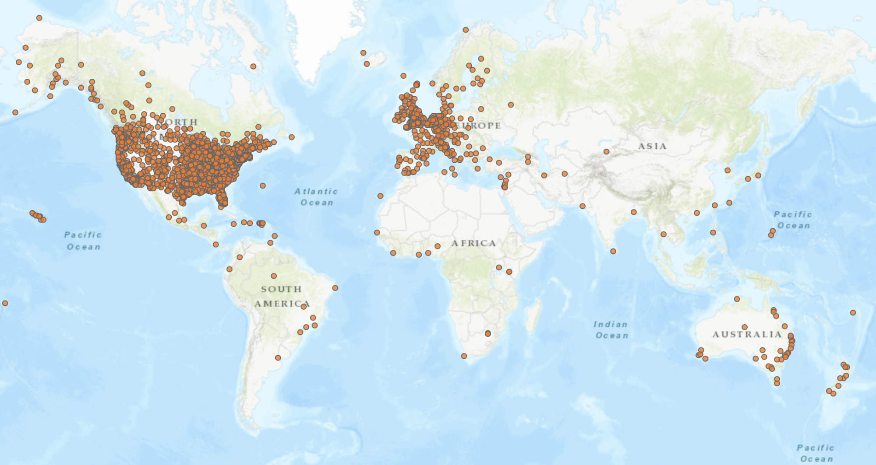
While the protests started in America, Black Lives Matter has become a global rallying cry as image 1.1 highlights the 4,140 cities or towns that have held anti-racist protests and gatherings in support of George Floyd and the Black Lives Matter Movement. Protests have occurred in Rio, Tokyo, Nigeria, Kazakhstan, and many other places.
Image 1.1 created by Creosote Maps and published by Bloomberg News
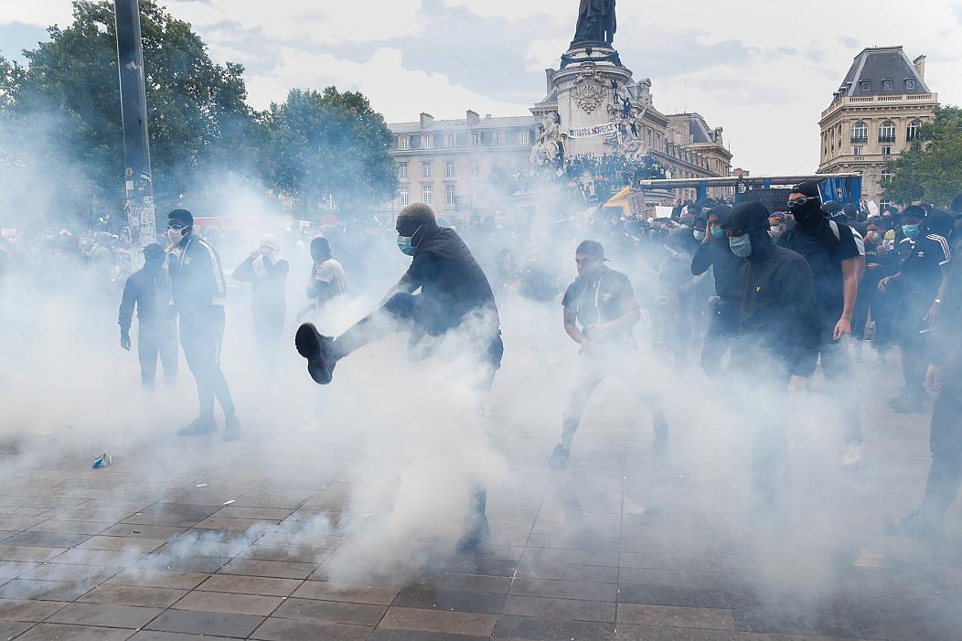
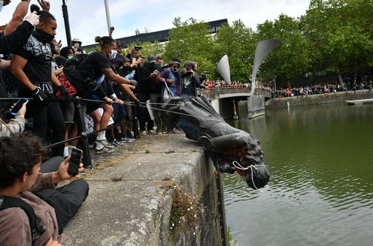
Initially, global protests began in solidarity with those protesting in America, but quickly shifted towards highlighting racism in their own country. In Brussels, protesters carried signs challenging its colonial history and current inequalities, as a statue of King Leopold II, the Belgian ruler whose colonial aspirations and economic exploitation led to the deaths of millions of Congolese people, had the flag of the Democratic Republic of Congo positioned above it (Vox). Thousands took part in a protest in Paris, organized in support of Adama Traore, a young black man who was killed in police custody in 2016 (EuroNews). Image 1.2 shows a clash between protestors and police in Paris on June 13, 2020. In Bristol England, protestors brought down a statue of a 17th century slave trader, Edward Colston, and subsequently tossed it into a river (see image 1.3) (Forbes).
Image 1.3 Ben Birchall for AP Photo
Image 1.2 Thibault Camus for AP Photo

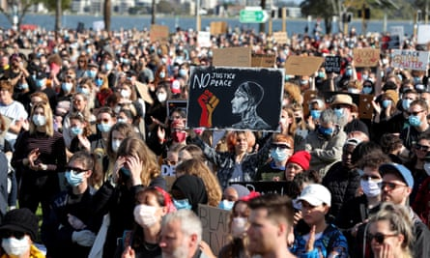
Protests were not restricted to just Europe and North America. In Tokyo, organizers said more than 3,000 people marched through the streets with the purpose about introducing conversations about race in Japan (The Japan Times). In Sydney, Australia, CNN estimates that 10,000 people gathered to protest about black deaths in the custody of Australian Police (See Image 1.4). Protestors specifically called for justice for David Dungay, an Aboriginal man who died in a Sydney prison in 2015. Like George Floyd, Dungay's family say his last words were, "I can't breathe."
Image 1.4 Richard Wainwright from EPA

While the Black Lives Matter Movement began in the United States it has become a global rallying cry to end, or at least begin to solve, systemic racism. The idea that the dominant economic and political system and the institutions that maintain that system are inherently racist-favoring one race over the others and encouraging and defending the exploitation of races to enhance the power of the dominant race. Several countries in the Global North who have had a history of imperialism and racism. The old imperialism created the colonial empires of France, Britain, Germany, the Netherlands and Belgium. The white settlers from Britain in Australia ruthlessly overwhelmed the indigenous Aboriginal communities and the Dutch and British exploited and brutalized the various tribal communities in South Africa. Their legacy was the creation of a racist apartheid system that physically separated the races and assigned all the political and economic power to the minority whites. Not surprisingly, these countries have experienced large protests and significant support for the global social justice movement . The killing of George Floyd may have sparked something larger than a global movement for police reform, it may be a new global civil rights movement. Before all of these large powers can look outward on the global stage as protectors of human rights, as interveners in humanitarian crisis, they first must look inward and make sure that they are supporting human rights domestically.

Written by Daniel Rainey and Steven L. Lamy

Discussion Questions

- What is structural racism and how is this a global issue?

- This case illustrates the importance of social media and its ability to spread ideas around the world. Can you identify other social justice issues that spread around the globe like this one?

- Review the theories presented in Chapter 3. Which of these theories are more concerned about social justice issues within nation-states and globally?

- Are there examples of domestic social justice policies that seem to be working that other countries might consider when addressing their own social justice problems?

- What is the position of the UN and its agencies in this issue area? How are those agencies addressing global social justice issues?

