Chapter 3: The Byzantine Empire, c. 500-1000

Test Bank

Type: multiple choice question
Title: Chapter 3 - Question 1
1) Immediately after the disintegration of the Roman Empire, the Byzantine Empire was:
Feedback: Page reference: p. 62
*a. considerably better governed and more prosperous than the states of Western Europe
b. considerably weaker in terms of government and prosperity than the states of Western Europe
c. much the same as Western Europe in terms of government and prosperity
d. stronger than Western Europe in terms of government but poorer in resources

Type: multiple choice question
Title: Chapter 3 - Question 2
2) Byzantium took its religion from Christianity and its culture from Greece, but its governmental structures were largely ________.
Feedback: Page reference: p. 64
a. barbarian
b. pagan
c. Islamic
*d. Roman

Type: multiple choice question
Title: Chapter 3 - Question 3
3) Monophysites were:
Feedback: Page reference: p. 65
a. scholars who tried to understand physics and mathematics
b. missionaries to northern Europe
*c. people who believed that Jesus had a single, divine nature
d. Byzantine bureaucrats who served both the religious and governmental hierarchies

Type: multiple choice question
Title: Chapter 3 - Question 4
4) Iconoclasm means:
Feedback: Page reference: p. 67
*a. smashing of icons
b. the requirement that each church had at least one icon
c. worship of icons
d. creation of icons

Type: multiple choice question
Title: Chapter 3 - Question 5
5) One particularly important practice within Byzantine religion was:
Feedback: Page reference: p. 67
*a. Monasticism
b. private prayer
c. confession of sins
d. public processions

Type: multiple choice question
Title: Chapter 3 - Question 6
6) Which part of the Byzantine Empire served as an important source of grain prior to its capture in the seventh century?
Feedback: Page reference: p. 69
a. Lombardy
b. Syria
*c. Egypt
d. Morocco

Type: multiple choice question
Title: Chapter 3 - Question 7
7) The Byzantine diet centered on:
Feedback: Page reference: p. 69
a. meat and cheese
*b. grain, oil, and wine
c. soup and ale
d. pasta, sauces, and greens

Type: multiple choice question
Title: Chapter 3 - Question 8
8) The disease known as “Justinian’s Plague” or the “first pandemic” may have killed as many as: ____
Feedback: Page reference: p. 69
a. 2,500 people
b. 25,000 people
*c. 25 million people
d. 250 million people

Type: multiple response question
Title: Chapter 3 - Question 9
9) Elite women in Byzantine society could be influential as:
Feedback: Page reference: p. 70
*a. Empresses
*b. Composers of religious texts
c. Bishops
*d. Nuns and abbesses

Type: multiple choice question
Title: Chapter 3 - Question 10
10) Eunuchs were:
Feedback: Page reference: p. 70
*a. castrated men who served in elite households
b. women renowned for their “manly” features
c. men who dressed as women and women who dressed as men
d. male homosexuals

Type: multiple choice question
Title: Chapter 3 - Question 11
11) How did the status of the Byzantine peasantry change between 500 and 1000?
Feedback: Page reference: p. 71
*a. many lost their freedom as social inequality increased
b. many gained their freedom and went to the cities
c. many used the army to increase their social standing and were able to become nobles
d. many became richer than town-dwellers

Type: multiple choice question
Title: Chapter 3 - Question 12
12) Before marrying Justinian, the Empress Theodora was _______.
Feedback: Page reference: p. 76
a. the daughter of the Patriarch of Constantinople.
b. merchant
c. nurse
*d. prostitute

Type: multiple choice question
Title: Chapter 3 - Question 13
13) After Theodora’s death, Justinian:
Feedback: Page reference: p. 77
a. had a heart attack upon hearing the news and died himself three days later
b. went on to greater glory
c. remarried three times
*d. became despondent and had difficulty making decisions

Type: multiple choice question
Title: Chapter 3 - Question 14
14) Basil I and Basil II (“the Bulgar-Slayer”) belong to a dynasty known as:
Feedback: Page reference: p. 80
a. the Heraclians
*b. the Macedonians
c. the Lombards
d. the Avars

Type: multiple choice question
Title: Chapter 3 - Question 15
15) Saints Cyril and Methodius are significant for:
Feedback: Page reference: p. 80
a. their martyrdom in order to save the inhabitants of Constantinople
b. good advice to the Patriarch of Constantinople
c. miracles they performed in preventing defeat by the Islamic Empires
*d. converting the inhabitants of the Balkans to Eastern Orthodox Christianity

Type: multiple response question
Title: Chapter 3 - Question 16
16) Why, according to chronicles, did Vladimir I of Kiev choose Eastern Orthodox Christianity over Islam, Judaism and Roman Catholic Christianity?
Feedback: Page reference: p. 81
*a. He thought Western European churches were drab and uninspiring, unlike Hagia Sophia
*b. He didn’t understand how a chosen people (the Jews) could not have a country of their own
*c. He didn’t like that Islam prohibited the drinking of alcohol
d. He thought that the pope was condescending toward him

Type: multiple choice question
Title: Chapter 3 - Question 17
17) Western Europeans regarded Byzantine culture as:
Feedback: Page reference: p. 82
*a. luxurious and learned
b. primitive and rudimentary
c. too pious
d. insufficiently pious

Type: multiple choice question
Title: Chapter 3 - Question 18
18)
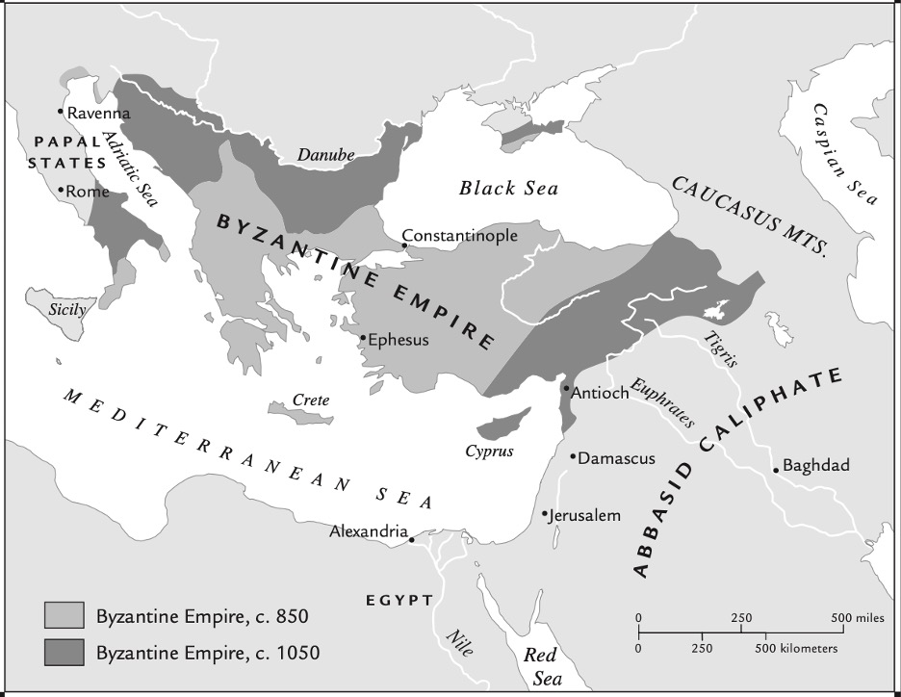

The area controlled by Justinian at the peak of his power was:
Feedback: Page reference: p. 78
*a. larger than the area covered by the Byzantine Empire in c. 1050
b. about the same as the area covered by the Byzantine Empire in c. 1050
c. about the same as the area covered by the Byzantine Empire in c. 850
d. smaller than the area covered by the Byzantine Empire in c. 850

Type: multiple choice question
Title: Chapter 3 - Question 19
19)
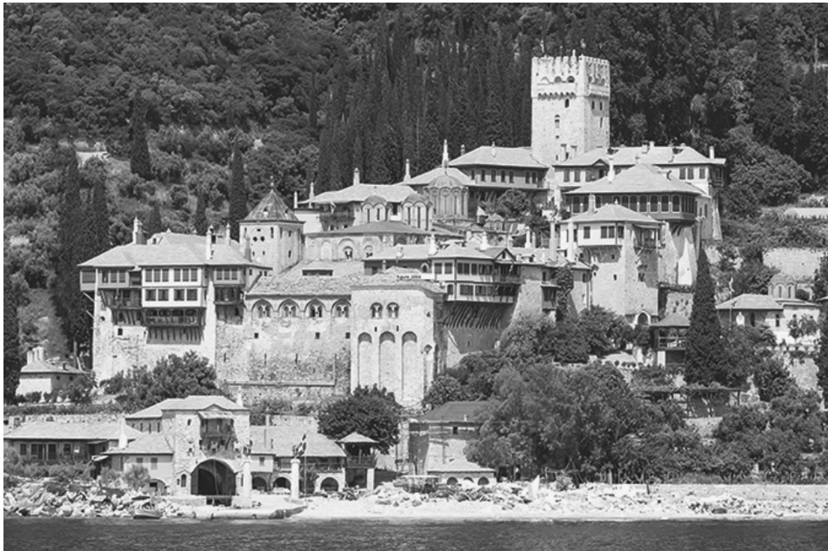

This image depicts one of many monasteries in a holy area known as:
Feedback: Page reference: p. 68
a. Mt. Sinai
b. Mt. Zion
c. Mt. Olympus
*d. Mt. Athos

Type: multiple choice question
Title: Chapter 3 - Question 20
20)
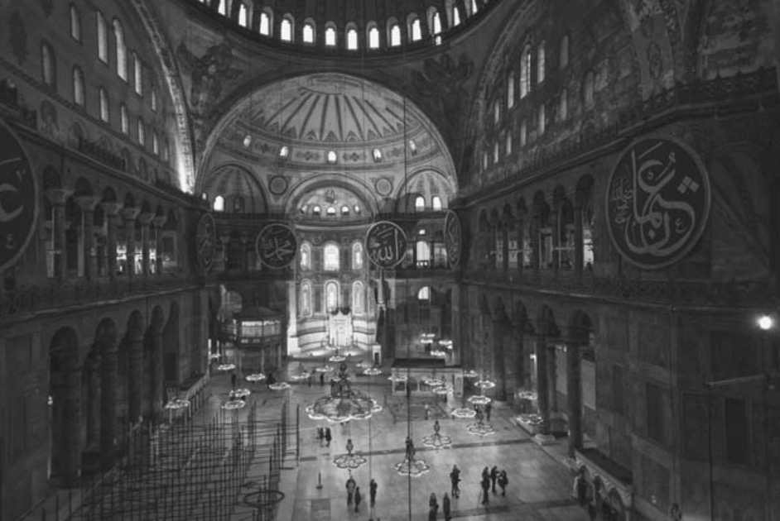

Which important building from Constantinople is depicted here?
Feedback: Page reference: p. 73
a. the emperor’s palace
b. the hippodrome
*c. Hagia Sophia
d. the emperor’s chapel

