Active Learning Exercise 18.1
to accompany
Vertebrate Life, Tenth Edition
Pough • Janis

Would you rather be chased by a crocodile or an alligator?

by Sharon L. Gilman
Coastal Carolina University
sgilman@coastal.edu

Sources:
Allen, V., J Molnar, W Parker, A Pollard, G Nolan, and JR Hutchinson. 2014. Comparative architectural properties of limb muscles in Crocodylidae and Alligatoridae and their relevance to divergent use of asymmetrical gaits in extant Crocodylia. Journal of Anatomy 225:569-582. http://onlinelibrary.wiley.com/doi/10.1111/joa.12245/full

Crocodilian.com.

Iijima, Masaya, Tai Kubo, and Yoshitsugu Kobayashi. 2018. Comparative limb proportions reveal differential locomotor morphofunctions of alligatoroids and crocodyloids. Royal Society Open Science. DOI: 10.1098/rsos.171774 http://rsos.royalsocietypublishing.org/content/5/3/171774

Activity

Crocodiles and the gharial are the only non-mammal vertebrates known to use an asymmetrical bounding and galloping gait on land. Interestingly, despite their obvious morphological similarity, this ability has never been observed in alligators and caimans. Normal walking (or the “high walk” on this link) are symmetrical gaits. Take a look at the photo and descriptions of the “high walk” and the “gallop” here:
http://crocodilian.com/cnhc/cbd-gb3.htm

There are videos of these gaits here: http://crocodilian.com/cnhc/crocsonfilm.html

1. Speculate on this. Why do you think this might be the case? How might you test your ideas?

One way this has been studied is by carefully investigating the limb anatomy of these animals. This is somewhat easier than trying to do behavioral studies because muscles and bones can be dissected from cadavers. Despite looking the same externally, maybe internally the crocodile and alligator limbs are structured differently and therefore have different abilities.

2. The first study you’re going to look at (Iijima et al. 2018) focuses on the limb bone structure of various crocodylians. Longer limbs would tend to facilitate more range of motion, so would you expect relatively shorter or longer limbs in crocs that can gallop?

Comparative anatomy studies are a bit tedious since statistical analyses need to be done on precise measurements, but this Fig. 5 from Iijima et al. 2018, is fairly straightforward.
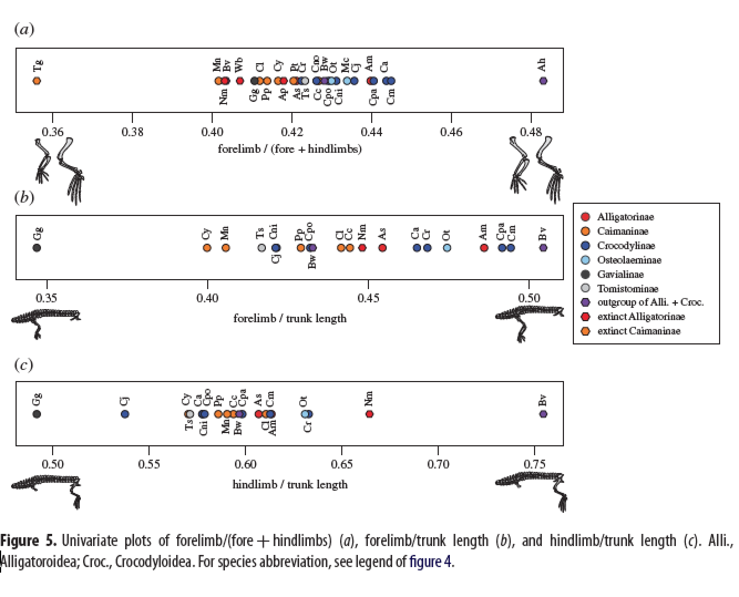
3. The alligatorinae are indicated by red dots, and the crocodylinae by green dots. Which ones tend to have longer limb bones?

The second study you’re looking at focused on the muscles in the limbs (Allen et al, 2014). If you compare muscles with similar properties such as fiber type, tendon components and the size and geometry of the attached bones, the following two characteristics generally determine how the muscles may move a limb:
- PCSA = physiological cross-sectional area determines the force a muscle may generate

- Fascicle length determines the “working range” over which a muscle may contract

A muscle of given mass may have either more, shorter fascicles (high PSCA but shorter working range) or fewer, longer fascicles (lower PSCA, but longer working range)

4. Consider the motion of the bounding gait. What would have to increase in the muscle to accomplish an increase in speed? What would you hypothesize about the differences in muscles in the limbs of an animal that could gallop versus one that could just walk.
Allen et al, 2014 found that the crocodylidae had significantly longer fascicles in most of their pectoral limb muscles and in their ankle plantarflexors. No alligatoridae muscle fascicles were found to be significantly longer than those in the crocodilidae.

They also found that the crocodylidae have significantly more massive pectoral limb muscles (2.7% body mass) than in alligatoridae (2.7% body mass).

5. Remember that the faster asymmetrical gaits require larger arcs of limb motion and more force. Do the data above support this for the crocodiles versus the alligators? Explain.

Generally only smaller crocodilians have been observed bounding, so one could hypothesize that if their relatively long fascicles is what allows this, that difference may diminish as the animals grow. This can be measured via scaling patterns—do the relative lengths of the fascicles change as the animals grow? This is allometric ontogenetic scaling. This study found that they do not, in either the alligators or the crocodiles. So the muscle fascicles remain long in the crocodiles relative to the alligators as they both grow.

6. Given the data shown and described here, which animal, a crocodilidae or an alligatoridae would you prefer to have to outrun, and why?

