Principles of Psychology by Matt Jarvis and Paul Okami

Concept map guide

Introduction
This guide is intended to help you as a student of psychology to develop their skills at concept-mapping, and ultimately their ability to recall information in a meaningful way. Concept maps are graphical tools for organizing and representing knowledge (Novak & Cañas 2008).
You can use concepts maps to present information for lots of different reasons, including:
- To give an overview of a long or complex topic. For example, offering a visual map of how different theories and studies of intelligence fit together or diverge. Key terms in the map may act as cues when revising the topic which are more accessible than reading extensive notes.
- To demonstrate connections within or between different areas. For example, the psychodynamic perspective can be found within several different topics: lifespan development, mental health treatment and anti-social behaviour. A concept map can help clarify and structure the underlying theories, evidence and critique of this perspective.
- To elaborate a basic idea using multiple sources. For example, a simple concept map created from the sleep disorder section in this book could be extended using findings from journal articles or even your own research. In this way, concept maps act as a tool to extend learning and think creatively about psychology.
There is a wealth of empirical support for the use of mapping in enhancing, retaining and improving knowledge (e.g. Schwartz 1988; Vekiri 2002; Davies 2011). As you will explore in Chapter 9 ‘Memory’, information which is processed more deeply tends to produce better recall. This means good concept maps can make excellent study aids in preparation for assessments. Although useful, concept mapping can be a challenging task. Condensing large amounts of information in a clear and meaningful way takes practice!

Creating your own concept maps
The following step-by-step guide is just one way on concept mapping, to illustrate the approaches you might take:
Step one: Consider layout
It is important to give yourself space on the page or screen to create your map. You may feel more comfortable using pens and paper or software designed for concept mapping. Either way, it is a practical task which involves trial and error so flexibility is key- you will want to rearrange the work as you go.
Step two: Identifying core concepts
Concept maps are usually hierarchical, meaning the broadest idea or term is at the top or centre of the map, with more specific terms below or flowing outward. It is helpful to identify the scope and purpose of your map before beginning. Consider listing all the concepts that will be included before trying to arrange them. For example, the concept map for Chapter 9 Memory begins with the core concept of ‘models’, ‘sins’ and reconstruction. However, you might consider more central ideas to be types and theories, which means you can structure the material differently in a way to suit your understanding.
Step three: Making meaningful connections
Another essential feature of concept maps is establishing links between ideas. You can do this in different ways such as labelling relationships, use of colour, number or images to make visual the relationships in your map. For example, the concept map example here uses key terms, arrows and connecting words:
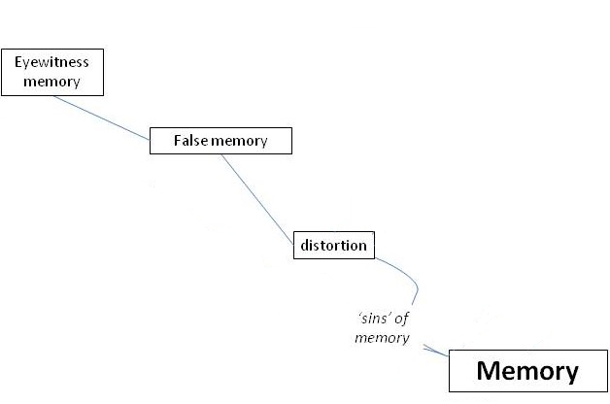

However, you might consider adding more detail such as important dates or theorists. For example:
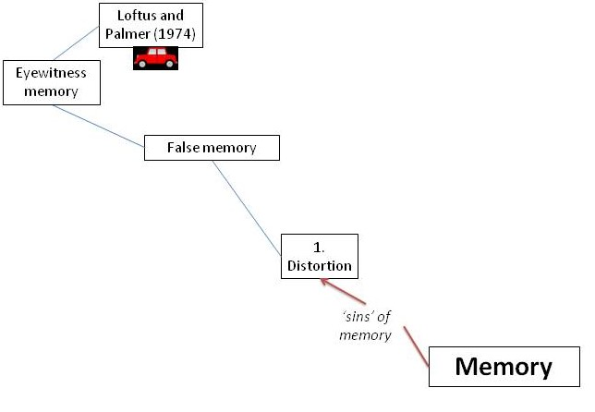
Step four: Review and evaluate
Once you have finished the concept map it is worthwhile looking over the work and asking yourself ‘how did I do?’ Think about whether the information and links are clear, and whether you were comfortable with the method you used. Consider contrasting your concept map to one created by someone else, such as the ones provided for each chapter. Thinking about the similarities and differences in how the same information was presented may get you thinking more creatively.

References
Davies, M. (2011). Concept mapping, mind mapping and argument mapping: what are the differences and do they matter? Higher Education, 62(3), 279-301.
Novak, J. D., & Canas, A. J. (2008). The theory underlying concept maps and how to construct and use them (Technical Report IHMC CmapTools 2006-01 Rev 01-2008). Florida Institute for Human and Machine Cognition.
Schwartz, N. H. (1988). Cognitive processing characteristics of maps: Implications for instruction. Educational and Psychological Research, 8, 93–101.
Vekiri, I. (2002). What is the value of graphical displays in learning? Educational Psychology Review, 14(3), 261–312.

