Data Analysis Problem
by Marianna Pap and József Szeberényi
to accompany
The Cell: A Molecular Approach, Eighth Edition
Geoffrey M. Cooper

20.2 The Enzyme Activity Associated with an Oncogenic
RNA Virus

This Data Analysis Problem does not appear in the textbook.

Source: Hatanaka, M., R. J. Huebner, R. V. Gilden. 1970. DNA polymerase activity associated with RNA tumor viruses. Proc. Nat. Acad. Sci. USA 67: 143–147.

Level of difficulty: Low

Corresponding chapter(s) in the textbook: Chapter 20

Review the following terms before working on the problem: oncogenic RNA viruses, deoxyribonucleosidetriphosphates, [³H]TTP, ether, in vitro enzyme assay, filter precipitation assay, radioactivity measurement

Experiment

Purified samples of an oncogenic RNA virus from viper were analyzed in this experiment. The virus samples were incubated in reaction mixtures containing dATP, dGTP, dCTP, and [³H]TTP, in the absence (●─●) or presence (○─○) of ether. Aliquots of the mixtures taken after the incubation times indicated in the figure were precipitated by ice cold trichloroacetic acid, the precipitates were collected on filters and the radioactivity of the filters was determined.

Figure

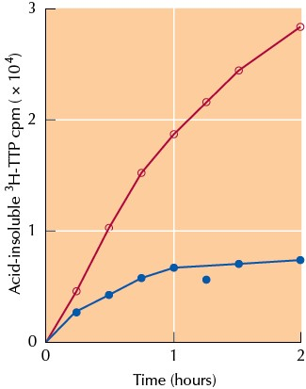

Source: Hatanaka, M., R. J. Huebner, R. V. Gilden. 1970. DNA polymerase activity associated
with RNA tumor viruses. Proc. Nat. Acad. Sci. USA 67: 143–147.

Questions

1. The radioactivity of what material was measured in this experiment?

2. What enzyme’s activity in the virus was identified?

3. Explain the effect of ether.

