Data Analysis Problem
by Marianna Pap and József Szeberényi
to accompany
The Cell: A Molecular Approach, Eighth Edition
Geoffrey M. Cooper

19.4 The Role of Apaf-1 Protein in Hyperosmotic Stress

This Data Analysis Problem does not appear in the textbook.

Source: Saikia, M., R. Jobava, M. Parisien, A. Putman, D. Krokowski, X.-H. Gao, B-J. Gnan, Y. Yuan, E. Jankonsky, Z. Feng, G-F. Hu, M. Pusztai-Carey, M. Gorla, N. B. V. Seput, T. Ran, M. Hatzoglon. 2014. Angiogenin-cleaved tRNA halves interact with cytochrome c, protecting cells from apoptosis during osmotic stress. Mol. Cell. Biol. 34: 2450–2463.

Corresponding chapter(s) in the textbook: Chapter 19

Review the following terms before working on the problem: Apaf-1 protein, cellular stress, osmosis, fibroblast, cell culture, sucrose, Western blot analysis, caspases, translation initiation factors, protein phosphorylation, tubulin

Experiment

The role of Apaf-1 protein in response to cellular stress induced by increased osmotic pressure outside the cells (hyperosmotic stress) was studied in this experiment.
Wild-type mouse embryonic fibroblasts (Apaf-1^{+/+} cells) and homozygous Apaf-1 knock-out fibroblasts (Apaf-1–/– cells) were cultured in hyperosmotic medium (brought up to 600 mOsmol/liter) for the time periods indicated in the figure. Protein extracts were prepared and subjected to Western blot analysis using anti-Apaf-1, anti-caspase-3, anti-eIF2α, and anti-tubulin antibodies, and an antibody specific for the phosphorylated form of eIF2α [labeled eIF2α-P(S51) in the figure].

Figure

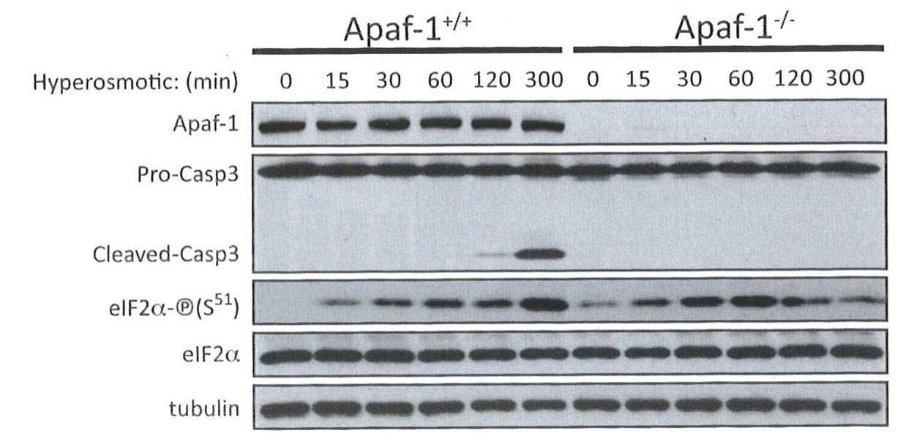
Source: Saikia, M., R. Jobava, M. Parisien, A. Putman, D. Krokowski, X.-H. Gao, B-J. Gnan, Y. Yuan, E. Jankonsky, Z. Feng, G-F. Hu, M. Pusztai-Carey, M. Gorla, N. B. V. Seput, T. Ran, M. Hatzoglon. 2014. Angiogenin-cleaved tRNA halves interact with cytochrome c, protecting cells from apoptosis during osmotic stress. Mol. Cell. Biol. 34: 2450–2463.

Questions

1. What was the goal of using anti-tubulin antibody?

2. How successful was the Apaf-1 gene targeting procedure?

3. Describe the pathway by which caspase-3 is regulated during hyperosmotic stress.

4. How is protein synthesis affected by hyperosmotic stress?

5. What is the biological response of Apaf-1^{+/+} and Apaf-1–/– fibroblasts to hyperosmotic stress?

