Data Analysis Problem
by Marianna Pap and József Szeberényi
to accompany
The Cell: A Molecular Approach, Eighth Edition
Geoffrey M. Cooper

19.3 The Effect of a Metastasis Suppressor Protein on the Response of Cancer Cells to Gamma Irradiation

This Data Analysis Problem does not appear in the textbook.

Source: Whitman, S., X. Wang, R. Shalaby, E. Shtivelman. 2000. Alternatively spliced products CC3 and TC3 have opposing effects on apoptosis. Mol. Cell. Biol. 20: 583–593.

Corresponding chapter(s) in the textbook: Chapter 19 (and 20)

Review the following terms before working on the problem: metastasis, lung carcinoma, stable transfection, plasmid, expression plasmid, cDNA, gamma irradiation, DNA staining, flow cytometry

Experiment

The cellular effects of a metastasis suppressor protein were studied in this experiment. CC3 protein, if expressed in small cell lung carcinoma, inhibits the metastatic spreading of tumor cells. N417 small cell lung cancer cells were stably transfected with an empty plasmid (N417neo), with an expression vector carrying the CC3 cDNA (N417cc3), with an expression vector carrying BCL2 cDNA (N417bcl2), or with both plasmids (N417cc3/bcl2). Cultures of these cell lines were then left untreated (top row of graphs) or treated with gamma irradiation (IR, bottom row). Cells were stained with propidium iodide (a DNA binding dye) and subjected to flow cytometry.

Figure

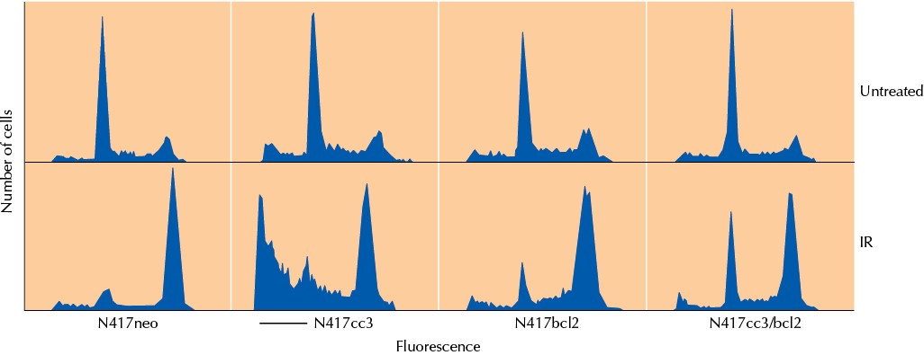

Questions

1. How does irradiation affect the control cell line (N417neo)?

2. What kind of cells are present in the part of the curve indicated by the bar?

3. How does irradiation affect the cell line expressing the CC3 protein (N417cc3)?

4. What is the effect of BCL2 protein in the double-transfectants (N417cc3/bcl2)?

5. What signaling mechanism is used by the CC3 protein to exert its effect?

