Data Analysis Problem
by Marianna Pap and József Szeberényi
to accompany
The Cell: A Molecular Approach, Eighth Edition
Geoffrey M. Cooper

19.2 The Effect of Etoposide on Human Leukemia Cells

This Data Analysis Problem does not appear in the textbook.

Source: Ura, S., H. Nishina, Y. Gotoh, T. Katada. 2007. Activation of the c-Jun N-terminal kinase pathway by MST1 is essential and sufficient for the induction of chromatin condensation during apoptosis. Mol. Cell. Biol. 27: 5517–5522.

Corresponding chapter(s) in the textbook: Chapter 19

Review the following terms before working on the problem: leukemia cells, cell culture, topoisomerases, detergent, centrifugation, ribonuclease (RNase), protease, agarose gel electrophoresis, ethidium bromide staining

Experiment

Cultures of human leukemia cells were treated with etoposide (a topoisomerase inhibitor) for the time periods indicated in the figure. Cells were then incubated with a buffer containing Triton X-100, and chromatin was pelleted by centrifugation. (Note: Triton X-100 is a mild detergent.) The supernatants were treated with ribonuclease (RNase), then with protease, followed by precipitation with ethanol. Precipitates collected by centrifugation were analyzed by agarose gel electrophoresis, and the gel was stained with ethidium bromide (M, size markers).

Figure

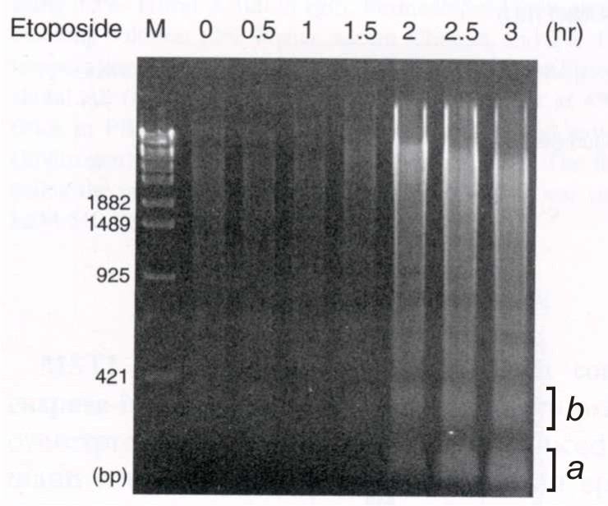
Source: Ura, S., H. Nishina, Y. Gotoh, T. Katada. 2007. Activation of the c-Jun N-terminal kinase pathway by MST1 is essential and sufficient for the induction of chromatin condensation during apoptosis. Mol. Cell. Biol. 27: 5517–5522.

Questions

1. What molecules were analyzed in this experiment?

2. What was the purpose of Triton X-100 treatment?

3. Describe the molecules that appear in bands a and b.

4. Name the type of enzyme that generates the band pattern that appears in samples after 2 hours of etoposide treatment.

5. Describe the effect of etoposide on cells.

