Data Analysis Problem
by Marianna Pap and József Szeberényi
to accompany
The Cell: A Molecular Approach, Eighth Edition
Geoffrey M. Cooper

19.1 The Role of Ras in the Prevention of Apoptosis by Growth Factors

This Data Analysis Problem is also found on page 667 of the textbook.

Source: Yao, R., G. M. Cooper. 1995. Requirement for phosphatidylinositol-3 kinase in the prevention of apoptosis by nerve growth factor. Science 267: 2003–2006.

Level of difficulty: High

Corresponding chapter(s) in the textbook: Chapter 19 (and 17)

Review the following terms before working on the problem: Ras proteins, growth factors, growth factor signaling, dominant negative mutation, cell culture, nerve growth factor (NGF), cell lysate, SDS polyacrylamide gel electrophoresis, extracellular signal-regulated kinase (ERK), diacylglycerol (DAG), epidermal growth factor (EGF), insulin, DNA extraction, agarose gel electrophoresis, Southern blotting, EcoRI restriction endonuclease, ³²P-labeled probe, autoradiography

Experiment

The role of Ras proteins in growth factor signaling was studied in PC12 rat phaeochromocytoma cells. Phaeochromocytoma is a malignant cancer of the adrenal medulla. PC12 cells differentiate into neurons upon treatment with nerve growth factor (NGF), provide an excellent model system to study the signal transduction mechanisms of neuronal differentiation and survival. (A) Wild-type PC12 cells and cells expressing a dominant negative Ras mutant protein [PC12(dnRas)] were incubated without (–) or with (+) NGF for 5 minutes, as indicated in the figure. Cell lysates were fractionated by SDS polyacrylamide gel electrophoresis, and the activity of extracellular signal-regulated kinases (ERKs) was determined by an in-gel kinase assay. In this technique, a target-protein of ERK (myelin basic protein) is polymerized into the SDS polyacrylamide gel. The protein samples are fractionated by electrophoresis. SDS is removed from the gel to renature proteins, and then the gel is soaked in a buffer containing [γ-³²P]ATP. After incubation, excess ATP is removed by washing the gel in nonradioactive buffer. The gel is dried, and autoradiography is performed. Figure A shows the autoradiograph. (B) PC12 and PC12(dnRas) cells were cultured in a serum-free medium in the presence of no additives (–), a phorbol ester (an activator of protein kinase C), epidermal growth factor (EGF), insulin, or NGF. After 24 hours of incubation, cells were collected from the tissue culture dishes. Soluble DNA fragments were extracted, separated by agarose gel electrophoresis, blotted onto a nylon membrane, and hybridized with ³²P-labeled, EcoRI-digested rat genomic DNA as a probe. The figure shows the autoradiograph of the Southern blot.

Figure

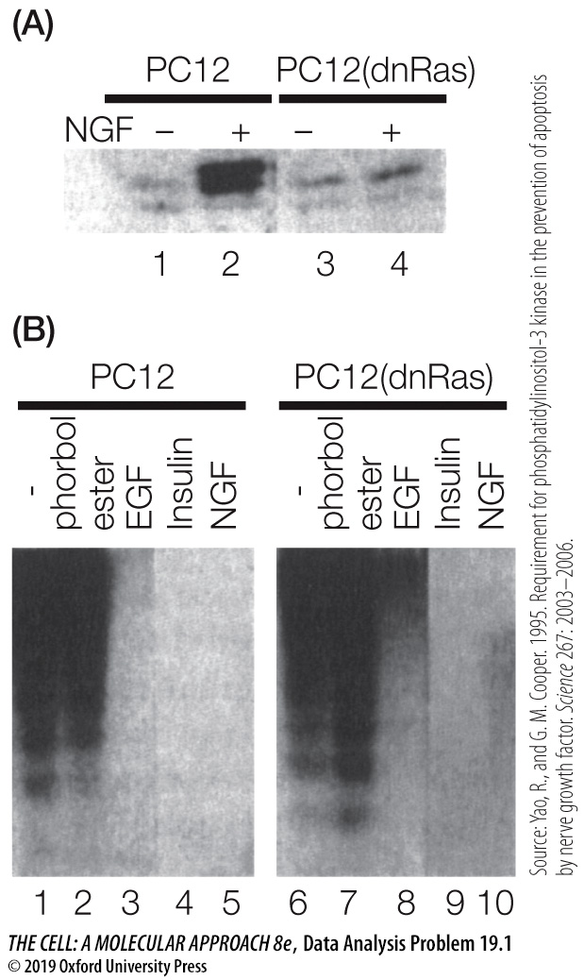

Questions

1. What was the purpose of soaking the gel in the buffer containing radioactive ATP?

2. What is the effect of NGF treatment on ERK enzymes (compare samples 1 and 2 in Figure A)?

3. What is the role of Ras proteins in the effect of NGF on ERK?

4. What effect of serum starvation was studied in this experiment (see samples 1 and 6 in Figure B)?

5. How do growth factors (samples 3–5) affect serum-starved PC12 cells?

6. How does stimulation of the protein kinase C pathway affect serum-starved PC12 cells (compare samples 1 and 2)?

7. What is the role of Ras proteins in the mediation of cellular responses shown in Figure B?

