Data Analysis Problem
by Marianna Pap and József Szeberényi
to accompany
The Cell: A Molecular Approach, Eighth Edition
Geoffrey M. Cooper

18.4 Autoradiographic Tracking of Histone H1 in Cancer Cells

This Data Analysis Problem does not appear in the textbook.

Source: Wu, L. H., L. Kuehl, M. Rechsteiner. 1986. Dynamic behavior of histone H1 microinjected into HeLa cells. J. Cell Biol. 103: 465–474.

Corresponding chapter(s) in the textbook: Chapter 18 (and 6)

Review the following terms before working on the problem: HeLa cells, cell fusion, red blood cell, radioactive labeling, histone H1, cell synchronization, DNA synthesis, autoradiography

Experiment

HeLa cells (a human cervix carcinoma cell line) were cultured in the presence of fluorodeoxyuridine (a DNA synthesis inhibitor) for 36 hours. The inhibitor was washed out with fresh medium, and after a 3 hour incubation, the cells were fused with human red blood cells (RBC) loaded with [³H]histone H1. The cells were further incubated overnight, and then light microscopical autoradiography was performed (scale bar, 20μm).

Figure

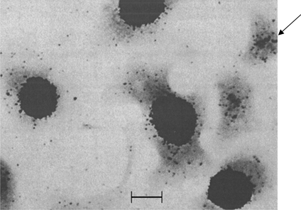
© 1986 Wu, L. H., L. Kuehl, M. Rechsteiner. Originally published in Journal of Cell Biology. https://doi.org/10.1083/jcb.103.2.465

Questions

1. When fused with RBCs, 90% of the HeLa cells were in the same phase of the cell cycle. What was that phase?

2. How did [³H]histone H1 behave in the HeLa cells?

3. Explain why the cell indicated by the arrow in the upper right corner looks different from the others.

4. Why are RBCs particularly suitable for this kind of experiment?

