Data Analysis Problem
by Marianna Pap and József Szeberényi
to accompany
The Cell: A Molecular Approach, Eighth Edition
Geoffrey M. Cooper

18.3 The Effect of Taxol on Fibroblasts

This Data Analysis Problem does not appear in the textbook.

Source: Schiff, P. B., S. B. Horwitz. 1980. Taxol stabilizes microtubules in mouse fibroblast cells. Proc. Nat. Acad, Sci. 77: 1561–1565.

Corresponding chapter(s) in the textbook: Chapter 18

Review the following terms before working on the problem: HeLa cells, fluorescent DNA dye, flow cytometry

Experiment

HeLa cells (a human cervix carcinoma cell line) were cultured under optimal conditions and then left untreated (control) or treated with taxol for the time periods indicated in the graphs. The cells were stained with a fluorescent DNA dye and then subjected to flow cytometric analysis.

Figure

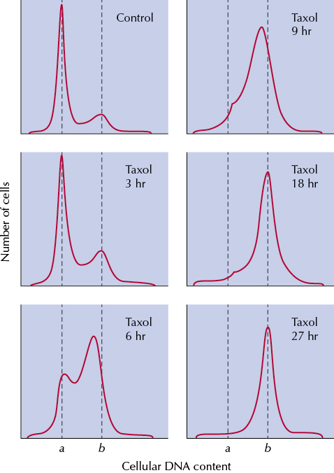

Questions

1. What can be concluded about the DNA content of cells indicated by arrows a and b?

2. What phase of the cell cycle do arrows a and b correspond to?

3. Describe the effect of taxol.

4. What is the effect and the most likely target of taxol?

