Data Analysis Problem
by Marianna Pap and József Szeberényi
to accompany
The Cell: A Molecular Approach, Eighth Edition
Geoffrey M. Cooper

18.2 Regulation of the Nuclear Lamina by Protein Phosphorylation

This Data Analysis Problem is also found on page 634 of the textbook.

Source: Peter, M., J. Nakagawa, M. Dorée, J. C. Labbé, E. A. Nigg. 1990. In vitro disassembly of the nuclear lamina and M phase-specific phosphorylation of lamins by cdc2 kinase. Cell 61: 591–602.

Level of difficulty: Medium

Corresponding chapter(s) in the textbook: Chapter 18

Review the following terms before working on the problem: nuclear fraction, nuclear lamina, protein kinases, protein phosphorylation, ATP, detergents, fixation, formaldehyde, indirect immunofluorescence microscopy, lamin proteins, phase contrast microscopy

Experiment

Nuclei isolated from embryonic chicken cells were incubated for the time periods indicated in the figure with highly purified cdc2 kinase (now known as cdk1) (a–d), in buffer without kinase (e, f) as the control, or with protein kinase C (an unrelated protein kinase) (g, h). Incubations were carried out in the presence of ATP. Afterwards, Triton X-100 (a mild detergent) was added to the nuclei, and nuclei were fixed and stained by immunofluorescence microscopy using an anti-lamin B antibody. Phase contrast micrographs corresponding to a, c, e, and g are shown in b, d, f, and h, respectively. Scale bar = 10 μm.

Figure

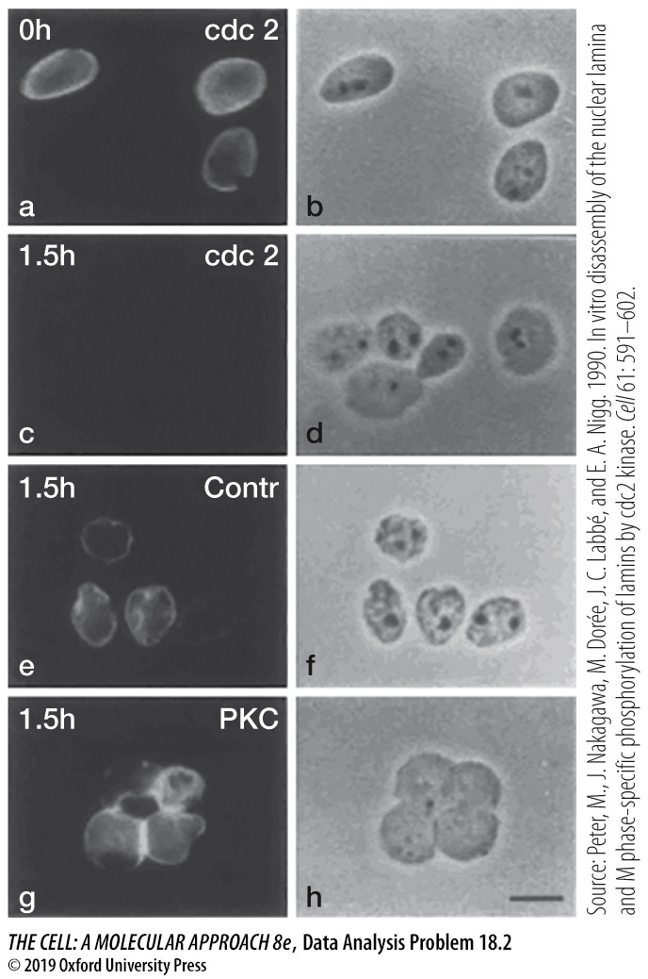

Questions

1. What was the role of ATP in the incubation mixtures?

2. What was the purpose of the Triton X-100 treatment?

3. Describe the effect of cdc2 kinase and protein kinase C on the nuclei.

4. Considering the function of cdc2, what is the physiological significance of the phenomenon revealed in this experiment?

