Data Analysis Problem
by Marianna Pap and József Szeberényi
to accompany
The Cell: A Molecular Approach, Eighth Edition
Geoffrey M. Cooper

17.1 The Effect of Cholera Toxin on the Transcription
Factor CREB

This Data Analysis Problem is also found on page 600 of the textbook.

Source: Li, Y., W. Kin, X. Wong, W. Zhu, Y. Huang, G. Yan. 2007. Cholera toxin induces malignant glioma cell differentiation via the PKA/CREB pathway. Proc. Nat. Acad. Sci. USA 104: 13438–13443.

Level of difficulty: Medium

Corresponding chapter(s) in the textbook: Chapter 17

Review the following terms before working on the problem: cell culture, glioma, heterotrimer G proteins, cholera toxin, nuclear protein extracts, Western blotting, cAMP response element binding protein (CREB)

Experiment

Cultures of rat glioma cells were treated with cholera toxin for the time periods indicated in the figure. (Note: Cholera toxin inhibits the GTPase activity of the G_{s} protein.) Nuclear protein extracts were prepared and subjected to Western blot analysis using anti-CREB and anti-phospho-CREB antibodies. The anti-CREB antibody recognizes all CREB proteins, no matter whether posttranslationally modified or not; the anti-phospho-CREB antibody used in this study binds to CREB molecules only if they are phosphorylated on Ser133.

Figure

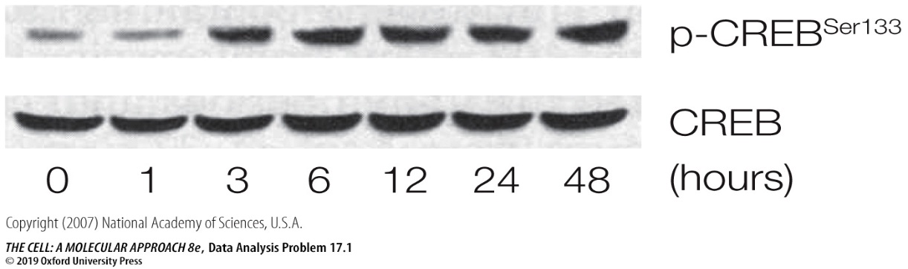

Questions

1. How does cholera toxin affect CREB expression and CREB phosphorylation?

2. Describe the chain of signaling events that lead to this effect of cholera toxin.

3. Does phosphorylation affect the nuclear localization of CREB?

