Data Analysis Problem
by Marianna Pap and József Szeberényi
to accompany
The Cell: A Molecular Approach, Eighth Edition
Geoffrey M. Cooper

16.5 Analysis of Cell Adhesion Structures in Cultured Cells

This Data Analysis Problem does not appear in the textbook.

Source: Zaidel-Bar, R., M. Cohen, L. Addadi, B. Geiger. 2004. Hierarchical assembly of cell-matrix adhesion complexes. Biochem. Soc. Transactions 32: 416–420.

Corresponding chapter(s) in the textbook: Chapter 16 (and 17)

Review the following terms before working on the problem: extracellular matrix, cell-matrix connections, endothelium, fibroblasts, fluorescent dye, actin filaments, immunofluorescence microscopy, tyrosine phosphorylation, vinculin

Experiment

Cell-matrix adhesion structures were studied in this experiment. Pig endothelial cells (a) and rat embryonic fibroblasts (b) were cultured on glass coverslips. The cells were fixed and stained with phalloidin labeled with a green fluorescent dye. (Note: Phalloidin is a peptide that binds specifically to actin filaments.) Immunofluorescent staining using an anti-phosphotyrosine antibody (a; red) or an anti-vinculin antibody (b; red) was also performed. The samples were visualized in a fluorescence microscope (scale bar, 5 μm; insets enlarged three-fold).

Figure

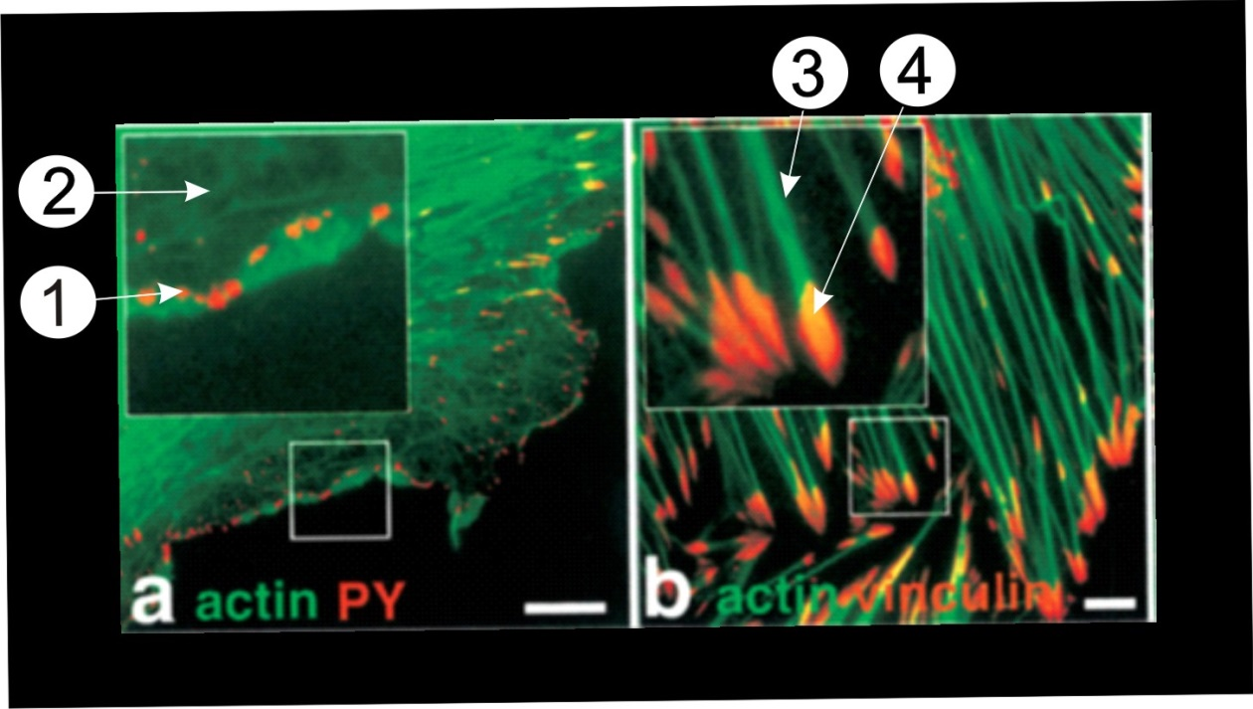
Source: Zaidel-Bar, R., M. Cohen, L. Addadi, B. Geiger. 2004. Hierarchical assembly of cell-matrix adhesion complexes. Biochem. Soc. Transactions 32: 416–420.

Questions

1. Name the structures indicated by numbers in the micrographs.

2. Name the enzymes responsible for the immunofluorescent staining of structure 1.

