Data Analysis Problem
by Marianna Pap and József Szeberényi
to accompany
The Cell: A Molecular Approach, Eighth Edition
Geoffrey M. Cooper

16.4 A Cell Culture Model to Analyze Collagen Synthesis

This Data Analysis Problem does not appear in the textbook.

Source: Chan, D., S. R. Lamandé, D. L. McQuillan, J. F. Bateman. 1997. In vitro expression analysis of collagen biosynthesis and assembly. J. Biochem. Biophys. Methods 36: 11–29.

Corresponding chapter(s) in the textbook: Chapter 16 (and 12)

Review the following terms before working on the problem: type I collagen, fibroblast, cell culture, recombinant virus, bacteriophage, RNA polymerase, promoter, transient transfection, expression plasmid, cDNA, [³H]proline labeling, cell lysate, pepsin, SDS-polyacrylamide gel electrophoresis, autoradiography

Experiment

Collagen biosynthesis was studied in mutant mouse fibroblast cultures in this experiment. Cell cultures were first infected with a recombinant vaccinia virus expressing the T7 bacteriophage RNA polymerase. (T7 polymerase provides very high RNA expression from its cognant promoter.) Some of the cultures (samples 7–12) were then transiently transfected with an expression plasmid containing the full-length cDNA of a type I collagen (collagen α1) transcribed from the T7 promoter. Other cultures were left untreated (samples 1–6). The cells were labeled with [³H]proline. Cell lysates (C) and culture medium samples (M) were prepared. Some of them were treated with pepsin (a protease that digests the non-helical regions only; samples 5–6 and 11–12), others with dithiothreitol (DTT, a reducing agent, samples 1, 3, 7, and 9). All samples were subjected to SDS-polyacrylamide gel electrophoresis followed by autoradiography.

Figure

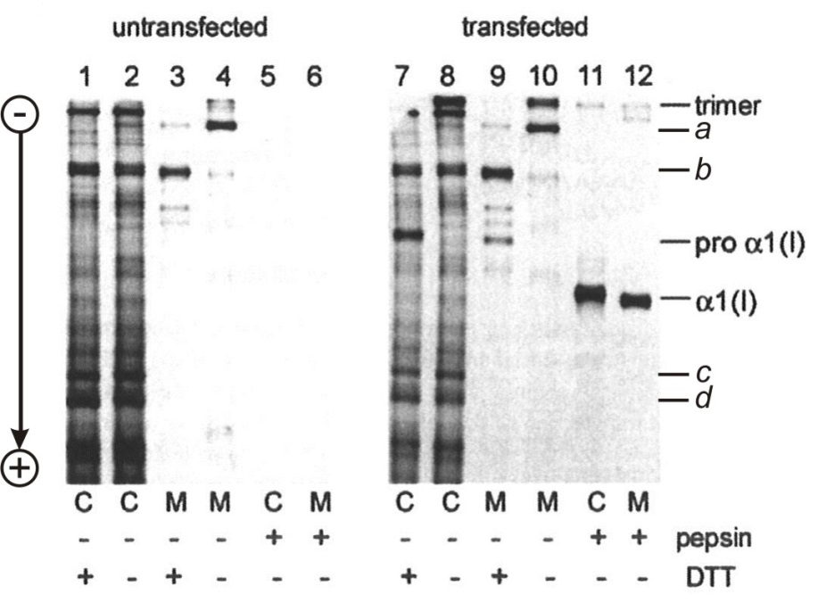
Source: Chan, D., S. R. Lamandé, D. L. McQuillan, J. F. Bateman. 1997. In vitro expression analysis of collagen biosynthesis and assembly. J. Biochem. Biophys. Methods 36: 11–29.

Questions

1. Which samples prove that the vaccinia virus infection was successful?

2. Which of the proteins labeled by letters a–d are specific to the vaccinia virus?

3. Interpret the effect of DTT.

4. Judging from samples 5 and 6, what is unusual about the mutant fibroblasts?

5. What conclusions can be drawn from comparing samples 8 and 11?

6. What conclusions can be drawn from comparing samples 10 and 12?

