Data Analysis Problem
by Marianna Pap and József Szeberényi
to accompany
The Cell: A Molecular Approach, Eighth Edition
Geoffrey M. Cooper

16.3 Analysis of the Pathomechanism of Pemphigus,
a Human Skin Disorder

This Data Analysis Problem does not appear in the textbook.

Source: Jones, J. C. R., J. Arnn, L. A. Staehelin, R. D. Goldman. 1984. Human autoantibodies against desmosomes: Possible causative factors in pemphigus. Proc. Natl. Acad. Sci. USA 81: 2781–2785.

Corresponding chapter(s) in the textbook: Chapter 16

Review the following terms before working on the problem: cell junctions, cell cultures, immunoglobulins, fluorescent dyes, immunofluorescence microscopy, phase-contrast microscopy

Experiment

Pemphigus is a skin disease characterized by the formation of blisters resulting from the separation of cell layers in the epidermis. The mechanism of skin blistering was studied in this experiment. A mouse keratinocyte culture was treated with serum from a pemphigus patient and monoclonal mouse anti-keratin antibody. The cells were then stained with fluorescein-conjugated goat anti-human immunoglobulin and rhodamine-conjugated goat anti-mouse immunoglobulin. The same cells were visualized and photographed under a fluorescence microscope using different filters to detect the fluorescein-conjugated goat anti-human immunoglobulin (a) and the rhodamine-conjugated goat anti-mouse immunoglobulin (b). The same cells were also photographed with phase-contrast optics (c). (Note: Although fluorescein and rhodamine are different colored fluorescent dyes, at the time of this study, only black-and-white photography was available. When the staining process described for micrograph a is performed on serum from a healthy person, no fluorescence is detected.)

Figure

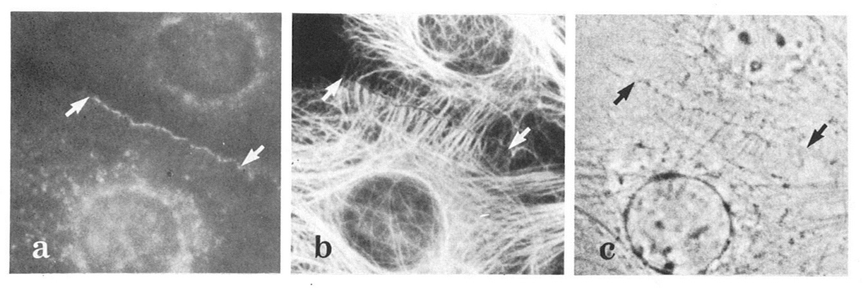
Source: Jones, J. C. R., J. Arnn, L. A. Staehelin, R. D. Goldman. 1984. Human autoantibodies against desmosomes: Possible causative factors in pemphigus. Proc. Natl. Acad. Sci. USA 81: 2781–2785.

Questions

1. What is the structure between the two arrows?

2. What cytoskeleton element was stained in micrograph b?

3. What kind of cell junction is stained in micrograph a?

4. Interpret the perinuclear fluorescence in micrograph a.

5. What conclusions can be drawn regarding the pathomechanism of pemphigus?

