Data Analysis Problem
by Marianna Pap and József Szeberényi
to accompany
The Cell: A Molecular Approach, Eighth Edition
Geoffrey M. Cooper

16.2 Synthesis and Secretion of Fibronectin

This Data Analysis Problem is also found on page 561 of the textbook.

Source: Tamkun, J. W., R. O. Hynes. 1983. Plasma fibronectin is synthesized and secreted by hepatocytes. J. Biol. Chem. 258: 4641–4647.

Level of difficulty: Low

Corresponding chapter(s) in the textbook: Chapter 16

Review the following terms before working on the problem: cell culture, immuno-fluorescence staining, albumin, fibronectin, fluorescence microscopy

Experiment

Rat liver cell cultures were studied by indirect immunofluorescence staining using antisera against albumin (A) or fibronectin (B). The cells were visualized by fluorescence microscopy (both micrographs display a single hepatocyte).

Figure

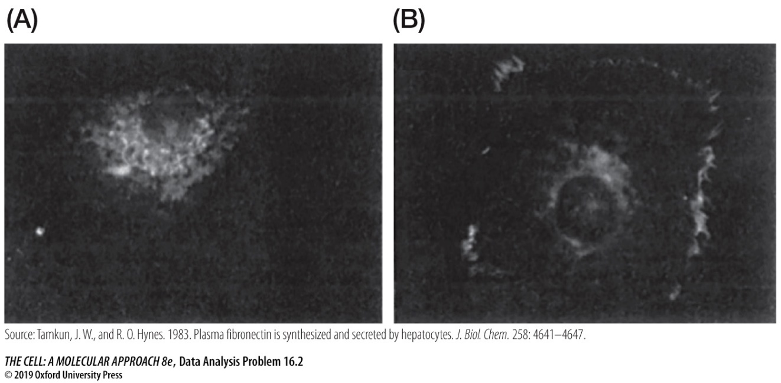

Questions

1. Interpret the staining pattern of the two proteins.

2. Suggest an explanation for fibronectin staining around the exterior surface of the cell.

3. What proteins in the cell membrane bind fibronectin?

