Data Analysis Problem
by Marianna Pap and József Szeberényi
to accompany
The Cell: A Molecular Approach, Eighth Edition
Geoffrey M. Cooper

16.1 The Pericellular Coat of Chondrocytes

This Data Analysis Problem is also found on page 560 of the textbook.

Source: Zaidel-Bar, R., M. Cohen, L. Addadi, B. Geiger. 2004. Hierarchical assembly of cell-matrix adhesion complexes. Biochem. Soc. Transactions 32: 416–420.

Level of difficulty: Low

Corresponding chapter(s) in the textbook: Chapter 16

Review the following terms before working on the problem: extracellular matrix, glycosaminoglycans, uranyl acetate, scanning electron microscopy

Experiment

Chondrocytes in suspension were either left untreated (A) or were treated with hyaluronidase (B). The cells were then fixed, treated with uranyl acetate, and analyzed by scanning electron microscopy (scale bar = 5 μm).

Figure

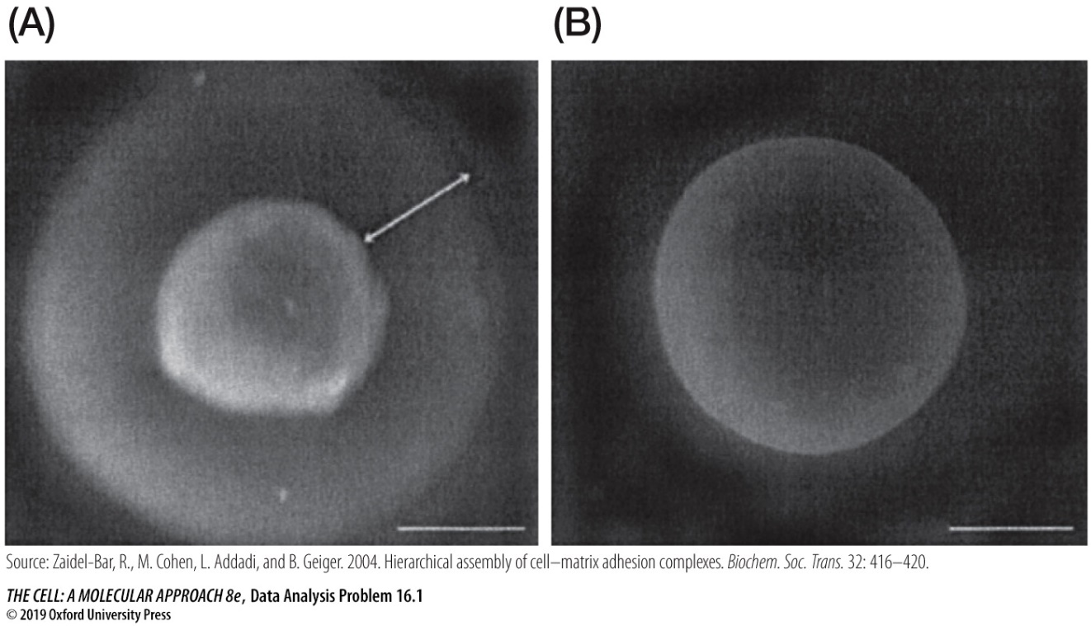

Questions

1. Briefly describe scanning electron microscopy.

2. What conclusion can be drawn about the chemical composition of the pericellular coat of chondrocytes (micrograph A)?

3. Determine the thickness of the pericellular coat.

