Data Analysis Problem
by Marianna Pap and József Szeberényi
to accompany
The Cell: A Molecular Approach, Eighth Edition
Geoffrey M. Cooper

15.4 The Pathomechanism of Cystic Fibrosis Caused by the ΔF508 Mutation

This Data Analysis Problem does not appear in the textbook.

Source: Pind, S., J. R. Riordan, D. B. Williams. 1994. Participation of the endoplasmic reticulum chaperone calnexin (p88, IP90) in the biogenesis of the cystic fibrosis transmembrane conductance regulator. J. Biol. Chem. 269: 12784–12788.

Corresponding Chapter(s) in the textbook: Chapter 15 (and 12)

Review the following terms before working on the problem: cystic fibrosis, ΔF508 mutation, deletion, cystic fibrosis transmembrane conductance regulator (CFTR), channel protein, endoplasmic reticulum, chaperone proteins, transfection, vector, expression plasmid, cDNA, [³⁵S]methionine, pulse-chase labeling, cell lysate, immunoprecipitation, chelator, SDS-polyacrylamide gel electrophoresis (SDS-PAGE), autoradiography

Experiment

The most common mutation leading to the inherited disease cystic fibrosis results in the deletion of phenylalanine at position 508 (ΔF508) in the cystic fibrosis transmembrane conductance regulator (CFTR) protein. The mutant protein still has Cl– channel activity, but it is retained in the endoplasmic reticulum and never reaches the cell surface. In this experiment, the role of calnexin, a transmembrane chaperone of the endoplasmic reticulum, in this process was studied.

Chinese hamster ovary cells (CHO-K1) were stably transfected with an empty vector (K1 in the figure, samples 1 and 6), with expression plasmids containing the cDNA of wild-type human CFTR (wt, samples 2, 4, 7, 9, and 11), or with expression plasmids containing the cDNA of ΔF508 CFTR (ΔF, samples 3, 5, 8, 10, and 12). Cell cultures were pulse-labeled with [³⁵S]methionine and chased for 2.5 hours. Cell lysates were prepared and immunoprecipitated with anti-CFTR (α-CFTR in the figure) or anti-calnexin (α-calnexin) antibodies. In lanes 11 and 12, anti-calnexin immunoprecipitates, were treated with a buffer containing EDTA (a chelator that disrupts the binding of client proteins to calnexin) followed by reimmunoprecipitation with anti-CFTR antibodies. Samples were fractionated by SDS-PAGE, and autoradiography was performed.
Figure

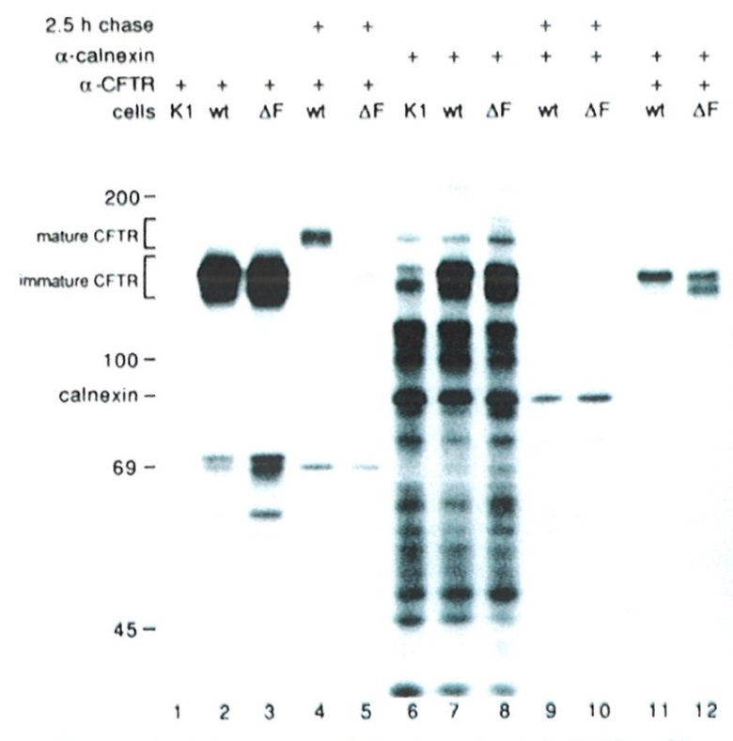
Source: Pind, S., J. R. Riordan, D. B. Williams. 1994. Participation of the endoplasmic reticulum chaperone calnexin (p88, IP90) in the biogenesis of the cystic fibrosis transmembrane conductance regulator. J. Biol. Chem. 269: 12784–12788.

Questions

1. What conclusions can be drawn from comparing samples 1, 2, and 3? (Disregard proteins around 69 Kd and shorter; they are most likely degradation products of CFTR and not relevant to this experiment.)

2. What conclusions can be drawn from comparing samples 2 and 4?

3. What conclusions can be drawn from comparing samples 4 and 5?

4. What do samples 6, 7, and 8 suggest about the promiscuous nature of calnexin?

5. What conclusion can be drawn from comparing samples 7 and 8 with samples 9 and 10?

6. Why does calnexin not appear in sample 1?

7. Why does calnexin not appear in samples 2 to 5?

8. What conclusion can be drawn from comparing samples 2 and 3 with samples 11 and 12?

9. Summarize the role of calnexin in CFTR metabolism. What role does calnexin play in cystic fibrosis pathogenesis?

