Data Analysis Problem
by Marianna Pap and József Szeberényi
to accompany
The Cell: A Molecular Approach, Eighth Edition
Geoffrey M. Cooper

15.1 The Effect of Antidiuretic Hormone on the Localization of Aquaporin in Kidney Cells

This Data Analysis Problem is also found on pages 535–536 of the textbook.

Source: Katsura, T., J.-M. Verbavatz, J. Farinas, T. Ma, D. A. Ausiello, A. S. Verkman, D. Brown. 1995. Constitutive and regulated membrane expression of aquaporin 1 and aquaporin 2 water channels in stably transfected LLC-PK₁ epithelial cells. Proc. Natl. Acad. Sci. USA 92: 7212–7216.

Level of difficulty: Medium

Corresponding chapter(s) in the textbook: Chapter 15 (and 17)

Review the following terms before working on the problem: epithelial cells, transfection, expression vector, cDNA, aquaporins, c-Myc protein, cell culture, antidiuretic hormone, adenylate cyclase, immunofluorescent staining, fluorescence microscopy

Experiment

Kidney cells were transfected with an expression plasmid containing a cDNA coding for aquaporin fused to a short peptide called a Myc tag. Stable transfectants were isolated, and cell cultures of the transfectants were either left untreated (A) or treated with antidiuretic hormone (ADH; B) for 10 minutes. Immunofluorescent staining was performed using an antibody specific for the Myc tag. The samples were analyzed in a fluorescence microscope.

Figure

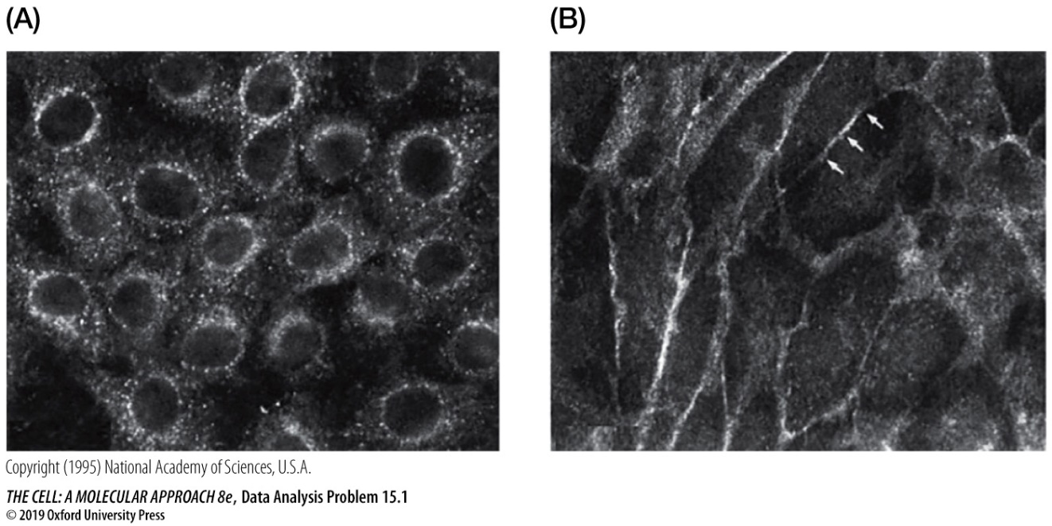

Questions

1. What was the purpose of Myc tag?

2. Describe the cellular distribution of aquaporin in untreated cells.

3. How did ADH affect the localization of aquaporin in kidney cells?

