Data Analysis Problem
by Marianna Pap and József Szeberényi
to accompany
The Cell: A Molecular Approach, Eighth Edition
Geoffrey M. Cooper

14.1 The Effect of Ionomycin on the Cytoskeleton of Fibroblasts

This Data Analysis Problem is also found on page 497 of the textbook.

Source: Ritter, M., E. Wöll, T. Haller, P. C. Dartsch, H. Zwierzina, F. Lang. 1997. Activation of Na⁺/H(⁺)-exchanger by transforming Ha-ras requires stimulated cellular calcium influx and is associated with rearrangement of the actin cytoskeleton. Eur. J. Cell Biol. 72: 222–228.

Level of difficulty: Low

Corresponding chapter(s) in the textbook: Chapter 14

Review the following terms before working on the problem: fibroblast, cytoskeleton

Experiment

The figure shows the results of an experiment in which the effect of ionomycin on mouse fibroblasts was studied. Ionomycin is a calcium ionophor that increases the permeability of the cell membrane to calcium ions. The micrographs show control cells (A) and cells treated with ionomycin for 1 minute (B) or 10 minutes (C).

Figure

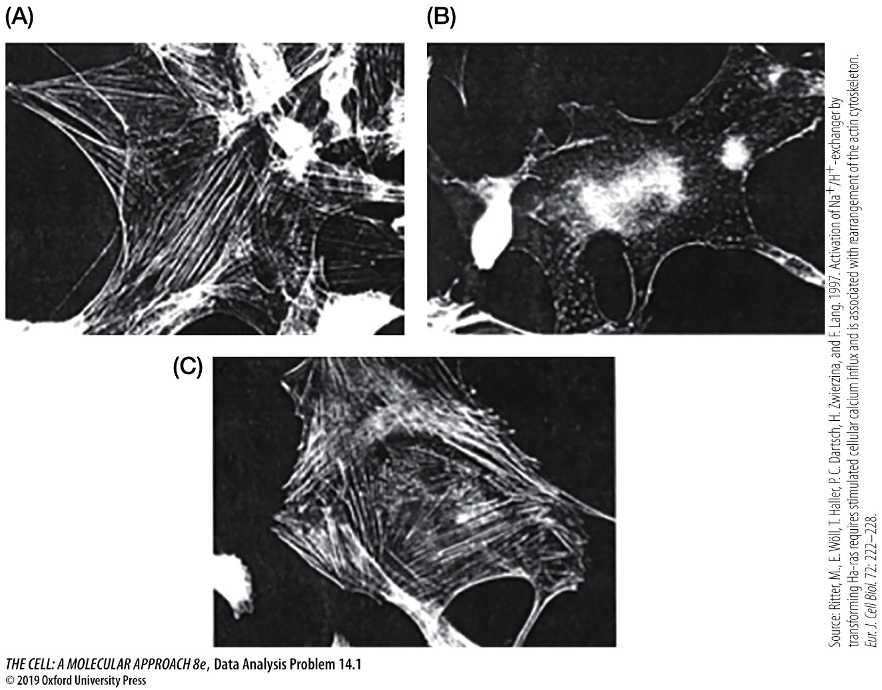

Questions

1. What method was used to visualize the cells?

2. What component of the cytoskeleton was studied?

3. What changes to cytosolic calcium levels are caused by ionomycin?

4. Describe the effect of 1-minute and 10-minute ionomycin treatment.

