Data Analysis Problem
by Marianna Pap and József Szeberényi
to accompany
The Cell: A Molecular Approach, Eighth Edition
Geoffrey M. Cooper

13.2 Staining of Mitochondria with a Fluorescent Dye

This Data Analysis Problem is also found on page 450 of the textbook.

Source: Johnson, L. V., M. L. Walsh, L. B. Chen. 1980. Localization of mitochondria in living cells with rhodamine 123. Proc. Natl. Acad. Sci. USA 77: 990–994.

Level of difficulty: Medium

Corresponding chapter(s) in the textbook: Chapter 13 (and 20)

Review the following terms before working on the problem: fibroblasts, Rous sarcoma virus, src gene, mitochondria, fluorescent dye, fluorescence microscope

Experiment

Rat fibroblasts were infected with a Rous sarcoma virus (RSV) strain carrying a temperature-sensitive mutation in the src gene. Cells were stained with a mitochondrion-specific fluorescent dye (rhodamine 123) at a nonpermissive temperature (39°C, which renders the src gene product inactive; A) and 30 minutes after shifting to a permissive temperature (34°C, at which the src gene product is active; B). The cells were imaged with a fluorescence microscope.

Figure

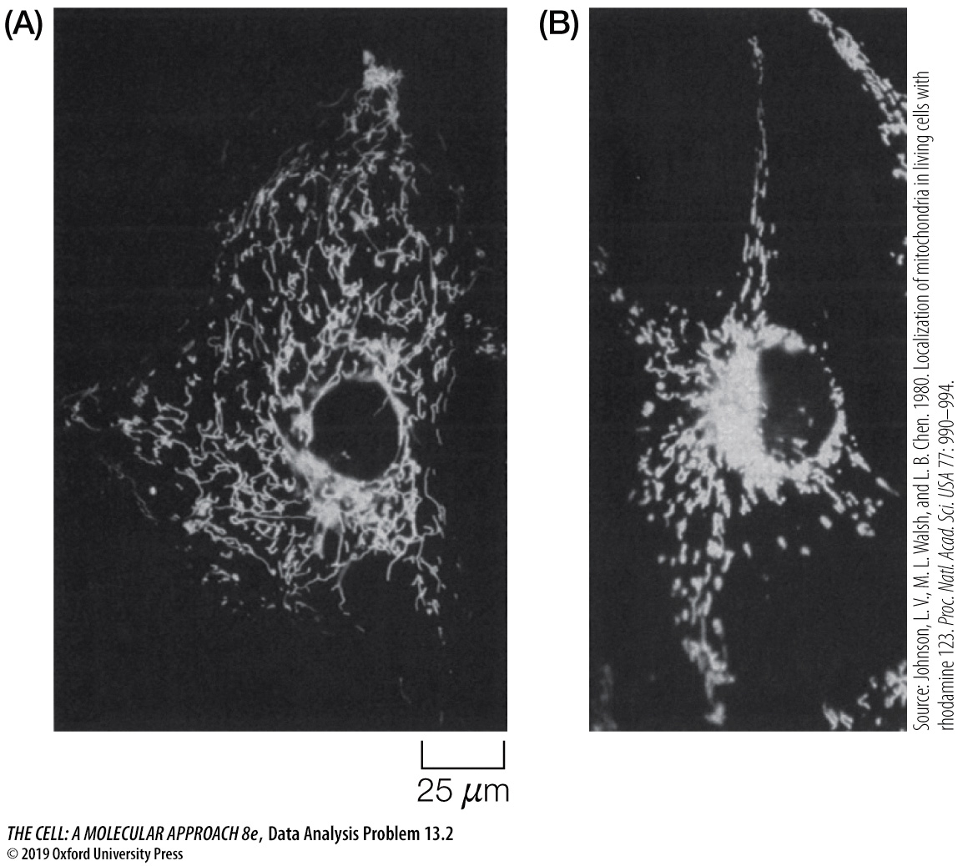

Questions

1. How does the RSV srv gene product affect the behavior or mitochondria?

2. How could you confirm that rhodamine 123 stains mitochondria specifically?

